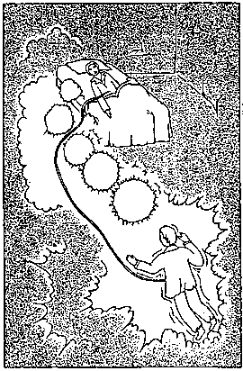
Watch over the Dream
Time has come to stop theorizing, it’s urgent to get to the facts. To look around in life, it’s practical brothers; time to be theorizing and speculating has gone. In occultism we must be practical because it’s necessary for the human being to see those internal worlds of which Theosophy tell us.
It’s indispensable for students to train in their ASTRAL body. I think you don’t ignore the trio of Body, Soul and Spirit. Certainly the Soul is wrapped in an ASTRAL body. it’s a wonderful body. With that body we can go in and out of our physical body at will, we can visit the superior worlds; we can go to others planets, etc…
Time has come to be practical. Life now goes on rails and theory it’s being left aside. The schools that don’t catch up in practical questions will fall into oblivion; it means that they will end up as old-fashioned schools. Learn to go out in Astral body. I’m going to give you the instructions.
WATCH OVER THE DREAM
During 40 continuous nights the student should spend time on observing very carefully the state of transition that exists between the vigil and sleep. It is necessary to pay attention in that state of special transition of sleepiness in which one is neither sleeping nor awake. Remember that when we are between the vigil and sleep, we are in fact before the door that allows us to go out in ASTRAL Study for 40 nights that door pay complete attention. After 40 nights you will know the state which exists between vigil and sleep. If you are sure you’ve studied very well the afore mentioned state of sleepiness in which one is neither sleep nor awake, then arise in those instants from your bed and go out of your room toward the place you like without fear.
When I say get up of your bed, in those moments while drifting off to sleep, I’m not saying you get up mentally what I’m telling must be translated in real facts. Do not think about the physical body, get up without any fear and that’s all. You can go anywhere in the world through the air, to go through any wall from side to side…
Samael Aun Weor. Esoteric Treatise of T. 3rd Edition and the Lecture: The Power of Mantra.
** These practices require for you to know how to relax your mind and body, in order to learn how to do it, we suggest you to take the course of Meditation.

------------------------------------------------------------------------------------------------
Instituto Cultural Quetzalcóatl de Antropología Psicoanalítica, A.C.
www.samaelgnosis.us and www.samaelgnosis.net

