The Vowels and the Chakras

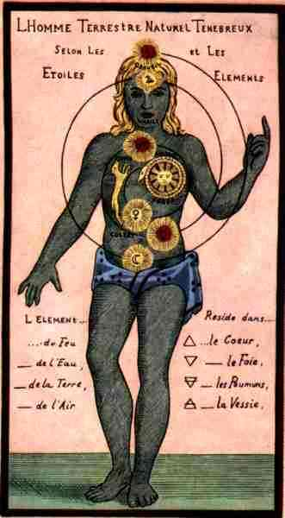
Let us remember that in the beginning was the Verb and that the Verb was with God and that the Verb was God.

In ancient times, the seven vowels of nature resounded in the entire human organism from head to toes, and it is now necessary to restore the seven notes in the marvelous harp of our organism, in order to restore the lost powers.

The vowel “I” causes the Pineal and Pituitary glands to vibrate; these two small glands are united by a small extremely subtle canal or capillary, which has already disappeared in cadavers.

The Pineal gland is located in the superior part of the cerebrum and the Pituitary gland, in the cavernous plexus between the two eyebrows. Each of these two small glands has its Vital Aura and when these two auras blend, the Spatial Sense is developed and we see the ultra of all things.

The vowel “E” causes the thyroid gland which secretes the biological iodine to vibrate.

This gland is located in the throat and in it resides the chakra of the magical ear.

The vowel “O” causes the heart chakra, the center of Intuition and all types of powers to
travel in the Astral, Jinns state, etc., to vibrate.

The vowel “U” causes the solar plexus, located in the umbilical region, to vibrate. This solar plexus is the Telepathic Center and the Emotional Cerebrum.

The vowel “A” causes the pulmonary chakras, which permit us to remember our past lives, to vibrate.

The vowel “M”, profanely held as a consonant, is vocalized with the lips closed, without opening the mouth, and the sound that then comes out through the nose is the “M”.

The vowel “M” causes the Ens Seminis, the waters of life, the Mercury of secret philosophy, to vibrate.

The vowel “S” is a sweet and gentle hissing which causes the fire inside of us to vibrate.
Seated in a comfortable armchair, we have to vocalize I. E. O. U. A. M. S., carrying the sound of each of these seven vowels from the head to the feet.

It is necessary to inhale, then exhaling the air together with the well prolonged vowel sound, until exhausting the exhalation.

This exercise has to be done daily in order to develop the internal magical powers.

Samael Aun Weor: Esoteric Treatise of Hermetic Astrology

Do you want to learn how these letters must be chanted? Visit our Mantra section.

