VIPARITA KARANI MUDRA
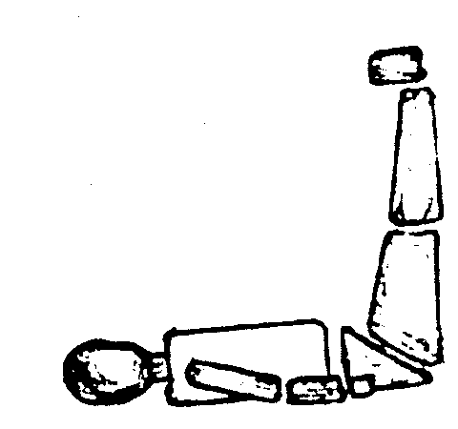
Lie down in the floor facing up, then rise up your legs and place them in a vertical position against the wall. For this exercise you’ll need to be very close to the wall; the back on the floor without a pillow, the arms along your body a little bit bended, on the floor…
…This is called in the East Viparita Karani Mudra, the blood flows to the head and precipitate to the skull to put to work different areas of the brain, to fortify the senses, to fortify the sense of sight, it is necessary to have very good sight, good sense of smell, good sense of touch, good sense of hearing, good sense of taste, etc, etc.
…you should start with 5 min and later increase the time gradually, slowly, with patience; for example increasing one minute every day. For those who long to rejuvenate the body and to heal from all sickness, here we give you the marvelous formula: The Viparita-Karani-Mudra. Understood?
…To each position or sadhana corresponds a meditation, a prayer; this is to say, to each change of position, intensification in any of the mystic aspects according to what it has to do.
…This question isn’t done overnight, this is not like “blow and make bottles”, this isn't like drink a glass of water (everything cost a sacrifice). The Viparita Karani Mudra, well understood it’s a penance. Yes, a very sacred penance…
…It is, then, the Viparita Karani Mudra, a penance. We shouldn’t dismiss the penance. We need not the old-fashion penance from the Age of Pisces, but the new penance, the one from the Age of Aquarius: a scientific, esoteric, mystic, highly transcendent and transcendental one, which operates great changes in all the psycho-physiological centers of our organism.
Samael Aun Weor. (Different works)
More practices at http://www.samaelgnosis.us/practice/
----------------------------------------------------------------------------------
Instituto Cultural Quetzalcóatl de Antropología Psicoanalítica, A.C.
Gnosis Immortal Wisdom www.samaelgnosis.us and www.samaelgnosis.net

