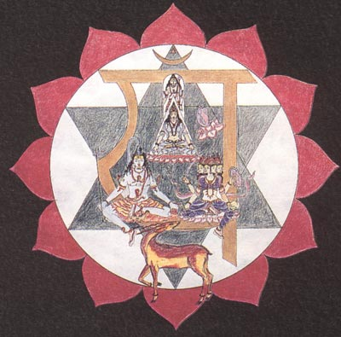
Practice for making vibrate the Chakra of the Heart

Mantra TOM-DOM
Vocalize like this my brothers:
TOOOOMMMMMM DOOOOMMMMMMM
TOOOOMMMMMM DOOOOMMMMMMM
TOOOOMMMMMM DOOOOMMMMMMM
…like imitating the sound of the parish bells.
Continue now: IIIIIIIIII, UUUUUUU, EEEEEE, IIIIIII, trying to imitate the sound that the breeze produces between the foliage of the trees.
The mantra TOM-DOM must be done as clearly as possible to make vibrate the chakra of the heart.
Samael Aun Weor.

In the Mantras’ section of our website you can listen to the way of pronouncing the mantra:
TOM-DOM

Glossary:
Chakra. - Disc or Wheel. Center that once developed gives us faculties.
Anahata Chakra or heart’s. - Gives us intuition.
Mantra. - Wise combination of sounds to produce a desired effect in the emotional, physical or mental aspect, etc. In this case the awakening of the chakra of the heart.

------------------------------------------------------------------------------------------------
Instituto Cultural Quetzalcóatl de Antropología Psicoanalítica, A.C.
www.samaelgnosis.us and www.samaelgnosis.net

