The Tattvas of Nature.
The Great Master Huiracocha teaches a very simple practice to see the Tattvas. (Tattva is the vibration of the Ether).
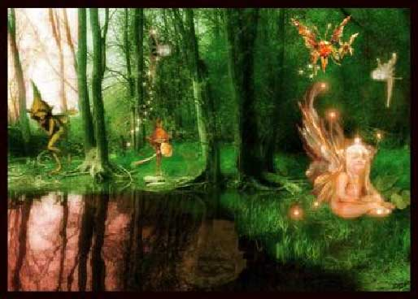
The exercise is the following: The devotee should place his thumbs in his ears, close the eyes and seal them with the index fingers, close the nose with the middle fingers and finally, seal the lips with the ring and little fingers. In this condition the student should try to see the Tattvas with the sixth sense. This eye is located between the eyebrows.
Yogananda, who gives the same exercise as Krumm Heller, advises to also use the mantra OM. Yogananda says that the devotee should rest his elbows on some cushions, which should be placed on a table.
The devotee will do this practice before the table, with his face toward the East. Yogananda advises that the chair on which the devotee sits to do this practice should be covered with a woolen blanket.
This reminds us of Apollonius of Tyana who wrapped himself in a woolen mantle to totally isolate himself from disturbing currents. Many authors give this exercise and we consider it very good. We believe that with this practice one can develop clairvoyance and the magic ear.
At first, the devotee will see nothing but darkness.
Nevertheless, the more effort one puts into the practice, the more the clairvoyance and the magic ear will develop, slowly but surely.
At first, the devotee will hear nothing but his physiological sounds. However, little by little he will hear during the practice each time more and more delicate sounds. In this way he will awaken his magic ear.
Instead of the reader getting indigestion with so many contradictory theories, it is better that he practice and develop his internal faculties.
The process of Regeneration should progress intimately linked with esoteric training. Science states that an organ which is not used becomes atrophied. It is necessary to use these organs of clairvoyance and of the magic ear. It is urgent to train these organs and regenerate them to attain internal realization.
These practices are not opposed to any religion, sect, school or belief. All priests, guides, instructors of all schools and orders, can do these exercises to develop their faculties. Thus they will better be able to direct their respective groups.
The awakening of internal faculties should progress parallel with cultural, intellectual and spiritual development.
Samael Aun Weor. The Perfect Matrimony.

If you want to know more about the Tattvas we suggest you to study the Book: Introduction to Gnosis. You can find it in the Books section. Read
If you want to know more about the Chakras, Mantra, etc., ask for the Antechamber Course of Gnosis. Subscription

Glossary
Tatvva. - (Sanskrit) This is the way they name the soul of the elements (Fire, Air, Water and Earth)
Ether. - This is the fifth element, the root of the four fundamental elements.
Mantra. - Wise combination of sounds that can bring a physical, mental, or spiritual benefit.
Clairvoyance. - The capacity of seeing the ultra of Nature.
Magic Hearing. - Also called the "clairaudience" (super-hearing sense) it's the capacity of hearing the superior dimensions, this is why Pythagoras used to speak of the music of the Spheres.
Apollonius of Tyana. - Pythagorean and thaumaturgy philosopher, born in Cappadocia a few years after Christ, he preached the reform of the customs and the correction of the abuses; he had many disciples. He established a Pythagorean school in Ephesus. He died in the year 97.
**Practice guided by a gnostic instructor in mp3 format. Click here
Note: The audio guided practice is not in real time, it’s just a sample of how should be done. The Gnostic student can take all the time he wants to complete it.
------------------------------------------------------------------------------------------------
Instituto Cultural Quetzalcóatl de Antropología Psicoanalítica, A.C.
www.samaelgnosis.us and www.samaelgnosis.net

