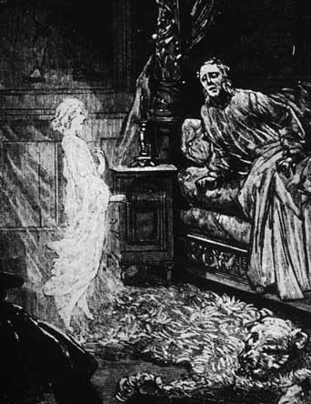
The Mantra TAI-RE-RE-RE (for the astral projection)
For this it’s needed that the disciple has faith and tenacity, since there are many who learn this in the same say, and there are others who take months and even entire years to learn what some others do in one day. Everything depends on the evolution of the individual. The Key to get out in the ASTRAL body it’s very simple; just get asleep chanting the powerful Mantra (Magical Words) TAI-RE-RE-RE. The exact punctuation shows how to chant it. Then, when the disciple is in that state of transition between the vigil and sleep, he will get deeper inside himself by means of deflection, and then softly he will rise from his bed…
[Samael Aun Weor. Kindergarten’s Perfect Matrimony.]
Another method is for the disciple to lull himself to sleep vocalizing this Mantra: TAI RE...RE...RE... This Mantra should be sung strongly accenting the vowel A: TAAAAAAIIIIIIIII The three remaining syllables are vocalized giving the E a ringing melodious, prolonged sound. The R is not made to vibrate, but is only pronounced in a simple form: REEEEEEEE... REEEEEEEEE... REEEEEEEE… The syllable TAI is sung in a deep tone. The repetition of RE, in a higher tone than TAI.
When the disciple is already falling asleep, when he finds himself in that precise state of transition between vigil and sleep, he should rise from his bed without hesitation, laziness, doubts, reasoning, naturally, like a reflex or in an instinctive manner, automatically, and absolutely childlike.
Observe the birds: When they are going to fly, they do not reason about it, they do not harbor doubts nor preconceptions, but simply fly away instinctively; we can say: automatically. The disciple should proceed in that manner: imitate the birds. He should rise, therefore, from the bed and leave the room and head for any Corner of the infinite, or wherever he likes.
When we say that the student should RISE from the bed, this should be translated into effective and immediate actions, without stopping to think.
[Samael Aun Weor. Logos, Mantra, T.]
Mantra Tai-re-re-re chanted by the V.M. Samael Aun Weor: Click here.
------------------------------------------------------------------------------------------------
Instituto Cultural Quetzalcóatl de Antropología Psicoanalítica, A.C.
http://samaelgnosis.us and http://samaelgnosis.net

