Mantras Suira Suera Suora Suura Suara

We suggest relaxing the body and mind, closing the eyes and vocalizing the mantras given below for the development of the Chakras (magnetic centers).

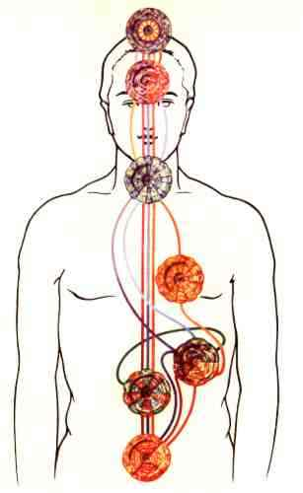

SUIRA Clairvoyance: Frontal Chakra
SUERA Clairaudience: Larynx Chakra
SUORA Intuition: Heart Chakra
SUURA Telepathy: Solar Plexus
SUARA Memory of Past Lives: Pulmonary Chakras
VOCALIZATION
The Student should note the accentuation of the vowels which form the fourth column, and the accentuation of the A in each Mantra.
According to the Vedas, the silent Gandana, the Celestial Music, is contained in the sublime SUARA.

With these Mantras of the Fourth Series, the Fire of the Solar Plexus is conducted to each of the Chakras of the Astral Body.

We insist that the first Mantric syllables of this series: SUI, SUE, SUO, SUU, SUA, are vocalized with the intonation of a diphthong accentuated on the last vowel, which will be prolonged for a long time.

Samael Aun Weor. Excerpt from the book: “Logos, Mantra, T”

Mantra in MP3 by the Master Samael Aun Weor:
http://www.samaelgnosis.us/practice/audio/suira.mp3

------------------------------------------------------------------------------------------------
Instituto Cultural Quetzalcóatl de Antropología Psicoanalítica, A.C.
http://samaelgnosis.us and http://samaelgnosis.net

