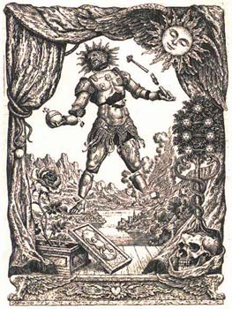
For this week we suggest to study through the Psychological Self-Observation the “States of the Ego” during our daily life and in a physical and mental relaxed stated to try to understand the functioning of them within us.
The States of the Ego
The states of the ego are classified in the following manner:
-STEREOPSYCHIC: Are the identifying states which are intimately related with the exterior perceptions which are received through the five senses and which are connected with the world of impressions.
-NEOPSYCHIC: Are the data processing states, in other words, those which properly interpret or misinterpret all the multiple situations which the intellectual animal lives. Our bad secretary, the personality, works in these states.
-ARCHEOPSYCHIC: Are the regressive states —memory of the ego— which are found in the 49 levels of the subconscious. They are the memories of the past which are filed in a photographic and phonographic manner.
Samael Aun Weor. The Revolution of the Dialectic.
Practice of:
Physical relaxation: http://samaelgnosis.us/practice/more_practices/relaxation.html
Mental Relaxation: http://samaelgnosis.us/practice/more_practices/mental_relaxation.html
Psychological Self-Observation: http://samaelgnosis.us/practice/more_practices/observer_observed.html

------------------------------------------------------------------------------------------------
Instituto Cultural Quetzalcóatl de Antropología Psicoanalítica, A.C.
http://samaelgnosis.us and http://samaelgnosis.net

