The Mantra Rusti and the Astral Projection
The disciple should lie on his bed in an horizontal position. Relax the body so that no muscle applies pressure on the astral body. Become drowsy singing the mantra Rusti like this: Ruuuuuuussssstiiiiiii. This mantra is sung mentally. In those instants, the student should become a “spy of his own sleeping process”
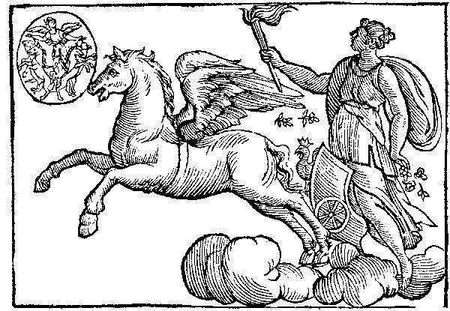
When the student already finds him in that state of drowsiness or somnolence that precedes sleeping, he should get out of bed and leave the room. How? In what manner?
Almost all students suppose that it is an exercise of magnetism or auto-suggestion, etc., but they are lamentably mistaken because here we are not dealing with auto suggestion or hypnotisms. Simply get out of bed for Nature will do the rest. She will know how to separate the astral body from the physical body. The disciple merely needs to stand up and leave his room for Nature will do the rest. Already out of his room, the student will take a little hop with the intention of floating in space. (Samael Aun Weor. Zodiacal Course.)
--------------------------------
1. - What is the projection?
A. - Do you ignore what the projection (astral projection) is? I understand very well young lady that your question is sincere. The projection is extremely simple and easy; it's a natural phenomenon like eating, drinking, etc., etc.
It's clear that when the physical body is sleeping, the soul go out of it and travels everywhere; when the soul comes back and enters again in its body remembers many times the places where it was, the people it spoke to, etc. and that is called dreams; such is the projection (Astral projection).
2. - This can only be done while sleeping or also at will?
A. - Anyway the sleep is needed to project even if it's at will.
3. - Is the projection dangerous?
A. - I think that to be oneself conscious of its own natural phenomenon could never be dangerous; one must be conscious of the food that eats, of what one drinks, the state of health and also the projection process that occurs in every living creature.
4. - Tell me the technique to be able to project myself; I’d like to go to Paris at will.
A. - That what you always do in an involuntary way, unconscious, learn to do it in a voluntary and conscious way. You'd always projected; when it is having doze, every soul go out of its body unfortunately in an unconscious way; do the same, but in a voluntary and conscious way; when you feel the drowsy state before sleeping, when you start dreaming, imagine yourself as a delicate and steamy ghost; think you're going out of your body; comprehend that you are not the body, understand that you are a soul; feel yourself as a soul and get smoothness up, delicately from your bed, as the souls get up.
This what I'm saying must be fulfilled; it's not about thinking, but doing; after you woke up take a little hop inside your own bedroom with the firm intention of floating in the space; therefore, it´s clear that if you float it's because you're already out of your physical body; then you can go out of your bedroom and to float in the space; you can go to Paris or London or wherever you want to; but if you don't float it's because you've woken up with the physical body, then go inside you bed again and repeat the experiment.
5. - When floating, the physical body remains in the bed?
A. - I want you to understand me; it's clear that if you float in the environment it's because you're out of the physical body; in this concrete case you must understand that your body remains in the bed and that you're out of the body and far from the bed.
6. - When one feels that is floating, one must think that travels to a specific place?
A. - I want you, dear lady to understand that this is not about thinking, but doing which is different. For example, I'm seeing you seated in that chair, but if you think that you're going to stand up and go out to the street and you don't act, it's clear that you'll remain seated in the chair; action is needed, have you understood me? (Samael Aun Weor. Beyond the Death.)

**To deepen in what is the awakening of the consciousness here in the physical world and in the astral world, request the Antechamber course of Gnosis (introduction of 40 lessons) in our courses section
http://www.samaelgnosis.us/courses/
** If you want to learn how to pronounce the mantra of this practice you can listen to it directly (mp3) in our website, in the mantra section
http://www.samaelgnosis.us/mantram/
Practice lead by a Gnostic instructor
http://www.samaelgnosis.us/practice/more_practices/rusti.htm
Note: The guided practice in audio is not in real time, it is only a sample of how to do it. The Gnostic student should take all the time he wants to perform it.
------------------------------------------------------------------------------------------------
Instituto Cultural Quetzalcóatl de Antropología Psicoanalítica, A.C.
www.samaelgnosis.us and www.samaelgnosis.net

