Rune Rita

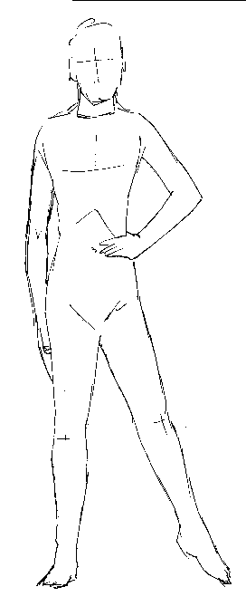
The fundamental mantras of the RUNE RITA are:
RA…….. RE………. RI……….. RO……… RU…………
… So, in the present RUNE RITA we must open one leg and one arm. Thus, in this position, the GNOSTIC students will see that they in themselves are forming the RUNIC Letters, such as they are written.
The present RUNIC practice has the power of liberating the INTERNAL JUDGMENT.
We need to convert ourselves into JUDGES OF CONSCIOUSNESS. TO AWAKEN THE BUDDHATA, the SOUL is urgent.
The present RUNE has the power of AWAKENING the CONSCIOUSNESS of the JUDGES.
Let us remember what is called REMORSE, which certainly is the accusing VOICE of the CONSCIOUSNESS.
Those who never feel remorse are truly very far from their Interior JUDGE. Commonly, they are lost cases.
People like that must work very intensely with the RUNE RITA, thus, this is how they will liberate their Interior Judgment.
We need with URGENCY to learn how to be guided by the voice of the silence, that is to say, by the Intimate Judge.
Samael Aun Weor. Magic Runes

More practices:
www.samaelgnosis.us/practice/morepractices.htm

----------------------------------------------------------------------------------
Instituto Cultural Quetzalcoatl de Antropología Psicoanalítica, A.C.
Gnosis Immortal Wisdom www.samaelgnosis.us and www.samaelgnosis.net

