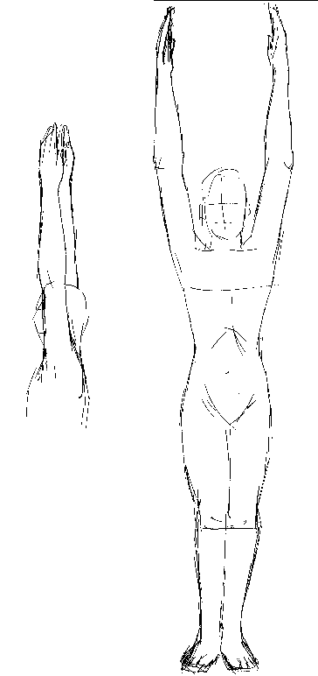
Rune IS
RUNE IS
God as FATHER is WISDOM. God as MOTHER is LOVE.
God as Father resides in the Eye of Wisdom. The Eye of Wisdom is situated between the eyebrows.
God as Love is found in the Heart-Temple.
Wisdom and Love are the two Main Columns of the Great White Lodge.
To love, what a beautiful thing it is to love. Only the great Souls can, and know how to love. Love is infinite tenderness... Love is the life that palpitates in every atom, as in every Sun.
Love cannot be defined because it is the Divine Mother of the World; it is what occurs to us when we are really in love.
Samael Aun Weor. The Perfect Matrimony.
---------------
Let us now practice with the RUNE IS and let us meditate on the Divine Mother KUNDALINI.
PRACTICE
Standing in a straight position, let us raise our arms in order to form a straight line with the whole body, and after praying and asking for help to our DIVINE MOTHER we must sing the MANTRA ISIS, as follows:
IIIIIIIIISSSSSSSS….IIIIIIIIIIISSSSSSSSSS. Prolong the sound of the two letters and divide the word in two syllables IS-IS. [The sound of the letter I is similar to that found in the word “tea”]
Afterward, the student must lay down with his relaxed body and filled with ecstasy must CONCENTRATE and meditate on the DIVINE MOTHER.
Samael Aun Weor. Esoteric Course of Runic Magic.
Mantra IS by the master Samael Aun Weor: www.samaelgnosis.us/practice/audio/isis.mp3

------------------------------------------------------------------------------------------------
Instituto Cultural Quetzalcóatl de Antropología Psicoanalítica, A.C.
www.samaelgnosis.us and www.samaelgnosis.net

