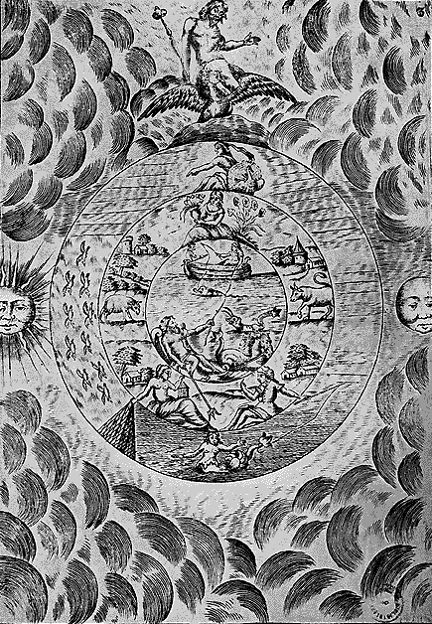
Retrospective Exercise.
Before falling asleep in their bed, our GNOSTIC disciples should PRACTICE a RETROSPECTIVE EXERCISE of their own life, like someone who is watching a movie from the end to the beginning, or like someone who reads a book from the end to the beginning, from the last to the first page.
The objective of this RETROSPECTIVE EXERCISE of our own life is to SELF-KNOW, SELF-DISCOVER OURSELVES.
To RECOGNIZE our good and evil actions, to study our own LUNAR EGO, to make CONSCIOUS the SUBCONSCIOUS.
It is necessary to arrive in a RETROSPECTIVE manner at our BIRTH and remember it. A superior effort will permit the student to connect his BIRTH with the DEATH of his previous physical body. DROWSINESS combined with MEDITATION, with the RETROSPECTIVE EXERCISE will permit us to remember our present life and the previous one and the past existences.
The RETROSPECTIVE EXERCISE permits us to become conscious of our own LUNAR EGO, of our own errors. Let us remember that the EGO is a bunch of MEMORIES, desires, passions, anger, covetousness, lust, pride, laziness, gluttony, self-esteem, resentments, vengeances, etc.
If we want to dissolve the EGO, we should first study it. The EGO is the root of ignorance and pain.
Only the BEING, ATMAN, is perfect, but HE is not BORN, neither does he die nor REINCARNATE; this is how KRISHNA said it in the BHAGAVAD GITA.
If the student falls asleep during the RETROSPECTIVE EXERCISE, so much the better, because in the INTERNAL WORLDS, he will be able to KNOW HIMSELF, remember his entire life and all of his past lives. In the same manner that the MEDICAL SURGEON needs to study a cancerous tumor before extirpating it, likewise the GNOSTIC needs to study his own EGO before EXTIRPATING IT.
Samael Aun Weor. Excerpt from the Book: Esoteric Treatise of Hermetic Astrology.

----------------------------------------------------------------------------------
Instituto Cultural Quetzalcóatl de Antropología Psicoanalítica, A.C.
Gnosis Immortal Wisdom www.samaelgnosis.us and www.samaelgnosis.net

