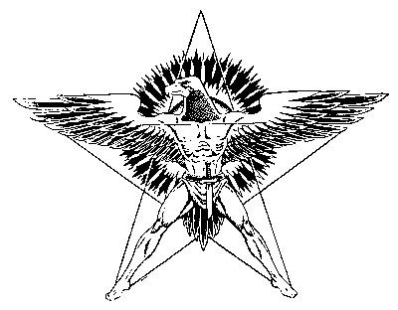
The Relaxation
The Gnostic Ascetic should lie facing up with the head towards the East. He can lie on his bed, or in the aromatic field or wherever he wants. It is delicious to lie down to meditate in the flowered fields or between that enchanting murmur of the ancestral pine woods, where the birds sing.
Also can the Gnostic Ascetic lie down over the rocks of the mountains or in the cliffs of the stormy sea. The friendly rocks offer solace to the Gnostic Ascetics.
Place your body in the shape of a beautiful five-pointed star or in the shape of a dead man, you pick the figure. The pentalfa happens to be profoundly esoteric; she can defend us from the attacks of the tenebrous ones.
The position of dead man is profoundly meaningful: “Dead is the crown of everyone” you know it. You should then look like a dead body; the feet touching each other by the heels and the points of separated as a fan.
The arms are extended alongside of the dead body.
Now breathe like the newborns babies do; observe the little ones, pay attention to their way of breathing; imitate them during the meditation.
How beautiful the newborn babies are! Their breathing certainly is the one of the SOUL OF THE WORLD.
The smell of the newborn babies happens to be wild, it taste to woods, to mountains; it has I don’t know what…
In the innocent creatures only the essence pure and ineffable is manifested.
Now we know the fundamental reason why the newborn babies are self-conscious.
However the elder ones with so much smugness suppose that the newborn is unconscious.
Observe the newborn babies; their little bodies in the cradle have an ineffable aspect.
Imitate the newborn creatures; relax your body as the children do.
Let no muscle remaining in tension; the legs and the arms of the newborn creatures look like made of silk.
The newborn babies sleep deliciously between their happy cradles and without problems of any specie.
Imitate to the innocent children during the inner deep meditation. Reconquer the childhood in mind and heart.
Samael Aun Weor. Excerpt from the book: The Science of Meditation.
Guided practice by a Gnostic instructor in (mp3).
http://www.samaelgnosis.us/practice/more_practices/relaxation.html
------------------------------------------------------------------------------------------------
Instituto Cultural Quetzalcóatl de Antropología Psicoanalítica, A.C.
http://samaelgnosis.us and http://samaelgnosis.net

