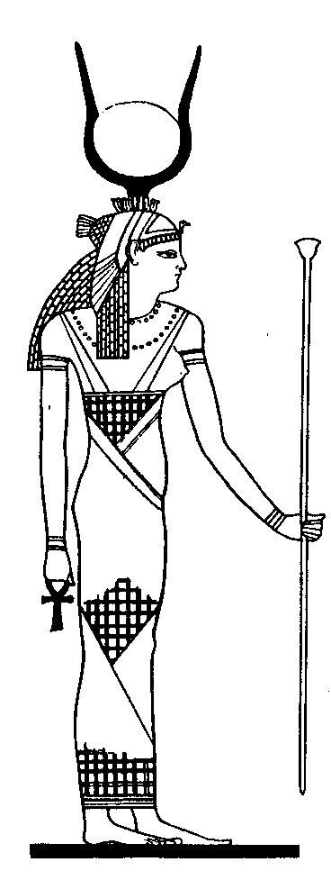
Prayer to the Divine Mother
We suggest you to relax the physical body and the mind. Once this has been achieved, try to be in the third Conscience State (being here and now), let’s do the next...
++++++++++++++++++++++
INVOCATION
"Oh Isis, Mother of Cosmos, root of Love, Trunk, Bud, Leaf, Flower and Seed of all that exists.
We conjure Thee, Naturalizing Force, we call upon the Queen of the space and of the night, and kissing your loving eyes, drinking the dew from your lips, breathing the sweet aroma of your body, we exclaim:
"Oh, Thou, Nuit, Eternal Seity of Heaven, who art the Primordial Soul, Thou who art what was and what shall be, whose veil no mortal has lifted, when Thou art beneath the irradiating stars of the nocturnal and profound sky of the desert, with purity of heart and in the flame of the serpent we call upon Thee".
Pray and meditate intensively. The Divine Mother teaches Her children. This prayer must be done combining meditation and sleepiness. Then, like in a dream vision, Illumination emerges. The Divine Mother comes to instruct the devotee in the great mysteries.
Samael Aun Weor. Esoteric Course of Kabbalah.
GLOSARY:
Divine Mother. - She is the Feminine aspect of the Being or Spirit inside every human being.
Isis. - It is the name of the Eternal, Divine Feminine Principle among the Egyptians.
Nuit. (Nut) - She is the Eternal Cosmic Mother, root of everything that exists, among the Egyptians too.
Serpent’s flame. - Among the ancient Egyptians can be understood as the Love’s sacred fire.
Third Conscience State. – To join the conscience to what we do, the Inner Self-Remembering.
Complementary information:
"…Among the Aztecs she is TONANTZIN, among the Greeks the CASTE DIANA, and in Egypt she is ISIS, the DIVINE MOTHER of whom no mortal has lifted the veil.
There is not any doubt whatsoever that Esoteric Christianity never stopped adoring the Divine Mother Kundalini; obviously she is MARAH or better said RAM-IO, MARIA or MARY".
"What orthodox religions did not specify, at least as far as the exoteric or public circle is concerned, is the aspect of ISIS in her human individual form".
"Ostensibly, only in secret were the initiates taught that this Divine Mother exists individually within each human being".
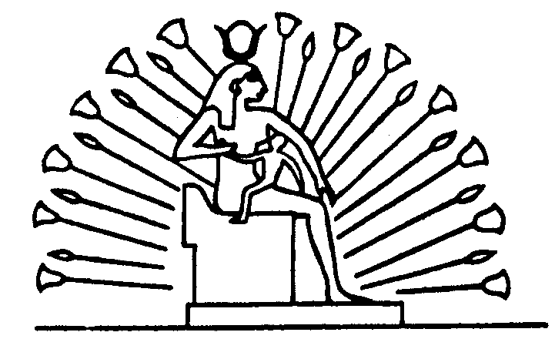
"It is not superfluous to emphatically clarify that Mother-God, REA, CYBELES, ADONIA or whatever we wish to call her, is a variant of our own individual Being here and now".
"Specifying, we will say that each of us has his own particular, individual, Divine Mother. There are as many Mothers in heaven as creatures on earth".

+++++ Samael Aun Weor. The Great Rebellion. ++++++++

** These practices require for you to know how to get mentally and physically relaxed, if you don’t know yet, get subscribed to our course of Meditation. www.samaelgnosis.us/courses/
** Practice guided by a Gnostic instructor in audio mp3:
http://www.samaelgnosis.us/practice/more_practices/prayer_divine_mother.htm

------------------------------------------------------------------------------------------------
Instituto Cultural Quetzalcóatl de Antropología Psicoanalítica, A.C.
www.samaelgnosis.us and www.samaelgnosis.net

