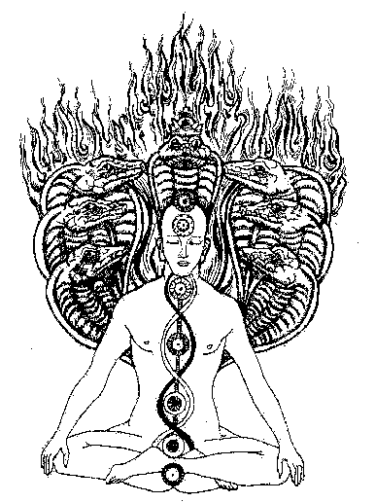
PRATYAHARA

THE REVOLUTION OF MEDITATION

The technique of meditation permits us to arrive at the heights of illumination and the Revolution of the Dialectic.

We should distinguish between a mind that is still and a mind that is stilled by force.

When the mind is stilled by force, it is really not still. It is gagged by violence and in the deeper levels of understanding, there is an entire tempest.

When the mind is silenced violently, it is really not in silence and deep within, it clamors, shouts and despairs.

It is necessary to put an end to modifications of the thinking principle during meditation.

When the thinking principle remains under our control, illumination comes to us spontaneously.

Mental control permits us to destroy the shackles created by the mind. To achieve the stillness and silence of the mind, it is necessary to know how to live from instant to instant, to know how to take advantage of each moment, to not live the moment in doses.

Take everything from each moment, because each moment is a child of Gnosis, each moment is absolute, alive and significant. Momentaneity is a special characteristic of the Gnostics. We love the philosophy of momentaneity.

Master Ummom said to his disciples: “If you walk, walk; if you sit, sit, but do not vacillate.”

A first study in the technique of meditation is the antechamber of that divine peace that surpasses all knowledge.

The most elevated form of thinking is non-thinking. When one achieves the stillness and silence of the mind, the ‘I’ with all it passions, desires, appetites, fears, affections, etc. becomes absent.

It is only in the absence of the ‘I’, in the absence of the mind, that the Buddhata can awaken to unite with the Inner Self and take us to ecstasy.

It is false, as is pretended by the school of black magic of the Subub that the monad or the great reality will penetrate in him who does not possess the superior existential bodies of the Being.

What enters in the tenebrous fanatics of the Subub are the tenebrous entities that are expressed in them with gestures, actions, bestial and absurd words. Those people are possessed by the tenebrous ones.

The stillness and silence of the mind has a single objective: liberate the Essence from the mind so that fused with the Monad or Inner self, it (the Essence) can experience that which we call the Truth.

During ecstasy and in the absence of the ‘I’, the Essence can live freely in the World of the Mist of Fire, experiencing the Truth.

When the mind is in a passive and receptive state, absolutely still and in silence, the
Essence or Buddhata is liberated from the mind and ecstasy arrives.

The Essence is always bottled up in the battle of the opposites, but when the battling ends and the silence is absolute, the Essence remains free and the bottle broken into pieces.

When we practice meditation, our mind is assaulted by many memories, desires, passions, preoccupations, etc.

We should avoid the conflict between attention and abstraction. A conflict exists between distraction and attention when we combat those assailants of the mind. The ‘I’ is the projector of said mental assailants. Where there is conflict, stillness and silence do not exist.

We should nullify the projector through self-observation and comprehension. Examine each image, each memory, each thought that comes to the mind. Remember that every thought has two poles: positive and negative.

Entering and leaving are two aspects of a same thing. The dining room and the bathroom, tall and short, pleasant and unpleasant, etc. are always two poles of the same thing.

Examine the two poles of each mental form that comes to the mind. Remember that only through the study of these polarities, one arrives at the synthesis.

Every mental form can be eliminated through the synthesis.

Example: The memory of a fiancée assaults us. Is she beautiful? Let us think that beauty is the opposite of ugliness and that if, in her youth she is beautiful, in her old age, she will be ugly. The synthesis: it is not worth it to think about her, she is an illusion, a flower that inevitably withers.

In India, this self-observation and study of our Psyche is properly called Pratyahara.
Bird- like thoughts should pass through the space of our own mind in a successive parade but without leaving any trace.

The infinite procession of thoughts projected by the ‘I’, in the end is exhausted and then the mind remains still and in silence.

A great self-realized Master said: “Only when the projector, in other words, the ‘I’, is completely absent, then befalls the silence which is not a product of the mind. This silence is inexhaustible, it is not of time, it is the immeasurable, only then arrives THAT which is.”

This whole technique is summarized in two principles:
(1) Profound reflection
(2) Tremendous serenity.

This technique of meditation with its non-thinking, puts to work the most central part of the mind, the one that produces the ecstasy.

Remember that the central part of the mind is that which is called Buddhata, the Essence, the Conscience.

When the Buddhata awakens, we remain illuminated. We need to awaken the Buddhata, the Conscience.

The Gnostic student can practice meditation seated in the Western or Oriental style.

It is advisable to practice with eyes closed to avoid the distractions of the exterior world.

It is also convenient to relax the body carefully, avoiding any muscle remaining in tension.

The Buddhata, the Essence, is the psychic material, the inner Buddhist principle, the spiritual material or prime matter with which we will give shape to the soul.

The Buddhata is the best that we have within and awakens with profound inner meditation.

The Buddhata is really the only element that the poor intellectual animal possesses to arrive at the experience of that which we call the Truth.

The only thing that the intellectual animal can do, unable to incarnate the Being due to the fact that he still does not possess the superior existential bodies, is to practice meditation to auto-awaken the Buddhata and know the Truth.

Samael Aun Weor, The Dialectic’s Revolution.

If you want to get the Weekly Practice in your e-mail, go to: New Features Subscription.
------------------------------------------------------------------------------------------------

Quetzalcoatl Cultural Institute of Psychoanalytic Anthropology
http://samaelgnosis.us

