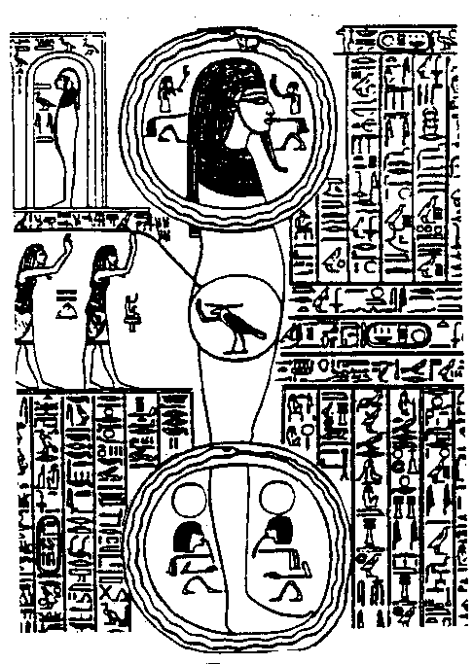
Omnis Baum Igneos

Put yourself to sleep pronouncing the mantra: OMNIS BAUM IGNEOS; like this: Ooooommmnisssssbaaaaauuuuuummmmiiiiiignnneeeeeoooooooooooossssss,
Syllabicating the mantra, lengthening the sound of each vowel and praying to the Intimate to take thee out of the body. Then softly get out of your bed and floating in space, go to the Gnostic C.
Samael Aun Weor. Zodiacal Course

Watch over the dream
That what you always do in an involuntarily, unconscious way, learn to do it in a voluntarily and conscious form. You’ve always projected; while falling asleep every soul gets out of the body in an –unfortunately- unconscious form. Do the same, but in a voluntarily and conscious way I repeat; when you feel that typical relaxed state while falling asleep, when you start to dream, imagine that you are like a subtle, steamy ghost; think that you’re going out of your body, understand that you’re not the body, understand that you’re a soul.
Feel yourself being a soul and leave your bed with gentleness and delicately, as the souls arise. What I’m saying must be translated in concrete facts; this is not about thinking, but about doing; after getting up, take a little jump inside your bedroom with the intention of floating in the space, this way, it’s clear that if you float it’s because you’re out of your physical body; then you can leave your bedroom and float in the space… you can go to Paris or London or wherever you like; but if you don’t float is because you’ve leaved your bed with your physical body, then get in again in your bed and repeat the experiment.
Glossary:
Mantra: Wise combination of sounds, with the power to help us, in this case to awake our consciousness in the astral world or world of dreams.
Gnostic C.: Center of Superior teachings in the astral world.
Intimate: It is the Spirit of every human being, the most divine part.

Listen to the mantra OMNIS BAUM IGNEOS

----------------------------------------------------------------------------------
Instituto Cultural Quetzalcóatl de Antropología Psicoanalítica, A.C.
Gnosis Immortal Wisdom www.samaelgnosis.us and www.samaelgnosis.net

