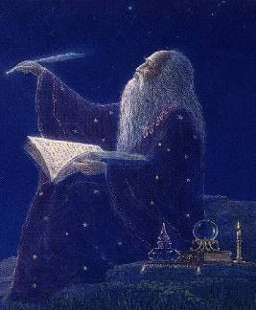
OM MANI PADME JUM
68. The mantra to awaken INTUITION is “OM MANI PADME JUM”.
69. This mantra is vocalized like this:
70. “OM MASI PADME YOM”.
71. The vocalization is letter by letter, like this:
72. OOOOOOOOOMMMMMMMM
MAAAAAAAA…. SIIIIIIIIIIIIIIII.
PADME YOOOOOOMMMMMMMMMM…..
73. Its meaning is: “Oh, my God in me!”
74. This mantra is vocalized adoring the INNER-SELF, rendering homage to the INNER-SELF.
Samael Aun Weor. Practical Magic.
The Mantra “Aum Mani Padme Jum” develops intuition when it is daily vocalized for ten minutes. This Mantra is vocalized as follows: “Ooooommmm mmmmmaaaa ssssssssiiiiiiiii padddddmeeeee yommmmm.” This is the mantra of intuition.
Samael Aun Weor. The Revolution of Bel.
Every man has his “Inner Being”, and every “Inner Being” has its father who engendered it; that is, our father who is in heaven. Aun mani padme jum; this mantra is esoterically pronounced like this: “Om masi padme yom”, (prolonging the sound of each letter, and syllabicating). The meaning of this mantra is: “Oh my God in me!” This mantra should be vocalized with the heart in profound meditation, adoring the “Inner Being”, rendering cult to the “Inner Being”, because the Inner Being is essentially the soul of our father incarnated in us, our divine individuality in which we need to absorb ourselves to enter that infinite and indescribable happiness of Nirvana, where neither suffering, tears, nor pain exist.
Samael Aun Weor. Zodiacal Course.
Mantra sung by a Gnostic Instructor http://www.samaelgnosis.us/practice/audio/om_mani_padme_jum_instructor.mp3
Mantra sung by the mantra Samael Aun Weor http://www.samaelgnosis.us/practice/audio/om_mani_padme_jum.mp3
----------------------------------------------------------------------------------
Instituto Cultural Quetzalcóatl de Antropología Psicoanalítica, A.C.
Gnosis Immortal Wisdom www.samaelgnosis.us and www.samaelgnosis.net

