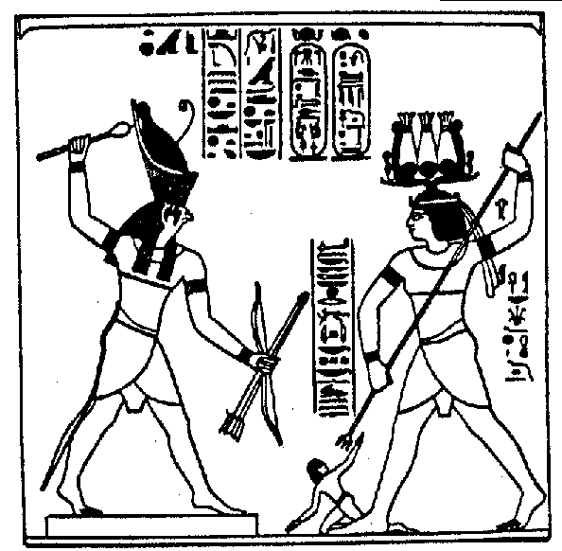
THE OBSERVER AND THE OBSERVED
It is very clear and not difficult to comprehend that when one seriously begins to observe oneself from the point of view that the “I” is not “one” but “many,” one then really begins to work on all that is carried within.
Hindrances, obstacles, stumbling blocks for the work of intimate self-observation, such are the following psychological defects: Megalomania (delusions of grandeur, to believe that one is a God). Self-worship (belief in a permanent “I”, adoration of any type of alter-ego). Paranoia (know-it all ignoramus, self-sufficiency, vanity, thinking oneself infallible, mystic pride, person who does not like to see another person’s point of view).
When an individual continues with the absurd conviction that myself is “one,” such a person possesses a permanent “I” Then, the serious work upon oneself becomes more than impossible. Whosoever always considers himself as “one” will never be able to separate the Self from his own undesirable elements. Such a person will consider each thought, sentiment, desire, emotion, passion, affection, etc. as different and unchangeable functionalisms of his own nature and will even justify himself before others saying that such and such personal defects are of a hereditary nature.
Whosoever accepts the Doctrine of the Many “I” based on self-observation, comprehends that every desire, thought, action, passion, etc., corresponds to this or that “I” meaning, to a distinct or different “I”. Whosoever works very seriously on himself, as any athlete of inner Self-Observation, exerts upon himself the effort to separate from his psyche the diverse undesirable elements which he carries within...
Thus, if one truly and very sincerely begins to observe oneself internally, one ends up dividing himself in two: the Observer and the Observed. If such a division is not produced, it is then evident that we would never take a step forward in the marvelous Pathway of Self Knowledge. How can we observe ourselves if we commit the error of not wanting to divide ourselves into Observer and the Observed? If such a division is not produced, it is obvious that we will never take a step forward upon the path of Self Knowledge. Undoubtedly, when this division does not occur, we then continue identified with all the processes of the pluralized “I”
Whosoever identifies himself with the diverse processes of the pluralized “I” is always a victim of circumstances. How could the one who does not know himself modify circumstances? How could a person who has never observed himself internally know himself? In what way can someone observe himself if this one, first of all, does not divide himself into Observer and Observed? Now then, no one can start to change radically as long as such a one is incapable of saying: “This desire is an animal “I” which I must eliminate.” “This egotistical thought is another “I” that torments me and that I need to disintegrate.” “This sentiment that hurts my heart is an intruding “I,” which I need to reduce to cosmic dust.” etc.
Naturally, the statements of the former paragraph are impossible to say for the one who has never divided himself between Observer and Observed. Whosoever takes all his psychological processes as functionalisms of a unique, individual and permanent “I” is identified with all his errors. He has them so tied to himself that he has lost the capacity to separate them from his Psyche. Obviously, people like that can never change radically; they are people condemned to the most complete failure.
Samael Aun Weor. Excerpt from the book: Treatise of Revolutionary Psychology.
------------------------------------------------------------------------------------------------
Quetzalcoatl Cultural Institute of Psychoanalytic Anthropology
http://www.samaelgnosis.us and www.samaelgnosis.net

