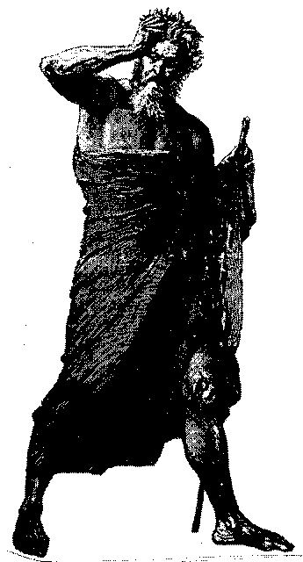
Negative thoughts
**We suggest as practice of this week to identify through the sense of Psychological Self-Observation the different Negative Thoughts that exist in our psychological world, with the purpose of understanding them, to identify their origin, how these Negative Thoughts harm us in our daily life, etc. We suggest at the end of the day, to study what we found during the day with the body and the mind well relaxed. If you don’t know how to relax your body and mind, you can learn by taking our free Course of Meditation (3 lessons) at the Courses section.
NEGATIVE THOUGHTS
In this devolving and decadent era, it is unusual for anyone to think with profundity and with full attention.
Diverse thoughts surge from the Intellectual Center, not from a permanent “I” as the learned ignoramuses foolishly assume, but from the different “I’s” in each of us.
When a person is thinking, he firmly believes that he is the one who is thinking in himself and by himself.
The wretched intellectual mammal does not want to realize that the multiple thoughts that cross his mind have their origin in the different “I’s” which we carry within.
This signifies that we are not true thinking individuals. Indeed, we do not yet have an individual mind.
However, each of the different “I’s” that we carry within utilizes our intellectual center.
At any time, as often as possible, each of them utilizes the intellectual center in order to think.
Therefore, to identify ourselves with this or that negative and harmful thought, believing it to be our particular property, would be an absurdity.
Obviously, this or that negative thought proceeds from any “I” which in a given moment has abusively used our intellectual center.
Different types of negative thoughts exist, namely: suspicion, distrust, ill-will towards another person, passionate jealousy, religious jealousy, political jealousy, family or friendship jealousy, covetousness, lust, revenge, anger, pride, envy, hatred, resentment, theft, adultery, laziness, gluttony, etc.
Indeed, we could not succeed in enumerating all the psychological defects we have since they are too many, not even if we had a steel palate and a thousand tongues to speak.
Therefore, and as a corollary to the former statement, to identify us with negative thoughts is an absurdity
Since it is impossible for an effect to exist without a cause, we solemnly affirm that a thought could never exist by itself, by spontaneous generation...
The relation between thinker and thought is obvious. Each negative thought has its origin in a different thinker.
Many negative thinkers exist within each one of us, as many thoughts of the same class.
Examining this subject matter from the pluralized angle of “Thinkers and Thoughts,” it is understood then that each one of the “I’s” that we carry in our psyche is certainly a different thinker.

Unquestionably, too many thinkers exist inside each one of us. Nonetheless, each one of these inner-thinkers, in spite of being merely one part, believes himself to be the whole, at any given moment...
The mythomaniacs, megalomaniacs, ego worshippers, narcissists and paranoid ones would never accept the thesis of the “Plurality of Thinkers,” because they love themselves too much. They believe themselves to be “Superman’s daddy” or “Wonder Woman mommy.”
How could such abnormal people accept the idea that they do not possess an individual, brilliant and marvelous mind?
Nevertheless, those know-it-all ignoramuses think the best of themselves and even wear the robe of Aristippus in order to demonstrate wisdom and humility...
It is stated, in accordance with legend of time that Aristippus wanted to demonstrate wisdom and humility. So, he decked himself with an old robe full of patches and holes, then held the rod of philosophy with his right hand and walked the streets of Athens...
When Socrates saw him coming, he exclaimed in a loud voice: “Oh Aristippus, your vanity is shown through the holes of your vesture.”
The one who unceasingly does not live in a state of alert novelty, alert perception, thinking that he is thinking, easily becomes identified with any negative thought.
Thus, lamentably, as an outcome of his behavior, he strengthens the disastrous power of the “Negative I” who is the author of the corresponding thought in question.
The more we identify ourselves with a negative thought, the more we shall be slaves of the corresponding “I” that characterizes it.
Regarding Gnosis, the Secret Path and the work upon oneself, our own particular temptations are precisely found in those “I’s” who hate Gnosis, who hate the esoteric work. These “I’s” do not ignore that their existence within our psyche is mortally threatened by Gnosis and by this Work.
Those quarrelsome and negative “I’s” easily take control of certain mental films that are stored in our intellectual center, which sequentially originate harmful and noxious mental currents.
If we accept those thoughts, those negative “I’s”, which at any given moment control our intellectual center, we shall then be incapable of freeing ourselves from their influence.
We must never forget that every negative “I” deceives itself and betrays to that end; it lies.
Each time that one feels a sudden loss of strength, when the aspirant becomes disillusioned about Gnosis, about the esoteric work, when one loses the enthusiasm and abandons what is best, it is obvious that one has been deceived by some negative “I.”
The negative “I” of jealousy deceives those beings who adore each other and destroys their happiness.
The negative “I” of mystical pride deceives the devotees of the Path. Thus, believing themselves to be wise, they despise their Master and betray Him...
The negative “I” appeals to our personal experiences, our memories, our best wishes, and our sincerity. Hence, amidst all of these things, through a rigorous selection, this negative “I” presents something under a false light, something that fascinates. Thus, the outcome is failure...
Nonetheless, when one discovers that “I” in action, when one has learned to live in a state of alertness, then, such a deception becomes impossible…
Samael Aun Weor. Treatise of Revolutionary Psychology.
------------------------------------------------------------------------------------------------
Instituto Cultural Quetzalcóatl de Antropología Psicoanalítica, A.C.
http://samaelgnosis.us and http://samaelgnosis.net

