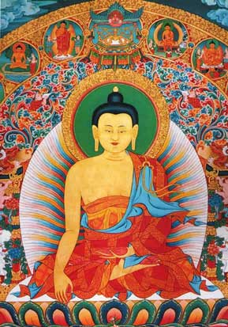
Mental Relaxation
Live the instant, moment by moment, without the painful past; with no hindrances of the future. Relax the Mind. Empty it of all kind of thoughts, wishes, passions, etc. Do not accept inside your mind any thought.
Before the Flame of Gold can burn with a serene light, the “lamp” must be well cared for, sheltered from all winds! The earthly thoughts must drop dead at the doors of the temple!
The mind must be quiet inside, outside and in the centre. Thus, in deep “Meditation”, and with the mind totally relaxed, you will experience the “Real”. Give in to your inner, profound God, totally oblivious of the mundane. During meditation keep the eyelids closed. So your physical vehicle will slumber delightfully. Meditation without slumber destroys the brain and upsets the mind. Deep Meditation, properly combined with slumber, leads to ecstasy, to SHAMADI. Combine sleep with Meditation in harmonic proportions.
Never forget the “Law of Balance”. You really need 50% of sleep and 50% of meditation. PRACTICE MEDITATION when you feel predispose to naturally sleep. The baker who wants to make bread must know how to combine the appropriate quantities of flour and water. If he mixes more water than needed for the flour, the dough will not become bread; the same if he mixes too much flour with the water. In a similar way works the process of Meditation. If we give into more sleep than meditation, we will fall into unconsciousness. If we force more meditation than sleep, we will ruin the mind and the brain; if we do not know how to combine harmoniously sleep and meditation, we will achieve that that is called SHAMADI, ECSTASY. Who pretends to meditate by radically eliminating sleep, is like the man who tries to start a car by violently stepping on the brakes.
Another example will clarify all this: imagine a rider on a horse. If the rider want the horse to walk, must let the rends as bit loose; but if instead he pulls of them, at the same time will hurt the animal that will feel uneasy, and the horse will stop, neigh, and might even thrust the rider over its head. Something similar will happen to the “devout” that will try to meditate eliminating sleep.
Mental relaxation must be perfect. Any idea, thought, wishes, etc., that in a given moment crosses the mind produces stress, and this is not relaxing. Perfect relaxation of the mind exclude wishes, ideas, thoughts, remembrances, passions, etc. To empty the Mind, make it a bottomless well, this really relaxes it. The superficial mind is like a puddle by the road; when the water evaporates under the solar rays, it only remains rotten lime. The Mind deeply and marvellously relaxed is like an unfathomable lake, in where they live innumerable creatures and there is abundant life.
When some one throws a pebble in a peaceful, serene lake ripples are produced from the centre were the pebble fell to the periphery, it’s the reaction of the water to the impact coming from the outside world. Similarly, we can say that the relaxed Mind is like a peaceful, serene lake, where it is reflected the Universe’s panorama. The impacts coming from the exterior world, at falling in the mind, cause ripples that go from its centre to the periphery. Those ripples agitate the mind of the Ascetic and lead them to failure. The Mind must be controlled from its centre, so it will not react to the impacts coming from the outside world.
Samael Aun Weor. The Science of meditation
------------------------------------------------------------------------------------------------
Instituto Cultural Quetzalcoatl de Antropología Psicoanalítica, A.C.
http://samaelgnosis.us and http://samaelgnosis.net

