Meditation on the Cardia
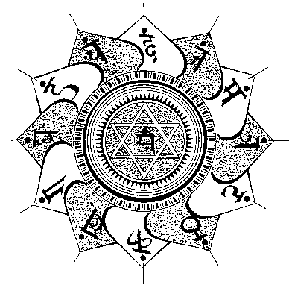
The student must practice every morning at dawn imaging in the east a large golden cross.
The student must imagine that from that large cross, divine rays come out and reach the cardia and they make it shine and sparkle marvelously.
This practice should be done one hour daily while chanting the mantra of this chakra, that mantra is the vowel “O”.
One must prolong the sound.
It is also necessary to identify ourselves with Vayu, the etheric principle of the air; to imagine that inside our heart there are mountains, woods, hurricanes and birds flying, etc.
By practicing daily the meditation on this chakra for three years it’s clear that develops the powers of heart.
It is needed to practice daily without stopping even a day, the unreliability practices are useless.
It is also suitable to go to the mountains where the winds blow to meditate on the cardia…
Samael Aun Weor. Esoteric Treatise of T. (3rd Edition)

------------------------------------------------------------------------------------------------
Instituto Cultural Quetzalcóatl de Antropología Psicoanalítica, A.C.
http://samaelgnosis.us and http://samaelgnosis.net

