Practice with the Mantra GATE and the Altar Q, from Copan, Honduras
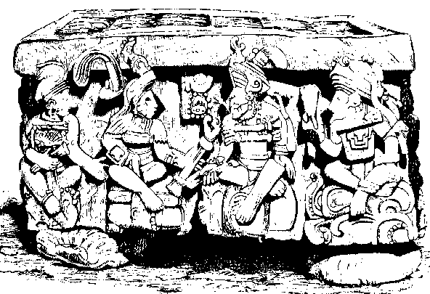 East Side
Altar “Q” description
We can see 4 figures, one of them a little bit disfigured. The Mayas always assure the existence of the four: The Unknowable Adhi-Buddha and the Three forces of the Creation, this is, the Trinity inside the Unity of Life.
We see in this altar the TE-TRA-GRAM-MA-TON very clearly.
PRACTICE
In front of this altar, do the following:
1. - Intense concentration in the four figures, half an hour.
2. - After the relaxation, leave the mind’s screen in blank.
3. - Chant the mantra GAAAAAA TEEEEEE. This mantra has to resound in the consciousness.
4. - To wait for the answer of the internal. Like so we make contact with the occult Mayan wisdom.
The mantra GATE acts upon the Eye of Dangma, it opens it and let us get the wisdom written in this marvelous sculptures.
First Position: The body in the position of a dead man, the heels together, arms all along, completely relaxed.
Second position: The body in the position of a dead man, the heels together, the hands in the same position as the steles. Place the fingertips in the center of the chest, in the Tipheret region, the human soul. Enter to the very bottom of the Soul.
Samael Aun Weor. The Mayan Mysteries.
----------------------------
Glossary:
Dangma (Sanskrit): In Esotericism, it’s a purified Soul. It’s an Initiate and clairvoyant, the one who has reached the complete wisdom. (H.P.B.)
Eye of Dangma: The internal or spiritual eye, the Eye which only the most elevated Initiate (Dangma or Mahatma). The Dangma’s opened eye it’s the spiritual intuition, by which mean it’s possible to attain the direct and secure knowledge, faculty intimately related with the “Third Eye”. “The Dangma’s Eye” it’s the same as what it’s known in India as the “Shiva’s eye”. (H.P.B.)
TETRAGRAMMATON (Greek): It’s the name of God made of four letters, its Greek title. The four letters are in Hebrew: “yod, hé, vau, hé”. (H.P.B.)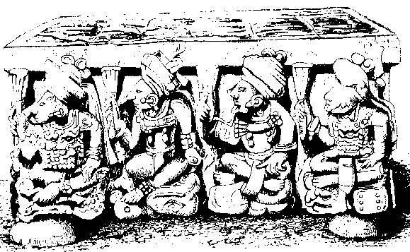
West side
North side
Cover of the Altar
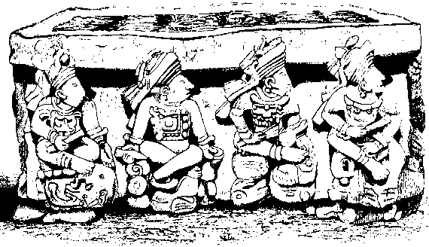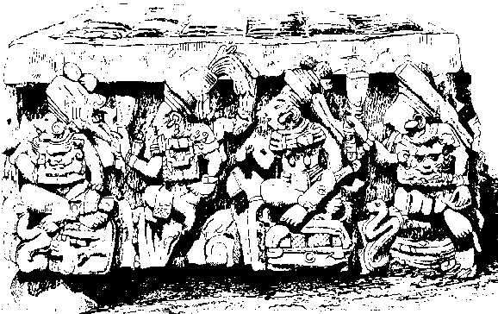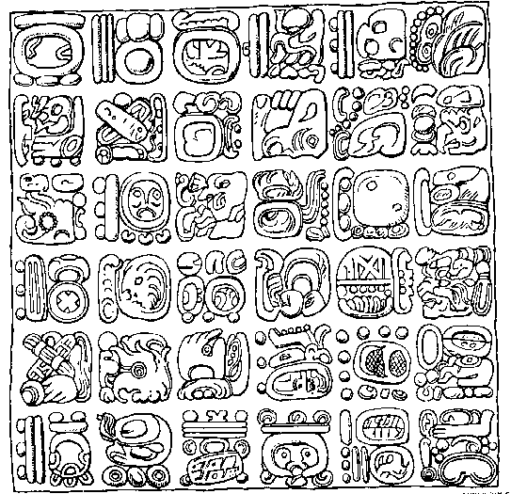
South side
North side
Cover of the Altar
Cover of the Altar

