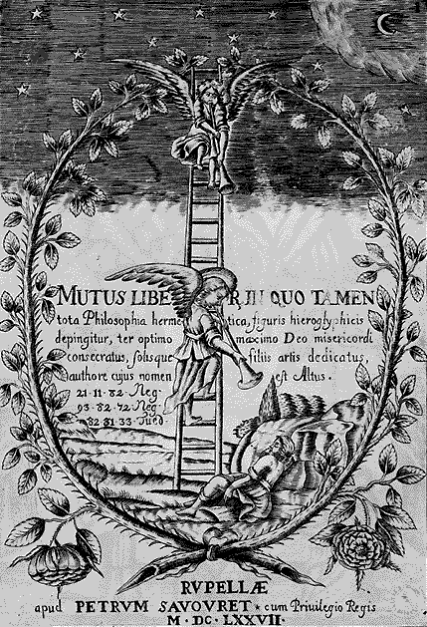
Mantra S and the Astral Projection.
What you always do in an involuntary way, unconsciously, learn to do it a voluntary and conscious way. You’ve always unfolded; while getting sleepy every soul gets out of the body in an unconsciously way unfortunately.
Do right that but in a voluntary an conscious way I repeat; when feeling in that state of lassitude typical of dreaming, when you start dozing, imagine yourself as a subtle ghost, diaphanous; think that you’re going out of your body; understand that you are not the body, understand that you’re a soul.
Feel yourself being a soul and get up of your bed with gentleness, delicately, as the souls arise.
This what I’m saying must be translated to concrete facts, it’s not about thinking but acting; after getting up, take a jump inside your own bedroom with the intention of floating in the space; like so, it’s clear that if you float it’s because you’re already out of your body; then you can go out of your bedroom and float in the space; you can go to Paris, London or the place you want to; but if you don’t float it’s because you’ve got up of your bed with your physical body, then get in your bed again and repeat the experiment.
Samael Aun Weor. Beyond Death.
“S”
The “S”, as a mantra, permits us to leave our cave (physical body) and to enter upon the mount (astral plane). The vowel “S” is a mantra for Astral Body projection.
The disciple must become sleepy while vocalizing the sweet and affable sound of the “S”. When the disciple reaches that state of transition between vigil and dream, then he must rise from his bed and leave the room, going towards the Gnostic C.
Once there, we will teach and instruct him in the Divine Wisdom. However, we must clarify to our disciples that this explanation which we have given must be understood as an immediate action.
The student must rise up from his bed, as naturally as would a child who knows nothing of occultism. It is not a mental practice. It is a practice which must be understood as a concrete action, just as when we rise up in the morning in order to eat breakfast. The vowel “S” has a terrific power.
Samael Aun Weor. Excerpt from the Book: The Igneous Rose

----------------------------------------------------------------------------------
Instituto Cultural Quetzalcóatl de Antropología Psicoanalítica, A.C.
Gnosis Immortal Wisdom www.samaelgnosis.us and www.samaelgnosis.net

