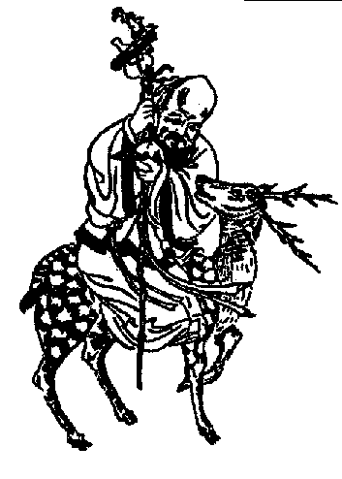
Mantra WU
After some time, Wu Wen went to Master Huai Shi, who taught him to meditate using the sacred mantra WU.
This mantra is chanted mentally with the letter “U” repeated twice “U...U...,” extending the vowel sound, as if imitating the sound of the hurricane howling through a mountain ravine or the terrible crash of waves against the beach.
This mantra is chanted mentally when we practice meditation, in order to clear the mind of all kinds of thoughts, desires, memories, preoccupations, etc. so that we can have a quiet and silent mind.
...
Wu Wen chanted the mantra “WU”; with “U,” he imitated the sound of the wind in a mountain ravine and the sound of the sea crashing against the beach. Wu Wen knew how to intelligently combine meditation and sleep.
Wu Wen vocalized his mantra mentally and thought of nothing.
Whenever some desire, memory, or thought sprang up in his mind, he did not reject it but studied, analyzed, and comprehended it in all levels of the mind, later forgetting it totally and definitely.
Wu Wen chanted his mantra continuously, desiring nothing and thinking nothing. Whatever desires or thoughts surfaced in his mind were duly comprehended and later forgotten. The repetition of the mantra was not interrupted…
Samael Aun Weor. The Buddha’s Necklace.
------------------------------------------------------------------------------------------------
Instituto Cultural Quetzalcóatl de Antropología Psicoanalítica, A.C.
http://samaelgnosis.us and http://samaelgnosis.net

