Mantra Ram Sua

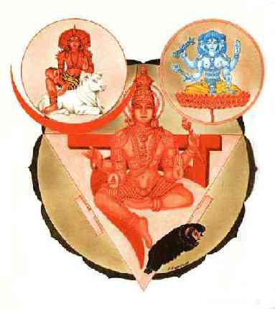
The church of Pergamum or Manipura Chakra is located in the epigastrium, a little bit upon the navel.
This is the Manipura Chakra. With this center the plexus of the liver and the spleen enter into activity. Ten Nadis emanate from this plexus. Its color is the resplendent red. The Tejas Tattwa is related with it.
With the mantra RAM-SUA Agni is invoked to help us to awake it.
This chakra is the telepathic center or brain of emotions. The mental waves of the persons that think on us get to the solar plexus, and then they pass to our brain. Therefore, it is a receptive antenna. The Pineal gland is the transmitter center.
Through this center it is gathered all the energy or solar forces which nourish all the plexus in the human organism.
Samael Aun Weor. The Mayan Mysteries

The recommended practice is to relax the body and mind and then vocalize (Mentally or verbally) the mantra RAM SUA (extending the vowels)

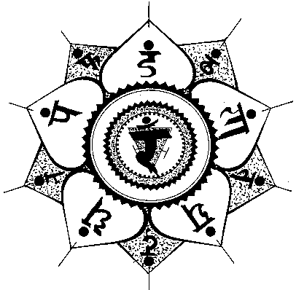
Glossary:

Chakra. - The Human Being has magnetic centers called chakras in the Eastern world and Churches in the book of Revelations. These magnetic centers are inactive because of the egoic manifestation that we have, (the gluttony and the drunks “I’s” are the defects that damage the telepathic center). Once the chakras get activated we recover the powers and faculties we are supposed to have like telepathy.
Nadis. - It is the name given to the channels through which the chakras distribute their energy to others parts of the body.
Tattwa. - It is the soul of Nature’s elements. The soul or etheric vibration of the element fire is called Tejas.
Epigastrium. - Region of the abdomen or stomach that goes from the sternum to close to the navel between the false ribs.

Práctica en audio dirigida por instructor en mp3 http://www.samaelgnosis.us/practice/more_practices/mantra_ramsua.html
------------------------------------------------------------------------------------------------
Instituto Cultural Quetzalcóatl de Antropología Psicoanalítica, A.C.
http://samaelgnosis.us and http://samaelgnosis.net

