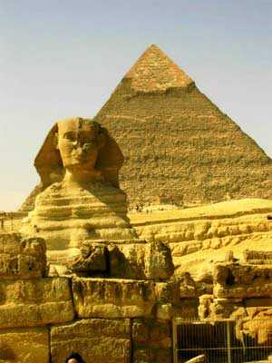
MANTRA PHARAOH
a- Lie down in your bed brothers, I repeat, lie down. It’s good to lie down facing up. Ok?
b- Relax your muscles… are you relaxed?
c- Close your eyes.
d- Lull yourself to sleep.
e- Chant the mantra “FARAON”, this mantra is wonderful to achieve the Astral body projection.
Chant like this:
FAAAAAAAAAAAAAAAAAAAA...
RAAAAAAAAAAAAAAAAAAAA...
OOOOOOOOONNNNNNNNNNNNNN....
Have you chanted already…? Good brothers.
f- Arise your knees, listen carefully brother, your knees. I want to tell you to bend your legs. Rest the palm of your feet over the bed. Of course by doing this operation the knees remain raised vertically… Right?
Repeat the mantra again like this:
FAAAAAAAAAAAAAAAAAAAA...
RAAAAAAAAAAAAAAAAAAAA...
OOOOOOOOONNNNNNNNNNNNNN....
g- Repeat this mantra so many times. You can chant it a little bit softly and also you can chant it mentally. Get asleep keeping the knees vertically, get asleep brothers, you must imagine vividly the Egyptians pyramids… understood? This is not laborious brothers; you convince yourselves that this is not laborious. Avoid any mental tension and get asleep. The result will be splendid. You enveloped in your ASTRAL (body) will awake far away in the internal worlds, abandon your physical body, without know when or how. You’ll awake in this way…! Consciously in your ASTRAL over there inside, inside you in any country of the world.
Samael Aun Weor. Lecture: The Power of Mantras.
-----------------------------------------------
Glossary:
Mantra. - Wise combination of sounds to achieve a physical, mental or spiritual benefit.
The Astral Body’s projection. - To be conscious of what we already do every time we go to sleep. A dream it’s an Astral projection but unconscious.
Internal Worlds. - Superior dimensions of Nature. We live in the physical world made of three dimensions (length, width and height), the dreams world is also called the Astral world or fifth dimension.

** Mantra FARAON (V.M. Samael Aun Weor) http://www.samaelgnosis.net/mantram/fa_ra_on.mp3
------------------------------------------------------------------------------------------------
Quetzalcoatl Cultural Institute of Psychoanalytic Anthropology
http://samaelgnosis.us

