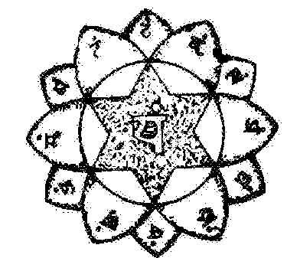
The Mantra OM
The mantra OM has the power to awaken the frontal and cardiac chakras, clairvoyance and intuition. By meditating on the OM, we arrive at enlightenment. Imagination, Inspiration and Intuition are the three obligatory paths of initiation.
Samael Aun Weor – The Greater Mysteries
PHILADELPHIA: CHAKRA Ajna: Located between the eyebrows. Mantra: OM. This CHAKRA is the one of the Clairvoyance or the psychic vision.
The plexus of this CHAKRA is a Lotus flower that radiates from the pituitary gland. This gland is the page from the Pineal gland, where the crown of the Saints is, the one-thousand petals lotus, the eye of Dagma, the eye of intuition.
Samael Aun Weor – Mayan Mysteries.
THE INTUITION
What is intuition? I’m going to tell you. The Intuition gives us the power of knowing without the depressive process of reasoning. Example: this is white because of that… etc.
In the Intuition the heart is set, the heart’s CHAKRA gives us the precious power of Intuition. The mantra for the development of Intuition is the sacred “OM”.
This syllable is pronounced like this:
OOOOOOOOOOOOOOOOOOOOOOOMMMMMMMMMMMMMMMMMMM…
As you can see the “O” is a very vital letter from the center of the heart.
Samael Aun Weor – Lecture: The Power of the Mantras
1. This CHAKRA is found connected to its marvelous center located between the eyebrows.
2. The Master who directs this center is Paramashiva.
3. The mantra that makes this chakra vibrate is OM:
OOOOOOOOOOOOOMMMMMMMMMMMMMM………
4. This CHAKRA has two petals.
5. This marvelous CHAKRA has a very pure white color. The cavernous plexus is the one that corresponds to this CHAKRA.
Samael Aun Weor – Mysteries of the Fire

------------------------------------------------------------------------------------------------
Instituto Cultural Quetzalcóatl de Antropología Psicoanalítica, A.C.
http://samaelgnosis.us and http://samaelgnosis.net

