MANTRA MA-MA PA-PA

Practices for the Imaginative Knowledge

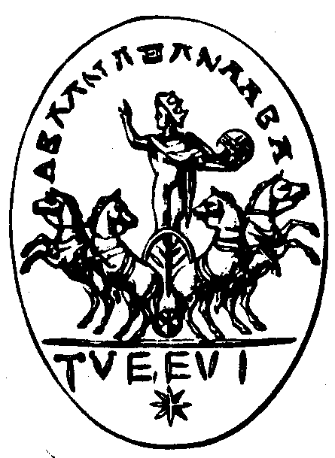
The syllables MA MA, PA PA, BA BA are the first syllables that we articulate in childhood. You can start the Initiation with these syllables. You must sing these syllables while assuming an innocent and infantile attitude. You can learn the intonation of these sacred syllables when listening to The Magic Flute of Mozart. Mozart placed these syllables in his marvelous opera.

The disciple must fall asleep assuming an infantile attitude while remembering the first years of his childhood and then mentally singing the sacred syllables.
The word PA PA should be vocalized intoning the first syllable PA in a high voice then the second syllable PA will be uttered in a lower voice. These two syllables should be pronounced many times. You must do the same thing with the syllable MA.

Fall asleep while meditating on your childhood. Review with your imagination your whole childhood and mentally articulate the sacred syllables.
You must know that every child is clairvoyant until the age of 4 years. Afterwards the innocent atoms of clairvoyance submerge themselves within the sub-consciousness.
Therefore, if you want to re-conquer clairvoyance, meditate on your childhood and profoundly fall asleep while articulating the first syllable of the child, MA MA, PA PA,
BA BA.

This type of meditation and the sacred syllables will awaken the infantile atoms of clairvoyance. Then you will elevate yourself into imaginative knowledge. You will learn to think with living images. The present Root Race only thinks in concepts of ideas. These ideas are the result of desire.
Somebody thinks about conquering a woman and then an idea assaults his mind, etc. The ideas belong to the “I”. Therefore you must learn to think with living images. The infantile meditation and the sacred syllables will awaken the infantile atoms for new activity.
Imaginative knowledge grants us the power to travel consciously and positively in the
etheric body. When the student has achieved imaginative knowledge, then he can start the exercises for inspirational knowledge.

Samael Aun Weor. The Message of Aquarius.

