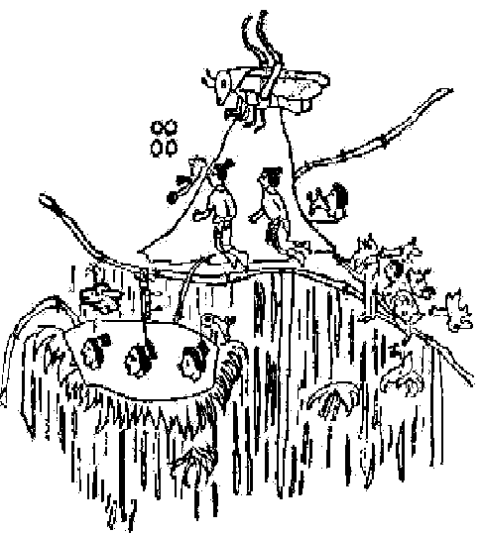
Mantra LA-RA and the Astral Projections
THE HILL OF CHAPULTEPEC.
Chapultepec. In the present chapter we see a fragment of a Mexican indigenous codex of the Hill of Chapultepec. At the top of the hill we see a grasshopper or cricket. In the august Rome of the Caesars, the cricket was sold in golden cages at high prices. In the Hill of Chapultepec exists an Aztec Temple in the “Jinas” state. We should now comprehend why this hill was considered sacred by the Aztecs. The indians of Mexico used to make long mystical pilgrimages to Chapultepec.

By carefully observing the fragment of the Mexican codex of Chapultepec, we see two human beings floating by the hill. Those two beings are traveling in the astral body. Someone pronounces a note, which comes out of his lips as two light waves. That note is the sibilant and sharp sound of the cricket. That note is a chorus; within that ineffable chorus is our keynote. If a musician, playing his instrument, was to play our keynote, we would instantly fall down dead. There is nothing in nature that does not have its keynote. The one who wants to come out in the astral body at will, should lull himself to sleep while mentally pronouncing the syllable “LA”. This syllable is mentally alternated with the syllable “R A”

Mentally pronounce these two syllables in an alternated and separate manner. The student should try to listen to the sharp sound of the cricket. That sound emerges from within the cerebral cells. One needs a serene mind, a good quantity of drowsiness and good attention on what one is doing. If the exercise is well done, then as soon as the student enters that transitional state that exists between vigil and sleep, he will feel the sharp sound of the cricket within his cerebrum. The student should then lull himself to sleep a little more, and increase the resonance of that sound by means of the will; he should then rise from his bed heading towards the Temple of Chapultepec, or the Gnostic C., or wherever he wishes.

When we say that he should get up from his bed, this should be translated into deeds. The student should rise from his bed. This is not a mental exercise. Really, it is not a matter of mentally rising; the disciple should rise with actions, with deeds. Nature will take care of separating the physical and the astral bodies, in order for the astral body to remain free and the physical body remains in the bed. What the student has to do is to get up from his bed, that’s all. With this clue, our Gnostic disciples will be able to transport themselves in the astral body to the mystery temples of the White Lodge.
(Samael Aun Weor. The Greater Mysteries)

Glossary:
Astral: Nature’s fifth dimension is the very same world of Dreams. We go out in astral body every night, what this is about, is to do consciously what we’ve done during our entire life every time we go to the bed.
Jinas: Things that are in another dimension, usually means the Fourth Dimension (Etheric or Vital world), but also it could refers to the Fifth dimension (world of dreams).
White Lodge: Group of superior Beings, Masters, Angels, Devas, etc.

Listen to the Mantra in our Mantra Section:
https://www.samaelgnosis.us/mantram/mp3_files/la_ra.mp3

------------------------------------------------------------------------------------------------
Instituto Cultural Quetzalcóatl de Antropología Psicoanalítica, A.C.
www.samaelgnosis.us and www.samaelgnosis.net

