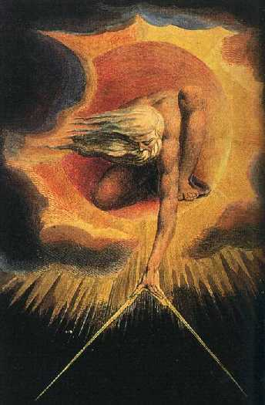
The Lord's Prayer
The Lord’s Prayer is the most perfect Prayer because it has Seven Magical Petitions.
PRACTICE:
ASANA: The student must lie down in the ground over a carpet. Open your right and left arms and legs to remain like a five-pointed star. Relax your whole body. Do not think in anything. Leave your mind in white. The student must be concentrated in his Inner God, star praying the Lord’s Prayer too slowly, thinking on the sense of each request, fall asleep until the deep sleep comes meditating on each word, on each phrase, worshipping… worshipping… worshipping…
When the student wake up in the morning, he doesn’t have to move… practice a retrospective exercise to remember your internal experiences, where you were, where you’ve been in the astral body, what you’ve done, what you saw, etc. etc. This exercise must be practiced daily, without getting tired of it. You got to see and hear the great internal realities.
Samael Aun Weor. The Esoteric Course of Kabala.
Really, it is necessary to learn how to PRAY scientifically; the one, who learns to intelligently combine PRAYER with MEDITATION, will obtain marvelous OBJECTIVE results.
But it is urgent to comprehend that there are different PRAYERS and that their results are different.
There are PRAYERS which are accompanied by petitions, but not all prayers are accompanied by petitions.
There are very ancient PRAYERS which are authentic RECAPITULATIONS of COSMIC events and we can experience their entire content if we meditate on each word, on each phrase, with true conscious devotion.
The OUR FATHER is a MAGICAL formula of immense sacerdotal power, but it is urgent to comprehend in depth and in a total manner the profound meaning of each word, of each phrase, of each supplication.
The OUR FATHER is a prayer of petition, a prayer to converse with the FATHER who is in secrecy. The OUR FATHER combined with deep MEDITATION produces MARVELOUS OBJECTIVE results….
…It is necessary to learn how to PRAY the OUR FATHER, to learn to converse with BRAHMA (THE FATHER) who is in secrecy.
A single OUR FATHER well prayed and wisely combined with Meditation, is an entire Work of High Magic.
A single OUR FATHER properly prayed is done in a period of one hour or in a little more than an hour.
After the prayer, we must know how to await the reply of the FATHER and this means to know how to meditate, to have the mind still and in silence, empty of all thoughts, awaiting the reply of the FATHER.
When the MIND is still, within and without; when the MIND is in SILENCE within and without; when the mind has freed itself from dualism, then the NOVEL comes to us.
It is necessary to EMPTY the mind of all kinds of thoughts, desires, passions, appetites, fears, etc. in order for the experience of what is REAL to come to us.
The ERUPTION of the VOID, the EXPERIENCE in the ILLUMINATING VOID, is only possible when the ESSENCE, the SOUL, the BUDDHATA frees itself from the intellectual bottle.
The ESSENCE is engrossed within the tremendous battle of the opposites: heat and cold, like and dislike, yes and no, good and evil, pleasant and unpleasant.
When the MIND is still, when the MIND is in silence, then the ESSENCE remains free and the EXPERIENCE of what is REAL in the ILLUMINATING VOID comes.
Pray, therefore, good disciple and then with the mind very still and in silence, empty of all kinds of thoughts, await the reply from the Father: “Ask and it shall be given; knock and it shall be opened.”
To PRAY is to converse with GOD and certainly one has to learn to converse with the FATHER, with BRAHMA.
The HEART-TEMPLE is house of PRAYER. Found in the heart-temple are the energies which come from above, with the energies which come from below, forming SOLOMON’S seal.
It is necessary to pray and MEDITATE profoundly. It is urgent to know how to relax the physical body in order for MEDITATION to be correct.
Before beginning the exercises of PRAYER and MEDITATION combined, relax the body properly.
The GNOSTIC Disciple should lie down in a FACE-UP position, in other words, lying on his back on the floor or in bed, legs and arms open to the right and left, in the form of a five pointed STAR.
This PENTAGONAL STAR position is formidable due to its deep meaning, but persons who for any circumstance are unable to meditate in this position, should then meditate by placing their body in the CORPSE POSTURE: heels together, tips of the feet spread out in the form of a fan, arms unbent along the sides, placed alongside the trunk
The eyes should be closed in order for things of the physical world to not distract us. Drowsiness properly combined with MEDITATION is very indispensable for the good success of the MEDITATION.
Samael Aun Weor. Esoteric Treatise of Hermetic Astrology.
Practice guided by an instructor in mp3 www.samaelgnosis.net/practice/

----------------------------------------------------------------------------------
Instituto Cultural Quetzalcóatl de Antropología Psicoanalítica, A.C.
Gnosis Immortal Wisdom www.samaelgnosis.us and www.samaelgnosis.net

