JEUSE, VAUSE. Clairaudience

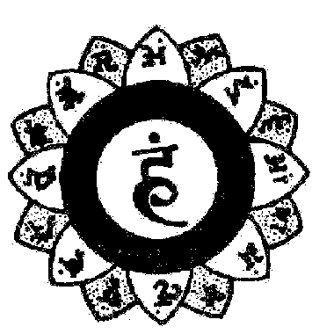
CLAIRAUDIENCE AND SPECIAL MANTRA
“Clair-Hearing is the “Occult Hearing”. It is developed with the following Mantras:
JEUSE - Vocalization: JJJJJJJEEEEEEE... UUUUU... SSSSS... EEEEE
VAUSE - Vocalization: VVVVAAAAA... UUUUU... SSSSS…..EEEEEEE
(As it can be noticed, the voice should be prolonged in the above repeated letters).
Sunk in profound meditation, the student will vocalize trying to lull himself to sleep.
Once he has managed to lull himself to sleep, he will exert himself to listen to the voice of his friends who are far away: so does one awaken the “Internal Ear.”

Samael Aun Weor. Logos, Mantra T.
--------------------------------
“You know that THE CLAIR-HEARING is the faculty that helps us to listen in the ultra…”
“This wonderful faculty is located exactly in the thyroid gland. The thyroid gland is in the larynx. It is very important. The thyroid gland releases iodine. In that gland, there is a wonderful chakra, that when awaken, confers the power to hear in the ultra of all things”.
Samael Aun Weor. The Power of Mantras.

**It is suggested to be in a comfortable posture (seated or lying down), to relax the body and the mind and vocalize the mantra (verbally or mentally) during the time you want to, you can start with 10 to 15 minutes. If you don’t know how to get relaxed, ask for the course of Meditation in our free courses section.

----------------------------------------------------------------------------------
Instituto Cultural Quetzalcóatl de Antropología Psicoanalítica, A.C.
Gnosis Immortal Wisdom www.samaelgnosis.us and www.samaelgnosis.net

