Imagination and Will (Astral Projections)

The Universal Mind.

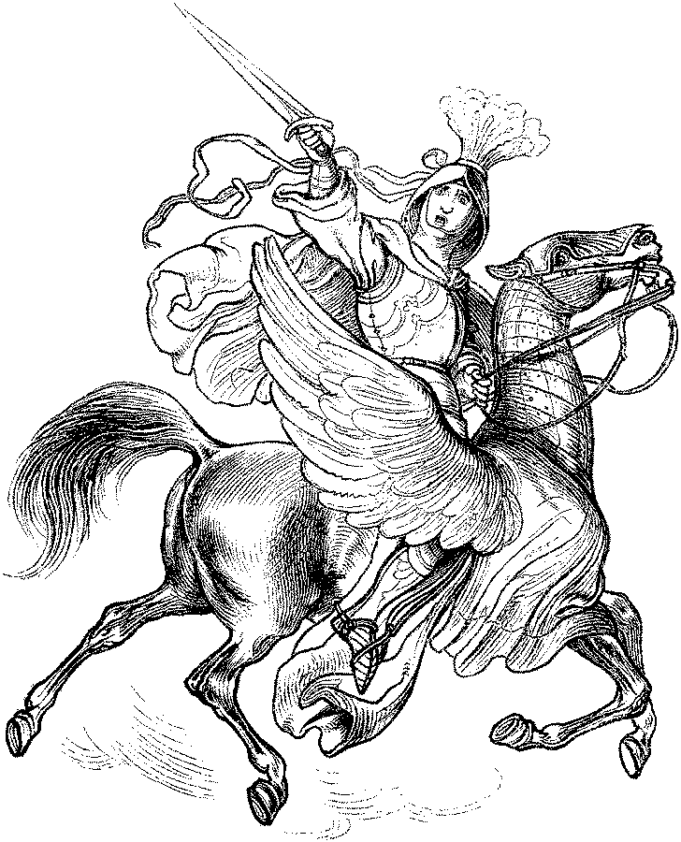
Social living is necessarily based on the functions of the mind. It is necessary to profoundly explore the diverse levels of the mind. The sphere of thought that man lives in is never locked up within the limited circumference of the cranium as is generally supposed by the ignoramus and even the illustrious ignoramuses of the world. If such a man existed, as those people believe, he would of course be the most unfortunate man in the world.

A man with his mind imprisoned in his cranium could not see or perceive anything; he would be a complete idiot, living in the most profound darkness; this unfortunate creature would not see the sun or the moon, or the stars, or the Earth on which we live, or the people, or the things, or the light. Nothing that has existence would exist in the mind of such a man as this; this is explained by the fact that man cannot perceive anything which does not exist beforehand in his own mind.

In his Critique of Pure Reason, Immanuel Kant said, “The exterior is the interior.” The entire universe exists in the cosmic mind. The mental sphere of each person extends throughout the entire cosmos and reaches the furthest stars; this is the cause whereby we see, hear and feel all that is created; this is the reason we can see the most remote stars. Our thoughts are not locked up in our cranium; our mind extends throughout the entire cosmos; our mind penetrates everywhere; worlds, suns, people and things, everything is within the mind of each man.

The mind is Universal Energy. The mind vibrates and sparkles in everything that is created. The brain is not the mind; the brain is only a receiving center, a radiotelegraphic office that receives messages from the mind. The brain does not think. What thinks is the mind, and that is not the brain.

Religions say that the human soul has a body of flesh and bones. The Theosophists maintain that, besides the body of flesh and bones, the soul has a mental body. All the Eastern and Western schools dedicated to the study of occultism teach their students how to use the mental body. The soul enveloped by the mental body can transport itself to other planets at will and see what happens there.

The entire universe is within the human mind. All minds are within all minds. We mutually live within the thought spheres of others. The economic and social problems of each person live in everyone; no one is alien to another.

We are all within the mind of everyone else. The beggar lives within the mind of the rich man and the latter lives in the mind of the beggar. We are all submerged in the ocean of universal mind.

IMAGINATION AND WILL.
Imagination and will are the two poles of the mind. Imagination is feminine and will is masculine. The key to success is found in imagination and will united in vibrant harmony.

MENTAL ACTION.
The inventor conceives the telephone, the radio, the automobile, etc., with his imagination and then, with the will, gives it shape, converts it into facts, into concrete realities. Paris designers dictate fashions just as they conceive them with their imagination.

MENTAL EPIDEMICS
If a man thinks in either a good or a bad sense, the waves that emanate from his mind reach the mental body of each individual. Mental waves are propagated in all places. When the waves are of wisdom and love, they benefit all those who receive them. When the waves are impregnated with devotion and veneration towards God, they carry peace and comfort to all those who are suffering. Poisonous mental waves harm the minds of others.

Mental waves of hatred, envy, covetousness, lust, pride, laziness, gluttony, etc., produce mental epidemics. Perverse mental waves poison many weak minds with their radioactivity. The case of the “rebels without a cause” is a good example of what mental epidemics are. The “rebels without a cause” have become an evil and harmful plague.

We should seek the cause of this mental epidemic in the ill-used imagination. Movie theatres show movies of bandits and gunmen that are then recorded in the minds of young people. Parents give their children guns, war trucks, tiny cannons, lead soldiers, toy machine guns, etc., etc., etc.

All this is reflected strongly in the imagination of children and adolescents. Then they comes the magazines and comic books of robbers and police, the pornographic magazines, etc. The results of all this await and shortly afterwards the child, the adolescent, in fact turns into the “rebel without a cause,” and later into the thief the bandit, the cheat, etc.

MENTAL HYGIENE.
It is necessary to practice mental hygiene. A preventive medicine is urgent. Cultivate wisdom and love. Pray a lot daily. Select works of art; we suggest good music, classical music, good paintings, the works of Michelangelo, the Great Operas, etc. Avoid spectacles harmful to the mind, bloody spectacles like boxing, wrestling, etc. These types of spectacles produce mental epidemics. Take care of your mind; do not permit evil thoughts to penetrate into the temple of your mind. Be pure in thought, word, and deed. Teach your children all that is good, true and beautiful.

ORIGINS OF THE UNIVERSAL MIND.
The Divine Great Reality surged forth from its own bosom in the aurora of this solar universe in which we live, move and have our Being. The Great Reality does not know itself but on contemplating itself in the living mirror of the great imagination of nature, then comes to know itself. In this manner, a mental vibratory activity is created by which the Great Reality knows its infinite images that shine marvelously in the cosmic scenery. This activity, which coming from the periphery is directed to the center, is that which is called Universal Mind.
All of us beings live submerged in the infinite ocean of the Universal Mind. So, we live within everyone and no one can separate mentally from anybody else. “The heresy of separativity is the worst of heresies.”

The intellectual activity of the Universal Mind comes from a centripetal force and, since every action is followed by a reaction, the centripetal force, on finding a resistance in the center, reacts and creates a centrifugal activity called Cosmic Soul. This vibratory Cosmic Soul turns out to be the Mediator between the center and the periphery, between the Universal Spirit of Life and matter, between the Great Reality and its living images.
A Great Master said, “The soul is the product of the centrifugal action of the universal activity impelled by the centripetal action of the Universal Imagination.”

Clarification of Terms: Centrifugal force tries to move away from the center, it is the force that goes from the center to the periphery. Centripetal force is attracted by the center, it is the force that flows from the periphery to the center.

Every individual can fabricate a soul. When we know the technique of internal meditation, when we direct mental power to the interior of our own divine center, the resistance that we will find will cause a reaction and the more vigorous the centripetal force we apply, the more vigorous the centrifugal force will be. In this way we fabricate a soul, in this manner the soul grows and expands. The strong and robust soul incarnates and transforms the physical body, transforms it into subtler and elevated matter until it also converts it into soul.

PRACTICE LEARN
to use your imagination and will, united in vibrant harmony Lying in your bed or seated in a comfortable chair, imagine a well-known faraway place (a house, a park, an avenue, a city, etc.) and lull yourself to sleep with that image in your mind. When you find yourself falling asleep with that image in your mind, make that image real; forget the place where your body is; put the force of will into play and, full of confidence in yourself walk through the imagined place.

Walk in the imagined place as if you were there in flesh and bones. If the practice is done correctly, you will unfold and your soul will be transported to that place and you will be able to see and hear everything that happens there.

**Samael Aun Weor. Introduction to Gnosis

Practice led by a Gnostic instructor in mp3: Click Here.

------------------------------------------------------------------------------------------------
Instituto Cultural Quetzalcóatl de Antropología Psicoanalítica, A.C.
www.samaelgnosis.us and www.samaelgnosis.net

