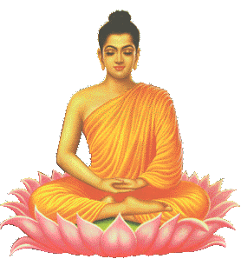
The Heartbeats and the Meditation.
It is necessary to pray and MEDITATE profoundly. It is urgent to know how to relax the physical body in order for MEDITATION to be correct. Before beginning the exercises of PRAYER and MEDITATION combined, relax the body properly. The GNOSTIC Disciple should lie down in a FACE-UP position, in other words, lying on his back on the floor or in bed, legs and arms open to the right and left, in the form of a five-pointed STAR.
This PENTAGONAL STAR position is formidable due to its deep meaning, but persons who for any circumstance are unable to meditate in this position, should then meditate by placing their body in the CORPSE POSTURE: heels together, tips of the feet spread out in the form of a fan, arms unbent along the sides, placed alongside the trunk. The eyes should be closed in order for things of the physical world to not distract us. Drowsiness properly combined with MEDITATION is very indispensable for the good success of the MEDITATION.
It is necessary to try to relax completely all the muscles of the body and then concentrate the ATTENTION on the tip of the nose, until we fully feel the heart pulse in that organ of smell, then we will continue with the right ear until we feel the heart pulse in the latter, then we will continue with the right hand, right foot, left foot, left hand, left ear and nose once again, fully feeling the heart pulse separately in each of these organs where we have focused the ATTENTION.
Control over the physical body begins with control over the pulse. The pulse of the tranquil heart is felt all at once, entirely, in its totality, within the organism, but GNOSTICS can feel it at will in any part of the body, whether it is on the tip of the nose, an ear, an arm, a foot, etc.
It has been demonstrated in practice that by acquiring the possibility of regulating, hastening or slowing down the pulse, the heartbeat can be hastened or slowed down. Control over the palpitations of the heart can never come from the heart muscles, but rather it depends totally on the control of the pulse. This is, beyond all doubt, the SECOND HEARTBEAT or GREAT HEART. The control of the pulse or control of the second heart is achieved totally through the ABSOLUTE RELAXATION of all the muscles. Through the ATTENTION we can accelerate or slow down the PULSATIONS of the SECOND HEART and the beats of the first heart.
Samael Aun Weor. Esoteric Treatise of Hermetic Astrology.
Practice leaded by a Gnostic Instructor in mp3 format: The Heartbeats and the Meditation
------------------------------------------------------------------------------------------------
Instituto Cultural Quetzalcóatl de Antropología Psicoanalítica, A.C.
www.samaelgnosis.us and www.samaelgnosis.net

