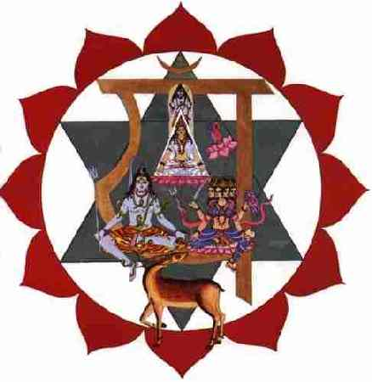
Meditation in the Heart

The devotee should concentrate on his heart, imagining there thunder and lightning, fast moving clouds that are lost in the twilight, blown by strong hurricanes.

The Gnostic should imagine many eagles flying in that infinite space which is within, very deep within his heart.

Imagine the profound forests of nature, filled with sun and life, the song of birds and the sweet and peaceful chirping of the crickets of the forest.

The disciple should fall asleep imagining all of this. Imagine now that in the forest there is a throne of gold, upon which is seated the Goddess Kakini, a very divine woman.

The Gnostic should fall asleep meditating on this, imagining all this. He should practice one hour daily, but if he practices two or three or more hours daily, even better.

He can practice seated in a comfortable arm chair, lying on the floor, or on his bed, with his arms and legs open both right and left as a five-pointed star. Sleep must be combined with meditation. One must have much patience.

These marvelous faculties of the cardia are obtained with infinite patience.

It is better that the impatient, who want everything straight away, who do not know how to persevere their whole life, should leave, because they are of no use. Powers are not obtained by playing around; everything costs. Nothing is given to us as a gift.

Samael Aun Weor. The Perfect Matrimony.

Practice guided by a Gnostic instructor at:
http://www.samaelgnosis.us/practice/more_practices/heart_temple.mp3
------------------------------------------------------------------------------------------------
Instituto Cultural Quetzalcóatl de Antropología Psicoanalítica, A.C.
www.samaelgnosis.us and www.samaelgnosis.net

