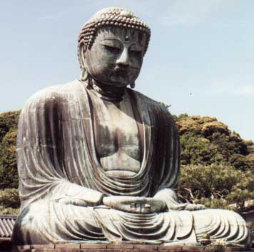
Gate Gate Paragate Parasamgate Bodhi Suaja
It is possible within a profound meditation practice, for a human being’s Consciousness to escape from the Ego and live the joy of the Illuminating Void. It is clear that if he achieves it, he will work with placer over himself, he will work with fervor, because certainly he would have experienced that what it’s the True. That, which doesn’t belong to time; which is beyond the affections, the body and the mind.
Here I’ve though you a simple form of meditation, because there is one type of meditation which is dedicated to the self-exploration of the Ego, with the purpose of disintegrate it, to turn it into ashes. There is also another kind of meditation, that has the purpose of getting one day to experience what’s Real. I hope you achieve it one day, so you keep being internally motivated and you work over yourselves. However, I think is necessary to have a Mantra that works.
The Mantra I’m going to give you is very simple: gate, gate, paragate, parasamgate, bhodi, swá, ha. This mantra must be pronounced like this: gaaateeeee, gaaateeeee, paragaaateeeee, parasamgaaaateeee, booodiiiii, suaaaa, jaaaaa. It should remain engraved on our hearts.
This mantra is pronounced softly, deeply and in the heart. It can also be used as a silenced word, because there are two types of words: the articulated word and the silenced word. The silenced word is powerful. I know that it opens the Eye if Dagma. This deep mantra you’ll let you someday to experience in absence of the Ego, the Illuminating Void. Then you’ll know what the Sunyata is, then you’ll understand what the prajña-paramita is. What’s needed is perseverance; you’ll be able to get far with this mantra.
It is convenient to experiment the great reality sometime, that fills us with motivation for the fight against ourselves. That is the advantage of the Sunyata. That is the greatest advantage in relation with the experience of what’s real. And today for us to make the most of the meditation and the Mantra, we’re going to enter a while in meditation with the Mantra.
MEDITATION PRACTICE. I beg all the brothers to enter into meditation. The body must be relaxed completely; once this is done we surrender ourselves completely to our deep inner God. Thinking in nothing, just reciting with the mind and heart the complete mantra. The Meditation must be deep, very deep, the eyes closed, the body relaxed, completely surrender to our interior God. No thought must be admitted in these instants. The surrender to our God must be total and only the mantra must resound in our heart. –Turn off the lights, relax all the body. –Complete relaxation and total surrender to our deep interior God. –Do not think on nothing of nothing, of nothing, of nothing, of nothing… -I will recite the mantra, I will repeat it several times for you not to forget it: gaaateeeee, gaaateeeee, paragaaateeeee parasamgaaateeeee, booodiiii, suaaaaa, jaaaaa... continue repeating in your hearts… do not think on nothing of nothing… -Feel yourself as a corpse, as a dead.
Samael Aun Weor. Excerpt from the book: For the Few ones
Glossary: Illuminating Void: Mystical experience, where the body being relaxed and the mind completely still, a mystical rapture is experienced, getting momentarily integrated with the Being. Deep Interior God: Our Being or Spirit. Mantra: Wise combination of sounds to produce a desired effect, may it be physical, mental or spiritual, in this case the mind relaxation.
Guided practice in mp3: https://www.samaelgnosis.us/practice/
----------------------------------------------------------------------------------
Instituto Cultural Quetzalcóatl de Antropología Psicoanalítica, A.C.
Gnosis Immortal Wisdom www.samaelgnosis.us and www.samaelgnosis.net

