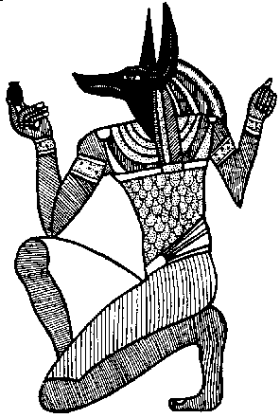
Favorable Circumstances:

Thought and action should always march totally united. Materialization of a project is only possible when the circumstances are favorable. Learn how to determine favorable circumstances for your business. Freud, the great psychologist, said that everything that man does in life has two fundamental causes: (1) sexual impulse (2) the desire to be great.
Every human being is motivated by the sexual impulse. Everybody wants to be appreciated. If you want to be surrounded by good circumstances for the crystallization of your business, then recognize the good qualities of others. Stimulate the good qualities of your fellowmen, do not humiliate anyone, do not despise anyone. It is necessary to encourage each one in his job, office or profession. By means of appreciation and encouragement we can awaken enthusiasm in all those people that interrelate with us.
Learn how to wisely praise your fellowmen without falling into flattery. People feel reassured with the food of esteem. Be gentlemanly; do not criticize anyone. In this way you will form the favorable atmosphere for the crystallization of your business. The sincere appreciation of the merits of one’s fellowman is one of the greatest secrets of success.
It is necessary to abandon the bad habit of talking about ourselves at every moment. It is urgent to employ the verb to strengthen and encourage the good qualities of our fellowman. The Gnostic student should abandon the terrible habit of talking about himself and telling the story of his life at every moment. The man or woman who only talks of himself or herself becomes unbearable. Persons like this fall into misery because people become tired of them.
Never say “I;” always say “we.” The term “we” has more cosmic power. The term “I” is egotistical and tires all those who come in contact with us. The “I” is egotistical. The “I” should be dissolved. The “I” is a creator of conflicts and problems. Always repeat: “we, we, we.”
Every morning before getting out of bed, with force and energy say, "We are strong. We are rich. We are filled with luck and harmony. OM, OM, OM.” Recite this simple prayer and you will see that you will be prosperous in everything. Have great devotion in this prayer; have faith.
Samael Aun Weor. Introduction to the Gnosis.

------------------------------------------------------------------------------------------------
Instituto Cultural Quetzalcóatl de Antropología Psicoanalítica, A.C.
http://samaelgnosis.us and http://samaelgnosis.net

