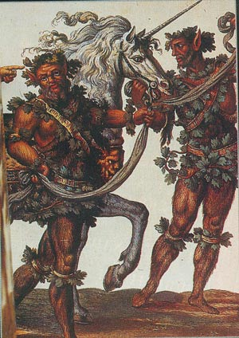
The Mantra EPHRAIM
The Mantra “EPHRAIM” has the power to develop all the chakras and power of our Cosmic Crestos. This mantra should be pronounced like this:
EEEEEEEEEEEEEEEEEEEEEEEEEEEE PPPPPPPPHHHHHHHRRRRRRRRRAAAAAAAAAIIIIIIIIIIIIIIIIIIMMMMMMMMM.
All the hidden powers of the Astral body get into activity with this powerful Egyptian mantra.
The vowel “H” is pronounced like a deep sigh and the letter “P” gives strength to this vowel, like when one is blowing the air.
A catholic priest asked an Aztec magician: How do you name your God? And the Aztec magician answered with a deep sigh; this sigh was the “H” vowel and the word “aliento” (breath in Spanish) should have the vowel “H”.
The “H” is vowel even though the grammarians don’t say so; the “H” is the breath of life, the igneous breath, and combined with the letter “P”, like “PH”, it gives the sensation like being hitting with the lips the breath of life.
Therefore, in this mantra there are terrible powers enclosed. The vowel “E” develops the chakra of the Thyroid gland and the powers of the mind. The “PH” takes the igneous breath to all the astral body’s chakras in order to awake them. The mantra “RA” makes vibrate all the chakras of the man’s astral body.
The vowel “I” awakes the chakras in the head and when combined with the vowel “M”, like “IM”, it gets a terrible power which propagates through all the astral chakras, motivating and lighting them.
The vowel “M” is pronounced like a sound that is felt in the mouth but as the lips are closed, it has to go out through the nose. This vowel “M” contains terrible powers.
Samael Aun Weor. The Seven Words

Practice guided by an instructor of Gnosis in mp3 : http://www.samaelgnosis.us/practice/more_practices/ephraim.html
------------------------------------------------------------------------------------------------
Instituto Cultural Quetzalcóatl de Antropología Psicoanalítica, A.C.
http://samaelgnosis.us and http://samaelgnosis.net

