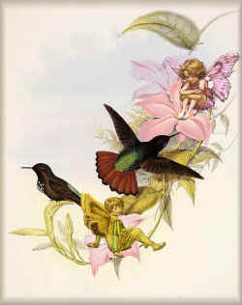
This key is useful for the awakening of the consciousness astral or dreams world. It has two basics aspects: the work upon ourselves with the death of our psychological defects to recover the innocence of our mind and the work with the elementals of the birds.
THE ELEMENTALS OF THE BIRDS.
“This was a series of mantric sounds with which one could consciously and positively achieve projection of the EIDOLON. For the benefit of our Gnostic students it is useful to establish didactically the skillful succession of these magic sounds.
a. A long and delicate whistle similar to that of a bird.
b. The intonation of the vowel "E" (as in the English word "let") (eeeeeeeeee) prolonging the sound with the note "RE" (D) of the musical scale.
c. Singing the "R", making it resonate with the musical "B", imitating a high pitched child's voice; something similar to the shrill sound of a hand mill or an extremely fine and delicate motor (rrrrrrrrrr).
d. Make the "S" resonate very delicately, like a sweet and gentle whistle (ssssssssss).
Clarification: Point a. is a real and effective whistle. Point d. is only similar to a whistle.
ASANA
The Gnostic student lies down in the position of a dead man - face upwards, on their back.
Splay the toes in a fan shape, feet together at the heels. Arms alongside the body; the whole physical vehicle well relaxed. The devotee should repeatedly sing the magic sounds in profound meditation whilst going to sleep.
ELEMENTALS
These mantras are found to be closely related to the elemental class of birds and it is evident that they will effectively assist the devotee by helping in the work of astral projection. Each bird is the physical body of an elemental and they always assist the neophyte provided that there is proper conduct.
If the aspirant is eager for assistance from the elemental class of birds, they must learn to love them. Those who commit the crime of confining creatures of Heaven in abominable cages will never receive this help. Feed the birds of Heaven, transform yourself into a liberator of these creatures, open the doors of their prisons and you will be helped by them”.

------------------------------------------------------------------------------------------------
Quetzalcoatl Cultural Institute of Psychoanalytic Anthropology
http://www.samaelgnosis.us and www.samaelgnosis.net

