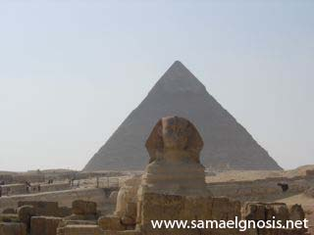
The Mantra Egipto
Our disciples must acquire the power to project the ASTRAL Body. That power is acquired by vocalizing for an hour, daily, the sacred mantra: “EGIPTO”.
The vowel “E” makes the thyroid gland vibrate and confers upon man the power of occult hearing.
The “G” awakens the chakra of the liver, and when this chakra has reached its full development, a man may then enter and leave the body whenever he wishes.
The vowel “I”, combined with the letter “P”, develops clairvoyance in man, and the power which enables man to project the ASTRAL Body through the Window of Brahma, which is the pineal gland.
The letter “T” strikes upon the vowel “O”, which is intimately related with the chakra of the heart, and thus man is able to acquire the power to detach himself from this plexus and leave in the ASTRAL Body.
The correct pronunciation of the mantra is: EEEEGGGGIIIIIIPTOOOO.
They, who have not yet been able to project the ASTRAL Body with the keys we have given, are unable to do so because they do not have that power. So, they must firstly acquire it by vocalizing for an hour daily the mantra “EGIPTO”.
This mantra develops totally the chakras related with the projection of the ASTRAL Body, and the disciple thus acquires the power of ASTRAL projection. The disciple will be able to enter and leave the physical body at will.
Samael Aun Weor. Excerpt from the Book: Tarot and Kabbalah.
Note: If you don’t know what the Astral World is, we suggest you to take the Free Course of Gnosis, you can subscribe yourself in the section of Courses.
GLOSSARY:
Astral: It is the same world of Dreams, fifth dimension or Eternity.
Chakra: Magnetic centers weakened by our wrong way of living, once activated they confer us again the lost hidden senses.
Mantra: Wise combination of sounds with the power to positively activate the centers related to the awakening of the consciousness in the world of Dreams, or Astral.
Practice lead by a Gnostic Instructor en mp3: www.samaelgnosis.us/practice/more_practices/egipto.html
----------------------------------------------------------------------------------
Instituto Cultural Quetzalcóatl de Antropología Psicoanalítica, A.C.
Gnosis Immortal Wisdom www.samaelgnosis.us and www.samaelgnosis.net

