Dream Yoga's Discipline
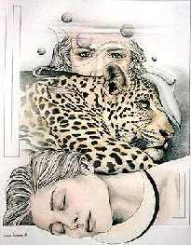
Those candidates who sincerely long for a mystical, direct experience must unquestionably begin with “Dream Yoga” discipline. The Gnostic must be very demanding with himself, and learn to create favorable conditions to remember and understand all those inner experiences that always occur during sleep.
Before retiring to your bed at the end of your daily routine, it is advisable to pay attention to the state you are in. Devotees whose circumstances make them lead a sedentary life will gain a lot if, before going to bed, they have a short, but very lively walk outdoors. A walk will relax the muscles. I must clarify, however, that we must never abuse physical exercises; we need to live in harmony.
Supper, or the final meal of the day, must be light and free of heavy or stimulating foods. Foods that keep us awake or alter our sleep should be avoided.
The highest way of thinking is not thinking. When the mind is quiet and silent — free of daily routine and mundane anxiety — it is then in a state that is one hundred percent favorable for the Dream Yoga practice.
When the Superior Emotional centre is actually working, the thinking process stops, at least for a brief moment. Evidently, the cited centre is activated with Dionysian intoxication. Such rapture is possible when listening with infinite devotion to the delightful symphonies of WAGNER, MOZART, CHOPIN, and others.
BEETHOVEN’s music is especially extraordinary because it makes the Superior Emotional centre vibrates intensely. The sincere Gnostic finds in it a vast field for mystical exploration, for it is not music of the form, but of archetypal, ineffable ideas. Every note has a meaning; every pause is a superior emotion. Beethoven — when feeling the cruel rigors and trials of the “spiritual night” — instead of failing, as many candidates did, opened the eyes of his intuition to the mysterious supernatural, the spiritual side of Nature, to that region where angelic kings of these universal creations (Tlaloc, Ehecatl, Huehueteotl, etc.) live. Observe the musician-philosopher all along his exemplary existence. On top of his table, he always had in plain view, his Divine Mother KUNDALINI, the ineffable NEITH, Anahuac’s TONANTZIN, or the supreme Egyptian ISIS. It is said that the great master had an inscription at the base of that adorable sculpture, written with his own hand that mysteriously asserted: “I am she who has been, is and will be; no mortal has lifted my veil.”
The revolutionary and inner progress becomes impossible without the immediate aid of our Divine Mother TONANTZIN. Grateful children must love their mothers; Beethoven loved his greatly. Outside the physical body, during the hours of sleep, the soul can talk to her Divine Mother. We must, however, begin with Dream Yoga Discipline.
We need to take care of the bedroom where we sleep; it must be pleasantly decorated. The colors best suited for the goal we seek — in spite of what other authors recommend — are precisely the three primary hues: blue, yellow and red. The three basic colors constantly correspond to the three primary forces of Nature: the Holy TRIAMAZIKAMNO — Holy Affirmation, Holy Negation and Holy Conciliation.
Let us remember that the three original forces of this great creation always crystallize in the positive, negative and neutral forms. The causa causans of the Holy TRIAMAZIKAMNO is found hidden in the active element OKIDANOKH. The latter, in and of itself, is only the emanation of the Sacred Solar Absolute. Obviously, if we reject the three fundamental colors — having given the above explanations — we become, by simple logical deduction, foolish.
Dream Yoga is extraordinary, marvelous, and formidable. It is, however, very demanding. The bedroom has to be perfumed and ventilated, but not pervaded with the cold night temperature.
After undergoing detailed and careful preparation of himself for bed, and of the room where he will sleep, a Gnostic must take care of his bed. If we observe any compass, we can see that the needle always points to the North. It is then possible to consciously take advantage of the planet’s magnetic current, which always flows from south to North. A bed should be placed in such a way that the head is facing north. In this way, we can intelligently use the magnetic current indicated by the needle.
The mattress should be neither too hard nor too soft. This means that its texture must in no way affect the psychic processes of the sleeping person. Squeaking bedsprings or a base that cracks with every small movement of the body, are serious obstacles for these practices. A pad or notebook and a pencil should be placed under the pillow so that they can easily be found, even in the dark. Bedclothes must be fresh and clean; the pillowcase must be scented with our favorite perfume.
After having met these requirements, the ascetic Gnostic will be ready for the second stage of this esoteric discipline. He will get into bed, and having turned off all the lights, will lay on his back with his eyes closed and place both hands on his solar plexus.
He will be totally quiet for some time, and, once he is completely relaxed, physically as well as mentally, he will concentrate on MORPHEUS, the god of sleep. Unquestionably, each part of our Real Being has specific tasks. It is precisely MORPHEUS (do not confuse with Orpheus) who is in charge of training us in the mysteries of sleep. It is impossible to trace a layout of our Being. Nevertheless, all the spiritual, isolated parts of the Being want to achieve absolute perfection in their tasks.
MORPHEUS enjoys this unique opportunity with which we provide him when we concentrate on him. We must know how to supplicate and have faith. We have to ask MORPHEUS to teach us and to awaken us in the supra sensitive worlds.
By this time, the esoterists Gnostic feels a very special somnolence, and he then adopts the “Lion Posture.”
Lying on his right side, with his head pointing north, he moves his legs slowly so that his knees are bent. In this posture, the left leg rests on top of the right one. He then places his right cheek on his right palm, and lets his left arm rest on the left leg.
When one wakes up, one does not have to move, because any movement shakes up our “VALUES,” and then the memory [of our dreams] is lost.
A retrospective exercise is needed in those moments when we want to remember our dreams.
The Gnostic has to take notes — carefully — of the details of the dream or dreams in the notebook or pad, which he placed of the dream or dreams in the notebook or pad, which he placed under his pillow.
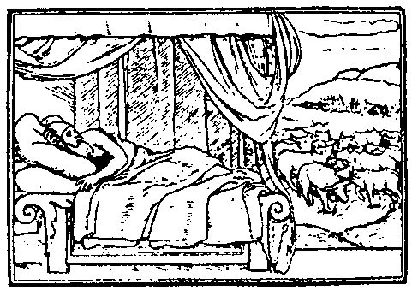
In this way, he will be able to have a detailed record of his inner progress in “Dream Yoga.”
Even if there are only vague fragments of the dream or dreams in our memory, these must be thoroughly recorded.
When nothing is left in the memory, the retrospective exercise must be based on the first thought we had at the moment we awakened. That thought, obviously, relates to the last dream. We must point out that the retrospective exercise should start before completely coming back to the vigil state, when we are still drowsy, to try to follow the dream sequence.
The practice of that exercise always starts with the last image that we had moments before coming back to the vigil state. We will terminate this chapter with the serious statement that it is not possible to go beyond this stage of the Dream Yoga discipline unless we have obtained the perfect memory of our dream experiences.
Samael Aun Weor. The Secret Doctrine of Anahuac
------------------------------------------------------------------------------------------------
Instituto Cultural Quetzalcóatl de Antropología Psicoanalítica, A.C.
http://samaelgnosis.us and http://samaelgnosis.net

