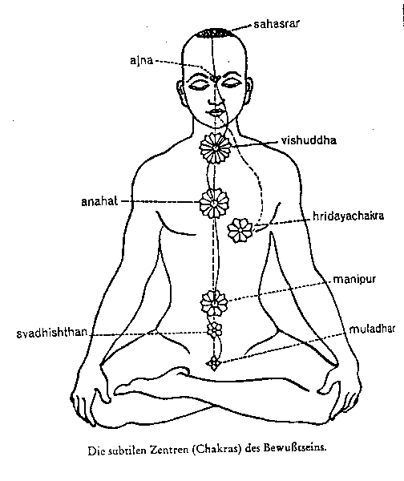
CHIS, CHES, CHOS, CHUS, CHAS
The vowels and the faculties of the chakras:
The seven vowels of Nature: I E O U A M S, resounded long ago in the human organism. When man came out of the “Jinn” Lands, Rhythm and Harmony were lost.
Man should perceive the urgent need for the Seven Vowels of Nature to vibrate once again in his organism, to resound with intensity in the interior boxes of resonance, as well as in each of the Plexus of Chakras of the Astral Body.
Clairvoyance is developed with the Vowel I. Clairaudience is awakened with the Vowel E. The Heart Center, which develops Inspiration, with the Vowel O. The Pulmonary Chakras, which enable us to remember past reincarnations, are awakened with the Vowel A. The Vowels M and S cause all internal centers to vibrate.
These vowels wisely combined with certain consonants, form the mantras which make possible the awakening of all the chakras.
Next are some series of Mantras offered to the disciple:
FIRST SERIES OF MANTRAMS
CHIS Clairvoyance: Frontal Chakra
CHES Clairaudience: Larynx Chakra
CHOS Intuition: Heart Chakra
CHUS Telepathy: Solar Plexus
CHAS Memory of Past Lives: Pulmonary Chakras
VOCALIZATION
The vocalization should be done as follows. The sound of each letter is prolonged. The combination CH is considerably abundant in the Hebrew Mantras and is of immense magical power.
The vocalization of each Mantra causes the vibration of the Magnetic Center, Chakra or Disc, with which ills related. The S is intimately connected to Fire and is vocalized giving it a special intonation: a sharp, hissing sound similar to that made by the compressed air brakes of any machine.
Samael Aun Weor. Logos, Mantra, Theurgy.
Glossary:
Chakra: Magnetic center, which once activated it awakes the senses that we’ve lost, because our bad way of living. They are in general, intimately related with the glands.
Mantra: Wise combination of sounds, which have the can produce a positive effect in the human being, in this case, the harmonious development of the chakras.
Jinn: This normally refers to the Fourth dimension. We live in a multidimensional world, but our senses only perceive 3 from the 7 fundamental dimensions.
Clairvoyance: The capacity of seeing the Ultra of Nature.
Clairaudience: The capacity of listening to the Ultra of Nature.
-------------------------------------------------------
Some images of the Chakras here.
If you want to study in deep in these topic and you are not subscribed to our courses yet, go here.
How to chant some Mantras by the V.M. Samael Aun Weor, here.
Guided practice by a Gnostic Instructor in mp3 http://www.samaelgnosis.us/practice/more_practices/mantra_chis_ches.mp3
----------------------------------------------------------------------------------
Instituto Cultural Quetzalcóatl de Antropología Psicoanalítica, A.C.
Gnosis Immortal Wisdom www.samaelgnosis.us and www.samaelgnosis.net

