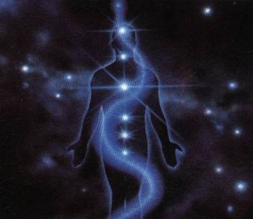
THE KEY TO AWAKEN OUR CONSCIOUSNESS WHILE SLEEPING.
It is not dangerous to come out in the astral body because the entire world comes out in the astral body during sleep. The one who wants to awaken consciousness during sleep, should know the “Key of Discernment”.
During sleep, every human being wanders in the internal worlds with consciousness asleep. The soul enveloped in its astral body abandons the physical body during sleep.
This is how the Etheric Body can repair the dense body. When the soul enters the body, we then wake up from natural sleep. In the internal worlds, the souls occupy themselves in the same daily chores. They then buy and sell as in the physical world.
The souls of the living and the dead live together during sleep. In the internal worlds, we see everything as in the physical world. The same sun, the same clouds, the same houses of the city; everything is the same. Our Gnostic disciples will now understand why the dead do not accept that they are dead.
Our Gnostic disciples will now understand why the souls of the living buy and sell, work, etc., during sleep. By coming out in the astral body we get to know the mysteries of life and death. Every human being comes out in the astral body during sleep. By awakening consciousness during normal sleep, we can know the great mysteries of life and death. In order to awaken consciousness during sleep, there is a clue. The key to awaken consciousness is that of Discernment.
Let’s see: If you are going down a street and you meet a friend, or you see objects that attract your attention, take a small jump with the intention of floating; it is logical that if you float it is because you are outside the physical body. However, if you do not float, it is because you are in the physical body.
It happens that in the internal worlds we act during sleep in the same manner as in flesh and blood, and if to that we add that there we see everything in the same manner as here in the physical world, we will then comprehend that it is only if we succeed at flying that we will awaken consciousness for us to realize that we are in the astral body.
This exercise is practiced at every instant during the vigil state before the presence of anything unusual. What is done in the vigil state is repeated during dreaming. If we do this exercise during sleep, the result will be that we will remain floating in the astral body when we jump. Our consciousness will then awaken and full of happiness we shall say, “I am in the astral body.”
Samael Aun Weor. Excerpt from the Book: GREATER MYSTERIES


THE KEY OF SOL
Whoever wants to awaken consciousness should begin by dividing their attention into three parts: subject, object, location.
Subject: inner remembrance of oneself from moment to moment. Do not forget yourself when confronted by any mental images or by any event.
Object: do not identify with anything, with any circumstance. Observe without identifying, without forgetting your own self.
Location: ask yourself, “What place is this?” Observe the place in detail, asking yourself, “Why am I in this place?”
The division of attention into three parts leads the aspirant towards the awakening of consciousness. Wanting to experience the great realities of the superior worlds without awakening consciousness here and now is to walk a path of error.
Samael Aun Weor. Excerpt from the book: The Buddha’s necklace.

++++++++++++++++++++++++++++++++++++++++++++++++++++++++++++++
This practice is intended to be made every moment of our lives in our daily life. If you want to know more about the Awakening of our Consciousness and the Gnostic Teachings, please visit our Courses Section.
Practice guided by a Gnostic Instructor: http://www.samaelgnosis.us/practice/index.html

------------------------------------------------------------------------------------------------
Instituto Cultural Quetzalcóatl de Antropología Psicoanalítica, A.C.
http://samaelgnosis.us and http://samaelgnosis.net

