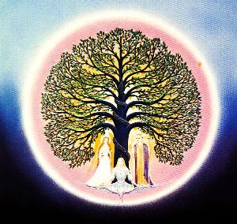
The Thymus gland and the mantra Abracadabra
When the human being is beyond his sexual maturity, then the thymus gland enters in its decrepitude. This is already proved. The Thymus gland is located in the very same bottom of the neck.
The Thymus gland has a structure of a completely irregular form. This gland is intimately related with the mammary gland. Now we can explain to ourselves why the milk of the mother is totally irreplaceable.
The Thymus gland regulates the vitality of the children. Astrologists say that this gland is influenced by the moon. The Gnostic wise men want to look after the Thymus gland, and not let it get into decrepitude. When this gland is active the organism doesn’t age. The ancient wise doctors used to say that the Vowel “A” when is wisely pronounced it has the power to make vibrate the Thymus gland. The old doctors from ancient times used that wise Mantra so popularized by the people, called ABRACADABRA apparently to keep active the Thymus gland during all the lifelong. They pronounced in the pagan temples forty-nine times that word in the next way:
ABRACADABRA
ABRACADABR
ABRACADAB
ABRACADA
ABRACAD
ABRACA
ABRAC
ABRA
ABR
AB
A
It is said that they prolonged the sound of the vowel “A”.
Some doctors start healing with musical sounds, it is good to know that the doctor’s voice, and every one of his words is source of life or death for the patients. The endocrinologist science must study the close relationship that exists between music and the endocrine glands. It is better to investigate, analyze and understand that to laugh of what we don’t know.
***Samael Aun Weor. Fundamental Notions of Endocrinology and Criminology. ***
Practice lead by a Gnostic Instructor in MP3. http://www.samaelgnosis.us/practice/more_practices/abracadabra.html
------------------------------------------------------------------------------------------------
Instituto Cultural Quetzalcóatl de Antropología Psicoanalítica, A.C.
http://samaelgnosis.us and http://samaelgnosis.net

