The Secret Teachings of the Popol Vuh
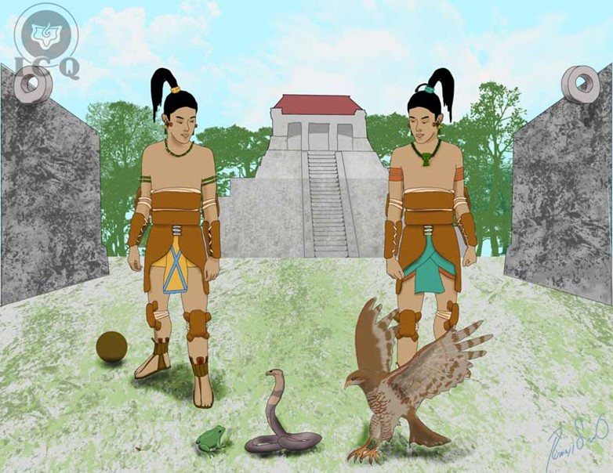

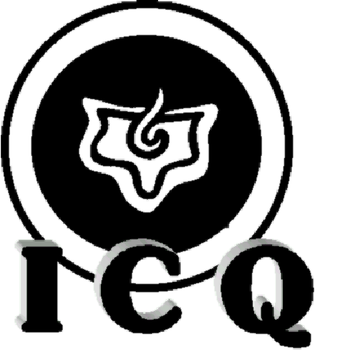
Authors: Jenaro Ismael Reyes Tovar and

María Guadalupe Rodríguez Licea

Illustrations: Rubén Soto Orozco

Translation: Ricardo Santana Laracuente

Didactic material for internal and exclusive use of the students of the Quetzalcoatl Cultural Institute (ICQ in Spanish) of Psychoanalytical Anthropology, A.C.
www.samaelgnosis.us

INTRODUCTION
The Maya inherited the Atlantean wisdom and based their teachings towards the development of a common feeling of all beings being a single Being, synthetizing it on the phrase: In lak’ ech a lak’ en (you are me, I am you). This is a reflection of the marvelous force of love, the ability to comprehend others; the foundation of the sacred teachings of all of the world’s great religions and the synthesis of the message left behind by all of the Great Masters.
In the Popol Vuh we come to find the magic of self-knowledge, Gnosis, the internal wisdom that through experience, can reunite us with our own spirit and consequently, with the unknowable Truth.
Let’s penetrate, in practice, into the sacred teachings of the Maya, let us discover that within each character represented in the Popol Vuh we will find elements we carry deep within, and let’s illuminate with the light of this ancient wisdom the darkness of our own ignorance.
Popol Vuh literally means “the Book of the Council” or “the Book of the Community”. The Maya accustomed to resolve all important issues through council under the primary authority of a council of elders; in “community”, it was the responsibility of the parents to transfer this millenary wisdom unto their children, and that is how they managed to deliver wisdom from lips to ear, from master to disciple.
In this book, we will focus on covering the second part of the Popol Vuh titled “The Magi” (The Lords of Ahpu).
Magic is a fundamental element of this second part, as true magic is “the art of influencing over our own interior nature”, as Novalis, the German poet, defines it.
The Popol Vuh is an antique writing that consolidates the elements of science, art, philosophy, and transcendental mysticism, which makes it both a practical knowledge applicable to our present time, and as such, its teachings are of use to be of use at every moment of our lives.
This book speaks of the birth of a pair of Twins born to divine grace, of how they defeat the force of darkness, overcoming a multiplicity of tests, until they emerge victorious.
The great deeds performed by the Twins Master-Magi (Hunahpu) and Little-Solar-Priest (Ixbalanque), are in reality the titanic task each one of us must realize here and now.
The Maya wisdom captured in the gnostic Popol Vuh is a marvelous story as it speaks to the magic of self-knowledge, which will lead us by the hand into the depths of eternal wisdom.

CHAPTER 1
THE ORIGIN
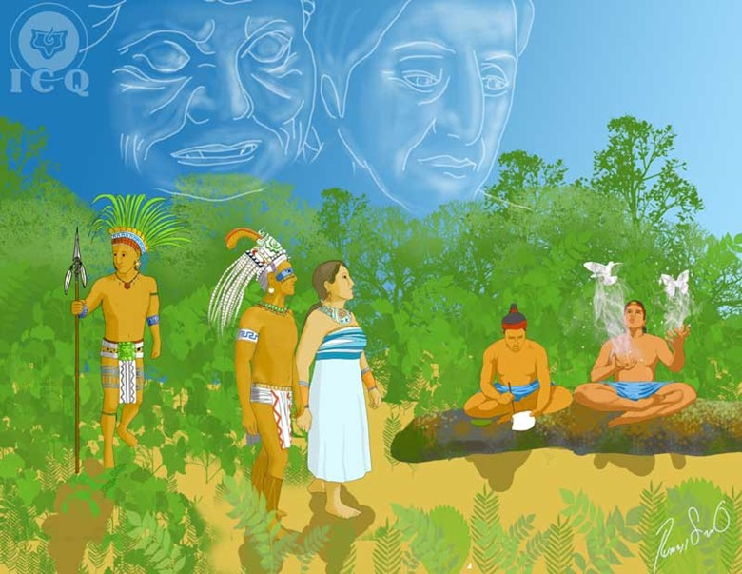
H
ermes Trismegistus wrote in his Emerald Table “as above, so below”, and these words give us the key to understand that every writing in the Popol Vuh is found within the interior of each person, as each one of us is, by themselves, a micro-cosmos.
Each location mentioned in the story, as well as each character, is nothing other than a part of the psychological universe we carry within. Let us search here and now, at this very same instant, the story narrated by the Popol Vuh within ourselves.

The Magi (The Lords Ahpu)
“This that will be mentioned will only be a fragment and will be hidden behind a mysterious veil. At an uncertain time and yet before light was manifested, the Magi were born (Ahpu), offspring of Ancient-Secret (Ixpiyacoc) and Ancient-Concealer (Ixmucane)”
The answer to the question “from where do we come from?” is articulated very delicately by the ancient wisdom. We originate from within the higher dimensions of nature and the answer to such question is found within Ancient-Secret (Ixpiyacoc), as he is our profound Real Interior Being, our “Father who is in Secret” as the Great Master Jesus referred-to. Each one of us has his own Ancient-Secret father within. Coincidentally, Arcanum #1 of the Kabala is called The Magician and it represents the Ancient of Days, He is the KETHER (CROWN) of the Tree of Life.
Ancient-Concealer (Ixmucane) is the Cosmic Mother; she is the Egyptian Isis, and coincidentally as well Arcanum number 2 represents the hidden (concealed) wisdom. She is the Divine Mother, God in its manifestation as Love. It is wonderful to know that each one of us carries their own Divine Mother within as an integral part of their Being.
Ancient-Secret (Ixpiyacoc) and Ancient-Concealer (Ixmucane) are our origin, they are our internal Father-Mother, the deepest root of the human being.
“And in such way, through the night, the Magi (Ahpu) come into existence; they are Supreme-Magi-Master (Hun-Hunahpu) and Principal-Magi-Master (Vucub-Hunahpu). As they grew they became dexterous in all arts and sciences, expert sharpshooters of the blowpipe, artists, magicians, goldsmiths; there were no arts unknown to them”
Analyzing the names of the Magi (Ahpu), we find deep revelations.
Within the name Hun-Hunahpu we find that “Hun” is ONE or SUPREME. “Hun” in Maya means “Master” and “Ahpu” means “Magician”. The number ONE is TRUTH and WISDOM. This ONE-Master-Magi or SUPREME-Master-Magi (Hun-Hunahpu) are the distinct divine parts of the Being that exist within us and that work incessantly within our internal universe to lead us again towards the unknowable Truth.
In Vucuc-Hunahpu we find that “Vucuc” means SEVEN or PRINCIPAL, “Hun” is “Master” and “Ahpu” is “Magician”. This SEVEN is “order”, “perfection”, and also the seven virtues, antithesis of the seven heads of legion or seven capital sins. PRINCIPAL-Master-Magi or SEVEN-Master-Magi (Vucuc-Hunahpu) is a symbol of fraternity, love, mercy, wisdom, humbleness, courage, temperance, etc.; values that should be part of the normal manifestation of the human being.
“Supreme-Master-Magi (Hun-Hunahpu) married Bearer-of-Monkeys (Ixbaquiyalo) and they had two children: Master-Ape (Hunbatz) and Master-Monkey (Hunchouen), who inherited all the wisdom of their parents”
The inheritors of wisdom: Master-Monkey (Hunbatz) and Master-Ape (Hunchouen) are everyone who has the opportunity to receive the wisdom of the spirit, of gathering the teachings delivered throughout millennia, of possessing the knowledge, and the keys to achieve the self-realization of the Being.

The Underworld (Xibalba)
The hell of the Maya is inhabited by sinister and perverse beings whose only purpose is to exert as much suffering to mankind as possible. These infernal regions are a representation of the human sub-consciousness where the Lords of Xibalba (our innumerable psychological defects) exist. Xibalba is translated from the Quiche-Maya as “ghost”, “demon” or “apparition”.
For years, specialists in the Maya culture have made an effort to geographically locate the region of Xibalba, but if we peek within ourselves, with ease we will find a great similitude between such a region and the abyss of our psychology.
“Supreme-Death (Hun-Came) and Principal-Death (Vucuc-Came) are the rulers of Xibalba, under their command are ten Princes, whose work is to hurt mankind, to cause misfortune, illness, and pain, inclusive of death”
It may be of a surprise that the first name of the rules of Xibalba is the same as that of the Magi (Ahpu), yet this is an indication of the eternal battle between light and darkness.
In the name Hun-Came we find “Hun” meaning ONE or SUPREME, and “Came” meaning “dead”. If SUPREME-Master-Magi (Hun-Hunahpu) is a symbol of the Sun, light, wisdom and truth, SUPREME-Death (Hun-Came) is the shadow of the Sun, the negative fire and animal passion.
In Vucuc-Came, “Vucuc” is SEVEN or PRINCIPAL and “Came” is “dead”. PRINCIPAL-Death or SEVEN-Death (Vucuc-Came) is the symbol of the seven heads of Legion, the seven capital sins: Greed, Envy, Gluttony, Anger, Lust, Pride, and Laziness.

The Ten Princes
“The Rulers of Xibalba; Supreme-Death (Hun-Came) and Principal-Death (Vucuc-Came) dictated what each of the Princes should do. EXTEND-CRIPPLE and GATHERER-OF-BLOOD had the primary task of making men die out of the flow of their own blood. MAKER-OF-ABSCESS and MAKER-OF-JAUNDICE had the task of developing tumors and abscesses on the legs and to turn men’s countenance yellow (make them ill with Jaundice). ROD-OF-BONES and ROD-OF-SKULLS, sheriffs of Xibalba, had the task to ossify men. MAKER-OF-TREASON and MAKER-OF-MISFORTUNE; to make men fall due to treason, before or behind their homes. HAWK-OF-BLOOD and OPPRESSION; to kill man of a sudden death, to destroy their throats, to make them vomit blood and die on their path”
The two kings and the ten princes of Xibalba are the thousands of defects that exist within our psychology; greed and fear are the cause of all wars, anger is the cause of many of our illnesses, pride is one of the roots of all problems at home, and lust is the basis of adultery, treason and misfortune.
The root of our problems is not outside of us, but within. Blaming our parents, the government, our spouse, or our children as the cause of our suffering is a reflection of our failure to recognize this. The Popol-Vuh is very clear indicating the cause of all our problems resides within the Lords of Xibalba.

The Playfield of Religious Ball
The most important events of this story took place on the playfield of religious ball. As the story unfolds, symbols emerge from which we can extract an occult teaching, provided we make the effort to receive the teaching itself.
In essence, the game of ball is akin to the work we must perform to find the path of Immortal Wisdom, as well as to the battles between the forces of light and darkness. Such a battle is prevalent at every instance of our lives, where the toughest battle is associated with the control of the energies that brought us into existence.
“The Magi (Ahpu) played the game of religious ball to perfection; they played every day one game after another, they cried out in happiness and were loud about it”
Each human being has the opportunity to work on the path to liberation, or not, as we are endowed with free will. There comes a time in one of our many existences where we come across the narrow path that leads us into the light and then, we do all within our power to walk it. This is the very meaning of playing the game of religious ball and the happiness reflected by the Magi (Ahpu); it is the happiness of the soul as it contemplates the opportunity to return to its point of origin, the limitless happiness.
“These outcries of happiness reached the ears of the Lords of Xibalba, and they were displeased; and claiming they were no longer being respected, they called into council their ten princes to orchestrate a plan to terminate those playing above their heads”
The wise Maya were knowledgeable of the human psychology and they describe the structure and transactions of the Ego (our psychological defects). They taught each “I”, or psychological defect, has its own life, its own thoughts and the ability to work with other defects to plot their way to appear.
Without a doubt anyone who makes an active effort to battler their defects and thus, effect a revolution within their own game of life, will inevitably make their defects aware of such effort and in turn, this will create a disturbance amongst the defects themselves. This must be expected, as for as long as we do not make a consistent effort to express altruism, diligence, love, and sincerity in our actions, our defects will roam around our psyche without restraint.
“The Lords of Xibalba sent their messengers, four owls, to ask the Magi to present themselves to Xibalba for a game with them. What they wanted was to see them murdered and safeguard the instruments used for the game of ball (their rings, gloves, ball, etc.)”
Our values are represented by the “instruments used in the game of ball”, and the many defects we carry within seek to take control of such values of the consciousness; this is how anger imprisons love, laziness imprisons diligence, and pride imprisons humbleness.
The owls (messengers of Xibalba) are a symbol of death, but also a representation of the Law of Karma – the law of cause and effect – better explained by the Great Master Jesus when he said: “we reap what we sow”. One of the owls is as fast as lighting (the lighting of cosmic justice, that fulminates he who disobeys the Great Law), the other is a giant owl (as there is nothing greater than the Law, nothing is beyond the Law of Karma), another is of a fiery red color (the law operates based on supreme mercy and supreme justice, nothing escapes the law), and one other owl is represented by a winged head (as a symbol of the wisdom in perfect equilibrium with the Law).
As messengers of Xibalba, they represent the Karma against the one who seeks the Light; he who owes and has to pay debt for all his wrongdoings; nothing escapes the Law.

The Hawk (Voc) Messenger of Master-Giant (Hurakan)
“From the sky comes down the hawk (Voc) to observe the Magi (Ahpú) playing, following the orders from Giant-Master (Huracán) the Heart of the Haven”
Master-Giant (Hurakan) is a designee of Divinity; it refers to the primordial breath of life from the first instant of creation and is found at the heart of the Heaven of the Maya. Everything is being watched by the unknowable divinity, nothing goes unnoticed, and every thought, feeling and action are constantly observed by its eyes. The Heart of the Heavens is the very same Divine Trinity of the many different religions: it is Cakulha-Hurakan (Master-Giant-Lighting), Chipi-Cakulha (Footprint-of-Lightning), and Raxa-Cakulha (Splendor-of-Lightning). They are the wisdom of the Father, the love of the Son and the power of the Holy Spirit.

CHAPTER 2
THE DEATH OF THE MAGI
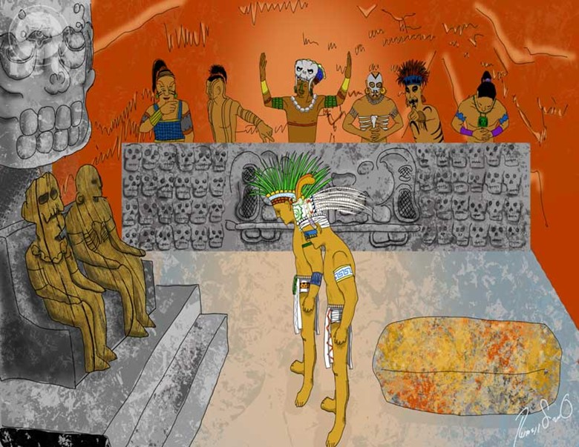
T
his narrative relates to how our psychological defects (the Lords of Xibalba) assume ownership of the transcendental values of our soul, by the killing the Magi (Ahpu).
“The four messengers of Xibalba told the Magi (Ahpu) they should present themselves at the underworld to face the Lords of Xibalba on a game of ball. The Magi (Ahpu) asked for the opportunity to say their goodbyes to their mother Ancient-Concealer (Ixmucane) and to the sons of Supreme-Master-Magi (Hun-Hunahpu). Ancient-Secret (Ixpiyacoc) and Bearer-of-Monkeys (Ixbaquiyalo), had died”
The death of Ancient-Secret (Ixpiyacoc) – meaning our Being, the Father who is in Secret – and Bearer-of-Monkeys (Ixpiyacoc) – wife of Supreme-Master-Magi (Hun-Hunahpu) – is an indication that we constantly shift farther away from the eternal values of the Spirit, that each day we are more inclined to materialism and thus, further away from eternal wisdom, love and its power.
“Ancient-Concealer (Ixmucane) cried as her sons said their goodbyes, and they said: ‘Mother, we have not died yet, allow us to depart and we will back at play shortly’. Supreme-Master-Magi (Hun-Hunahpu) addressed his sons by saying: ‘Warm the heart of your Grandmother, warm this home during your absence’, and then they departed”
There are plenty of revolutionary gnostic psychology techniques employed in these enigmatic dialogues; the Grandmother weeps because of the potential fate of her children – suffering for that which has not happened yet – and the phase “we have not died yet”, teaches us we have to learn to live from moment to moment, living the philosophy of present-time, in the remembrance of self. Just as the Masters of Buddhism have taught: “If you walk, walk”; we must bring consciousness into everything we do.
Lamentably we live our days either stuck the past or concerned about the future and thus, in constant affliction and misery. Every Wise Master has insisted us to make an effort of living intensely at the present-time, because every second of our existence is of such vital importance; and not to live a second before or a second after the present-time. The message has always been to live in the now.
At the same time, they suggest that we do not forget of our Divine Mother – to “warm the heart of the Grandmother” – as our Divine Mother is the one who can guide us down the path of the revolution of the consciousness. When we forget about her is when we deviate off the path and fall into mistakes.

The Descent to the Underworld
The underworld, the region of Xibalba, is nothing other than that invisible realm for the eyes of the flesh, but which is so much more real than the physical plane itself, as we spend most of our life in it; the underworld is the collection of our unconscious, subconscious and infra-consciousness.
“Guarded by the four owls, the Magi (Ahpu) embarked to the underworld (Xibalba), and walked past a river of boiling waters and a river of blood, not drinking of their waters, and making use of their blowpipes to help themselves cross the rivers without suffering any harm”
The rivers of boiling waters and blood are our brutal animal passions, which we can both identify easily by simple observation and overcome when putting our willpower into action. We overcome our passions with the correct us of our “blowpipe”, as the correct use of this weapon is a representation of the correct way in which we should make use of our creative energies.
“After descending off cliffs they arrived at the entrance of Xibalba, and leading to it, four paths: one was black, another white, one other yellow, and one other was red. The black path said unto them: ‘Walk this way, as I am the path of the Lord’”
In the study of medieval alchemy, we find the very same four colors in the alchemical process itself in the forms of the black crow, the white dove, the golden (yellow) eagle and the red pheasant. These alchemical processes are put into practice through the magic of love and make up the Great Work. Every initiate is given the opportunity to advance spiritually.
The descent down the cliffs to reach the underworld (Xibalba) is a symbol of the opportunity we are given to put into practice the mysteries in our matrimony, but just as the alchemists claim, we must purify the sacrament of love; that which is spiritual must unite with love.
Lamentably, many who start this work get stuck and take the black path; that is the path filled with animal passion. They may start the work, but they never purify the sacrament of love.
“They reached a cavern where Supreme-Death (Hun-Came), Principal-Death (Vucuc-Came) and the ten princes of Xibalba were united in council, and to trick the Twins, they had carved the two supreme rulers out of wood. Upon their arrival, the Magi (Ahpu), deceived, said: ‘Greetings Supreme-Death (Hun-Came), greetings Principal-Death (Vucuc-Came)’; and all in Xibalba burst into laughter, seeing their plan had effectively worked”
Many of us think we already know ourselves, we believe to be great people, humble, serviceable to others, good parents, better children, exemplary citizens; we believe to be tame sheep. But that is what the ego does for us, it leads us to believe such things and in turn, the ego itself laughs at us every time it fools us.
Meantime we are cruel with our children and we physically and emotionally punish them, justifying our actions making ourselves believe we are being just and that what we do, we do for their own good. We are extremely jealous, yet we fool ourselves believing everything we do, we do out of love. We criticize others and justify our slander thinking we do to help guide them into the rightful path. All of this is nothing other than our reactions to the deceptions of our psychological defects at every instant.
“’Here, we have a seat ready for you’ said the Lords of Xibalba to the Magi (Ahpu), and in reality, the seats were a previously heated stone; and when they took seat, the Magi burned. They mocked and made fun of Supreme-Master-Magi (Hun-Hunahpu) and Principal-Master-Magi (Vucuc-Hunahpu), as they believed defeating them was soon to be a done deal”
The stone heated by the ones of Xibalba used to burn the Magi is the very same stone of stumbling, and rock of offence mentioned in the Bible. The heated stone is a representation of the sexual temptations we allow ourselves to get caught into and that because of our daydreaming state, we fail when we face them, falling into adultery with its fatal consequences.

The House of Darkness (Quequma Ha)
The next morning the Magi were to face the Lords of Xibalba on a game of ball, but prior to that they had to spend the night in the House of Darkness. The Lords of Xibalba had set a series of houses to defeat their enemies: the one of darkness, one of coldness, one of blades, one of jaguars, one of fire, and the house of the bat. The first one was the House of Darkness.
“’Spend the night in the House of Darkness and we will play tomorrow’, they said, and sent them with their messengers a staff of resinous pine tree (ocote) and a cigar, so they could provide themselves light throughout the night, and they advised they should return both of these the morning after”
Just like the Lords of Xibalba have many houses to defeat their enemies, so our psychological defects have plenty of systems to lead us into failure, to keep us as their slaves so we can continue to feed them indefinitely.
And one of the systems used most often is the House of Darkness; there is only darkness in that house, and absolutely no light. The light is Gnosis, it is wisdom, the keys to achieve self-realization; the systems that aid us in self-knowledge. The vast majority of the people who live in this world are not interested in these teachings, they reject them as soon as they appear too harsh or too difficult.
And defects take advantage of this to offer us of a false light. The ‘ocote’ is a resinous wood that lights up fast and just as fast, burns out. It provides a short-lived light, symbol of the many false teachings that exist today: of false schools that have no solid foundation and offer a superficial teaching that does not educate on how to disintegrate our defects. These schools do not teach how to transmute our energy and they are not interested in the disinterested service for humanity.
“The next morning, the Magi (Ahpu) presented themselves to the supreme Lords of Xibalba, and were unable to return the staff of ocote and the cigar, so they were condemned to death”
What we are offered from the many schools, religions and philosophies of today will trap us in dogmas, useless theories, vane science, and will lead us into curtailing the values of our consciousness; the Lords of Xibalba (our psychological defects) will absorb us, dominate us and extinguish the few incipient values we still have.
“The Magi (Ahpu) were decapitated and their heads hung from a tree that had never bore fruit; but that night was the most silent night of its time and the following morning, the tree was covered in fruit, leading the heads of both Supreme-Master-Magi (Hun-Hunahpu) and Principal-Master-Magi (Vucuc-Hunahpu), to be blended and concealed within the tree”
This is a representation of the sad moment where we find ourselves in our own existence; our psychological defects have “decapitated” the values of our soul, they have terminated love, conscious charity, humbleness, diligence, altruism, temperance, etc.
“Because of the unexplainable behavior of the tree where the heads of the Magi (Ahpu) were hung, the supreme rulers of Xibalba prohibited any and all access to it”
And so is all of humanity, living their lives so far from the real values of a true human being, lacking interest and disproving of anything that carries the essence of a teaching that can lead to a radical transformation. Humanity lives their lives far from the unknowable truth.
CHAPTER 3
THE VIRGIN IXQUIC
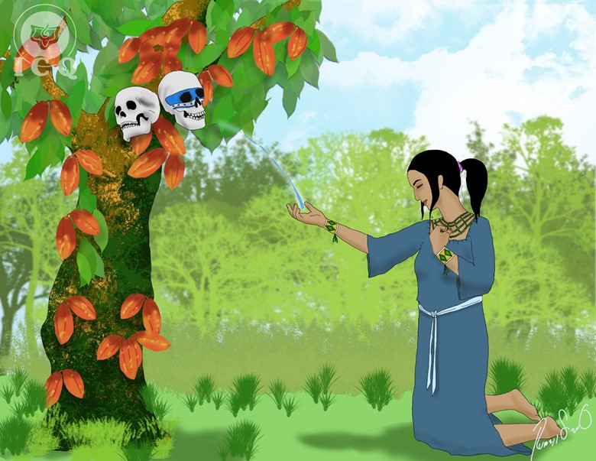
I
xquic is translated as “the one of the Blood”. Ancient proverbs state that light emerges from the darkness; let’s tear the veil of mystery and seek for the origin of the Twins: Master-Magician (Hunahpu) and Little-Solar-Priest (Ixbalanque).
“There was a virgin of name Ixquic (the one of the blood), daughter of one of the princes of the underworld: Gatherer-of-Blood (Cuchumacuic) was her father. The young Ixquic admired the story of that tree that bloomed unexpectedly, and she learned about the dire warnings imposed against anyone who dared to approach of it”
The young virgin Ixquic is a fundamental element of this narrative. Being a daughter of one of the princes of Xibalba, it shows us one of the greatest mysteries: just like the perfume of a rose emerges from the mud of the earth, from someone like us – filled with psychological defects and lacking virtues – can emerge the light of true wisdom.
“The maid Ixquic, against all warnings, walked to the tree where the heads of the Magi (Ahpu) were hung. As she stood before the tree contemplating its fruit, the cranium of Supreme-Master-Magi (Hun-Hunahpu), while blended amongst other fruit, asked her if she wanted one, to which she said yes. Then, Supreme-Master-Magi (Hun-Hunahpu) asked her to extend her right hand, and he spat on her hand. She immediately looked at her hand, but the saliva had already disappeared and at that very moment, without any contact with a man, she conceived”
We find marvelous parallel stories throughout the world related to the story of an immaculate conception; lest we remember the conception of Huitzilopochtli (Aztec Lord of War) when his mother Coatlicue (the one with the skirt of serpents) was sweeping the floor off feathers that had fallen from heaven and when placing them near her womb became pregnant; just as the birth of the Master Jesus where we find the same symbols with the Virgin Mary and the white dove of the Holy Spirit.
These similitudes speak of an internal birth based on incessant purifications, whether it is represented through the feathers that fall from heaven, the dove of the Holy Spirit or the saliva of Supreme-Master-Magi (Hun-Hunahpu). This narrative is a call to transmute the energies that brought us into existence (our sexual energy) and to avoid the incorrect use of them.
“And so came to be the words of the Heart of the Heavens: Master-Giant (Kakulha-Hurakan), Footprint-of-Lightning (Chipi-Cakulha), and Splendor-of-Lightning (Raxa-Cakulha)”
This is the divine plan from the Heart of the Heavens of the Maya; we walked out of paradise after eating of the forbidden fruit and only when we stop eating of such fruit will we be able to return into Eden. When we lie we set ourselves farther apart from the Truth who is the Father; when we hate we set ourselves farther away from Love which is the Son, and when we abuse of our sexuality, we move farther apart from the Holy Spirit, which is chastity.
“After six moons her pregnancy became evident and this bothered her father, who after seeking council from the supreme rulers of the underworld, determined that if she did not confess, she would be sacrificed at a place far from there. After all efforts to make her confess who the father was, the young Ixquic refrained to just say: ‘Father, I have not known any man’”
The six moons that lead to her pregnancy becoming evident are a symbol of the Star of Solomon with its six rays. The masculine forces are represented by the upward triangle and the feminine forces are symbolized with the downward triangle.
The wise combination of both masculine and feminine forces allow for the development of the solar forces within the human being, but we obviously do not refer to the combination of such forces via the infra-sexuality practiced by today’s humanity, but of a superior type of sexuality where the couple sees in love itself, the path to salvation.

The Red Tree
“The Lords of Xibalba sent the four owls to sacrifice the young Ixquic and gave them a bowl, so that as proof, they would bring back the heart of the maid. Once ready to sacrifice her, Ixquic pleaded for them to spare her life, claiming her innocence. ‘Don’t kill me’ – said the virgin to the owls – ‘and in turn the true fornicators will be yours’”
The four owls, messengers of Xibalba are the Law of Cause and Effect (Karma) acting against the seeker of wisdom as a consequence of the negative actions taken in this and previous lives, actions for which we must pay, as we all reap what we sow.
“The owls believe her, but they are uncertain on what to do next, as they were ordered to return with her heart. Then Ixquic makes an incision on a red pomegranate tree, which resin is as red as blood, and on the recipient meant to carry her heart, she poured the resin of this tree, and when it coagulated, it took the shape of a heart”
Karma is not only paid with suffering, it is also possible to pay Karma with love, helping and sacrificing for others. That is why a heart takes shape from the resin of the tree of blood; blood is symbol of life and sacrifice. While we work with love for humanity, it becomes possible for us to transcend the karma we have earned because of our psychological defects.
“The owls said: ‘Ascend to the surface of the Earth, we will follow you and we will know how to serve you’. When the alleged heart was burned before the ones from Xibalba they noticed a delicious aroma, and that is how they, the Lords of Xibalba, were deceived by the young Ixquic”
The owls that at first serve the Lords of Xibalba (the karma working against) can change, if our actions are the result of right thought, right action and right feeling. The Law of Karma can be in our favor.

CHAPTER 4
THE GRANDMOTHER AND THE YOUNG IXQUIC
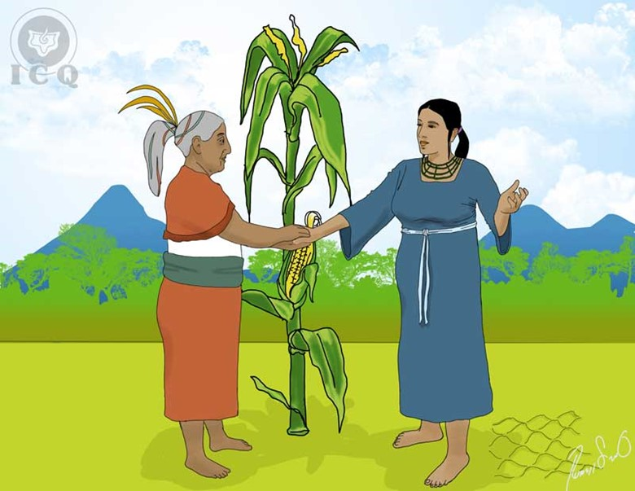
W
ithin every human being we find thousands of defects but also divine forces, luminous aspects that attempt to help us, orient us, protect us, and heal us.
“The young Ixquic rose to the surface of the Earth, escaping the death sentence from the Lords of Xibalba and she walked to her Grandmother’s house (Ancient-Concealer), who cried inconsolably the death of her two sons, the Magi (Ahpu), at the hands of the Lords of Xibalba. Her only consolation were her grandchildren, Master-Monkey (Hunbatz) and Master-Ape (Hunchouen)”
The Divine Mother is represented in various aspects that work within us. The millenary Hindu tradition speaks about MAHA KUNDALINI, the Cosmic Mother, and DEVI KUNDALINI, the individual, particular Divine Mother.
The Grandmother (Ancient-Concealer) represents one of those aspects of the Divine Mother as the root and origin of everything that is, has been and will be; the virgin Ixquic is also a symbol of the Divine Mother, as the Egyptian ISIS, the Aztec Tonantzin; symbols of wisdom, love and power.
“The virgin Ixquic presented herself to the Grandmother as her daughter-in-law, and displeased, the Grandmother did not believe her, as her children had died. But the insistence of Ixquic was such that she ordered her, as her daughter-in-law, to fulfill her duties; feed the ones who must be fed and asked of her to go into the cornfield to fill a net with corn”
There are many difficult circumstances we experience in life, illness, adverse economic situations, family problems, and other dramas that make up our existence. As usual, the mind complicates things but in reality, does not resolve any of these.
“At the cornfield there was only one corn stalk, and on it, only an ear of corn; troubled by this the young Ixquic cried and invoked the help of the Guardian of the Harvest Fields (Chahal), of the Goddess of Rain (Ixtah), of the Goddess of the Harvests (Ixcanil) and of the Goddess of Cocoa (Ixcacau). She pulled silk strands from the ear of corn and placed them carefully on the net, and the invoked gods transformed the silk strands to cobs”
In these modern days, we characterize ourselves for being conceited and self-sufficient, and we have forgotten that everything is ruled by intelligent divine principles; that each family, each town and each country has their own genie, angels, and masters, who rule the human activity and who are ready to help when, like Ixquic, are invoked from the bottom of our hearts and recognizing our own insignificance.
“The farm animals carried the net with all its cobs to the Grandmother’s house and placed it on a corner of the house, as if Ixquic had done it. As the Grandmother saw it, she did not believe the young woman could have done such feat and looked into the cornfield, seeing there an intact corn stalk and footprints from it. ‘You are really my daughter-in-law’ – she said – ‘only being my daughter-in-law would you have been able to do as you have done’ and the Grandmother accepted the young woman in her home”
Just like the Masters try to help us in everything possible, so the essence of the animals, (the elementals as known in Gnosis) can help us in many of our activities. Gnomes, elves, fairies, ondines, nereids, from times long gone, are closer to us than we believe. We find them in every plant, every animal and every mineral that surrounds us.

CHAPTER 5
THE BIRTH OF THE TWINS
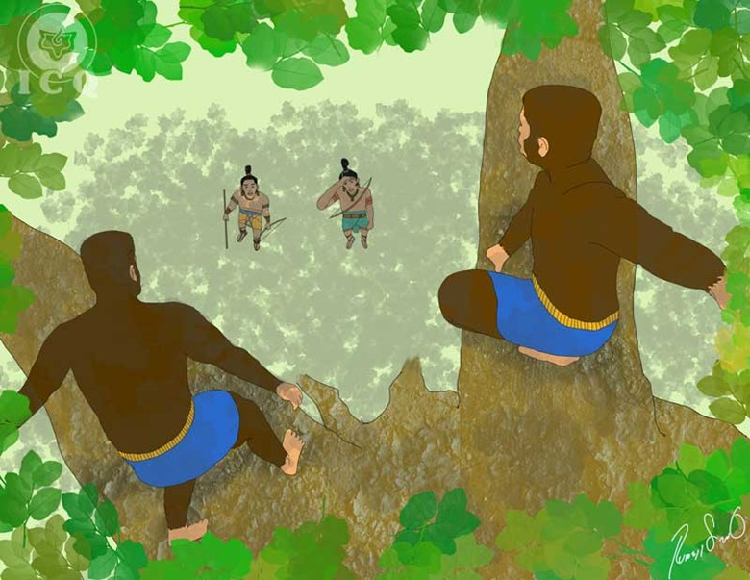
T
he birth of the Twins: Master-Magi (Hunahpu) and Little-Solar-Priest (Ixbalanque) is a magical wonder that must manifest within each one of us.
“The moment arrived for the birth of Master-Magi (Hunahpu) and Little-Solar-Priest (Ixbalanque); they were born on the mountain, the Grandmother did not wanted to see them, and later they were brought into the house, but they would not fall asleep and continually cried, which led the Grandmother to ask of them to be taken outside. Their older siblings, taking advantage of this, left them on an anthill so they would perish, as they were envious, but instead of being devoured by the ants, they slept peacefully. They were later taken into thorny bushes, but instead of these hurting them, there is where they were able to rest the best”
We find of interest the Twins were born on a mountain, as the work that leads us into liberation is generally represented by a hill or a mountain. Anyone who truly makes an effort to know thyself and through their effort they discover, recognize and comprehend their very own mistakes, will earn the right to enter the path to initiation and will experience the miracle of the Twins being born within.
Master-Magi (Hunahpu) and Little-Solar-Priest (Ixbalanque), are a symbol of the development of the principles of the psyche, which is the spiritual level the practitioner reaches as they become ready to face their own inhumane nature.
At the beginning of the work, the birth of the Twins represents a small percentage of free consciousness, which is not trapped within the ego itself. Based on the studies of Gnosis, we learn we typically have approximately 3% of free consciousness.
As we perform the internal work and start becoming liberated from our psychological chains, the Twins come to represent the completely liberated soul and ultimately, the incarnated Intimate Christ. This is why their names speak to the capacity to reach a transformation, of veneration and of wisdom.
The lack of tranquility of the Twins at the Grandmother’s house is representative of the internal urge typical of the one who seeks to learn mysticism, of the ones who are not accepting the routine of their lives and deep down feel there is “something else”; for them life is more than the mere sequence of birth, growth and the eventual death. Whenever we live our lives far from spirituality, the soul suffers and longs for its liberation. The soul is not content with being immersed in materialism.
The ants are a representation of the tenacity and organization required for the work, and seeing the Twins stop crying when left with the ants is a symbol of the calmness experienced by the consciousness as we work intensely in the great work. It is then that the consciousness feels it is complying with its true purpose.
The allegory of the Twins resting within the thorny bushes without being hurt by them is representative of the willpower required to effect the work itself. The thorns, just as we see them in the crown of the Christ, similar to the symbol of the sword in ancient legends, is a representation of willpower without desire, and consistency in the work being done.
“Master-Ape (Hunbatz) and Master-Monkey (Hunchouen), older brothers of the Twins, had inherited the wisdom of their parents, they played the flute, they were painters, sculptors, knew of their own birth and of the birth of their smaller brothers; they were conscious of being successors of the Magi (Ahpu) who were killed in the underworld. Nevertheless, they hated the Twins, were envious of them and mistreated them, though the Twins had never offended them”
Those who have access to spiritual wisdom become inheritors of the wisdom of the Magi (Ahpu); those of us who have in our hands the millenary wisdom of gnosis and do not apply it to our daily lives, but rather prefer to keep it in store as mere theories, will continue their lives with no change. Obviously such a posture will bring misfortune, as what happened to the older brothers Master-Ape (Hunbatz) and Master-Monkey (Hunchouen).
“And they grew up in the mountain: Master-Magi (Hunahpu) and Little-Solar-Priest (Ixbalanque), as their older brothers did not seek after them and neither loved them nor fed them. Every day the Twins brought home birds to eat and their older brothers consumed all of the bounty. But they never got angry, as they knew of their destiny and in its accordance, they acted”.
The attitude of Master-Magi (Hunahpu) and Little-Solar-Priest (Ixbalanque) is the attitude we must assume before all the adversities in life; rather than complaining or blaming others for our misfortune, we mush comprehend that we are the ones to be held responsible for our own consequences. We must learn that blasphemy would never resolve our problems and that in turn, we would be better off sacrificing for others, carrying good deeds to pay the karmic debt we have imposed into ourselves.

The Punishment of Master-Ape (Hunbatz) and Master-Monkey (Hunchouen)
The negative attitudes we exercise against others will always bear negative fruit and if we have the opportunity to carry the ancient wisdom in our hands, but do not put it into practice in our daily lives, then our lives will not only remain stagnant, but our actions will continue to hurt others. Eventually, we will sow the harvest of our own inhumanity.
“Then one day the Twins arrived without birds to eat, claiming the birds were too high on a tall tree, and that only their older brothers would be capable of reaching them. So the next morning they all arrived at the location and effectively, found many birds of diverse varieties, but could not capture a single one of them. The older brothers, Master-Ape (Hunbatz) and Master-Monkey (Hunchouen) proceeded to climb the tree and as they did, the tree suddenly started growing and widening its trunk and branches, making it impossible for them to descend. In an attempt to climb down, the older brothers adjusted their sashes, and were transformed into monkeys, and they ran into the forest”
It is a mistake for anyone who holds a superior knowledge to mistreat their parents, their spouse or their children, or for them to fill themselves with pride and hatred and yet to believe of themselves ‘good people’ just because they have access to superior teachings.
This conduct brings with it degeneration, represented by the monkeys. True wisdom must be demonstrated with clear and definitive actions. If our heart fills with envy because of the progress others make, then all possibilities of us achieving internal development stops.
“Inconsolably, the Grandmother begged for them to return and the Twins stated they could only return if she was capable of passing a test. The Twins were to bring back their older brothers by playing the drum and the flute, but when facing them, she was to remain composed and should not laugh. And the Twins played their drum and their flute and the older brothers returned as monkeys, dancing, but when the Grandmother saw them making faces, she laughed causing the monkeys to run away. On a second instance, the Twins again played the flute and the monkeys returned dancing with their monkeying around, which led the Grandmother to burst into laughter. A third time the Twins played and the monkeys returned; they ran into the kitchen and made grimaces, they spooked each other and the Grandmother, unable to resist, again broke into laughter. The Twins played the flute a fourth time, but this time the monkeys did not come back”
This test given to the Grandmother represents the seriousness and dedication required to perform the internal work. Her inability to hold her laughter is a symbol of the lack of sincerity many practitioners bring as they embark into the path of wisdom; their superficiality and lack of commitment on the Great Work to awaken the consciousness.
Many of us believe that life, which is the path to initiation, should be treated with the trivialities of going to the movies or playing a game for the sake of distraction. The laughter of the Grandmother is representative of senselessness, it is the performing of actions contrary to what we long to become; if we are seeking wisdom, our actions must reflect wisdom. If we seek to get closer to Divinity, each thought, each sentiment and each action should be in accordance to the principles of Love and Truth.
“Master-Ape (Hunbatz) and Master-Monkey (Hunchouen) did many a great thing as they were home with their Grandmother, they were invoked by artisans, singers, sculptors, and painters, yet they degenerated into animals as a consequence of the hatred they allowed into their hearts”
We must strive to manifest love towards each other. Having access to superior teachings brings with it superior responsibility and besides seeing each other as a brother, we must strive to demonstrate to each other fraternal love.
If we become selfish and seek wellbeing only for ourselves without caring for the suffering of others, we will fail. We must make the suffering of others our own and exercise the actions that will help alleviate the wounded heart of humanity.

CHAPTER 6
FINDING THE BALL
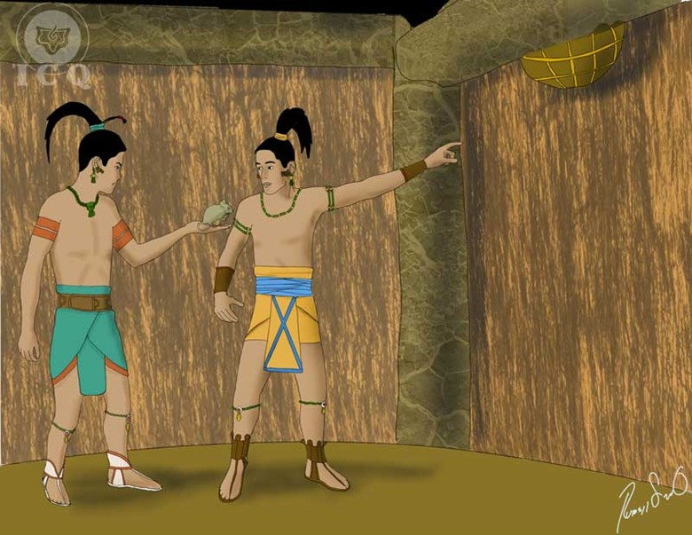
A
s we navigate through the labyrinth of theories that surrounds us, finding the teaching that truly leads us to a total transformation is akin to finding a precious treasure. The search for this treasure may take a whole life or successive lives.
“Now that the older brothers were not present, the Twins Master-Magi (Hunahpu) and Little-Solar-Priest (Ixbalanque) tried to accomplish all of their duties to bring consolation to the Grandmother and be in grace with their mother. First they went to the cornfields and asked for lunch to be brought to them at noontime. As they shove a stake on the ground, the land itself started sowing. The same happened with their axe, they shoved it into the trunk of a tree and the vines and the branches fell and gathered by themselves. Innumerable were the magical prodigies performed by the Twins”
We must strive to be good housekeepers. Anyone who strives for perfection must comply with their duties at home; as a son, a student, a citizen, and a parent. If we are unable to comply with physical laws, how can we expect to comply with the superior divine laws?
The day-to-day job we work to earn our living, the educational studies into which we invest to become professionals, the duties at home, etc. are all part of the responsibilities we must comply with, without looking for excuses, as they make up an integral element of the path towards self-discovery.
“And they placed a dove on top of a tree, so it would warn them when the mother and the Grandmother were close-by, and Master-Magi (Hunahpu) and Little-Solar-Priest (Ixbalanque) laid on the ground and played with their blowpipes while the tools worked by themselves. At noontime the dove sang and immediately one of them threw some wood chips on their head and grabbed the axe to make pretend he was working, the other one dirtied his hands and grabbed the stake and made pretend he sowed. Then the Grandmother arrived, they ate, and went home”
The forces of nature are willing to aid the human being in their everyday doings. The chirping of the birds, the clouds, the wind, the rain, and all of Nature is a great mirror that reflects its current happenings, the happenings to come, and of its mysteries. Our Mother Nature seeks, like all mothers, to care for her children.
Lamentably we have walked away from her and we have forgotten about her. We no longer seek her guidance, as in the past our elders relied on the phases of the moon to embark on their endeavors. Today we ignore the murmur of the wind before rain arrives, just like we ignore the howling and the barking of our dogs when they seek to warn us of impending danger. It has been written in the most ancient books that he who forgets about his mother, in this case Mother Nature, gets lost and falls into serious errors.
“The next morning they returned to the cornfield to find everything was exactly like before they started working; the branches and the trees that had been cut were intact, the same with the vines. The soil was unsowed, rocks were everywhere and a bit annoyed, they started ‘working’ to redo everything. That night they remained vigilant to catch the perpetrator and by midnight, a tiger, a coyote, a wildcat, a rabbit, a deer, and other animals appeared. They spoke to them in their own tongues saying: ‘Trees, grow; vines, rise; rocks, return…’ and as they conjured, the trees grew, the vines rose, and the rocks remerged, and the Twins coming out of hiding, tried to catch the animals, but they all escaped”
It is obvious that as humanity devolves it ignores more of the governing laws of nature and of our mission in life. At times everything seems to be working against us giving us a feeling that what we experience is Karma – the negative consequence of something we had done in some remote past; but not everything is Karma. At times, nature makes an effort to shift us into our vocation and does this by posing circumstances that if observant, will lead us into identifying our true objective in life.
“They were only able to hold onto the tails of the deer and the rabbit, but these still escaped; which is why today rabbits and deer have not tails, as Master-Magi (Hunahpu) and Little-Solar-Priest (Ixbalanque) ripped them away. They were only able to catch a mouse and they tried to choke him by squeezing on his neck, and they burned its tail; that is why today mice have their eyes popped and no hair on their tails… because the Twins burned them. And while they tried to kill the mouse he told them: ‘I must not die due to your hands, and your job, is not to sow the cornfields’”
The mouse is the call of the consciousness to return to the path from which we have stranded, the path of the revolution of the consciousness and psychological transformation. We have been stranded many times before because of our false perceptions of life and now is the time to return to the long-lost path.
“The mouse pleaded for his life, claiming he knew the life mission of the Twins and he asked for food as a condition to speak. ‘Speak first and eat last’ – said the Twins, then the mouse told them their Grandmother was hiding their fathers’ utensils, those necessary for the game of ball, and that she had hid them in the attic, but because these had been the cause of their death, she wanted to keep them a secret. These words brought happiness into the hearts of the Twins and they said: ‘From this moment, corn, cocoa, bean and everything stowed and forgotten belongs to you’ and that is how the meal of the mouse became that, and it was only from that moment-on, and not before, as the Twins said so”
When we seek for it, we discover the path lies within, not in books, or institutions, or people. Just as it is stated in the Greek temple of Delphos: GNOSCE TE IPSUM (know thyself), when the call from the consciousness (represented by the mouse) is felt, it expresses much joy as that is exactly what the consciousness has longed-for, through innumerable lives.
“To not upset the Grandmother they brought with them the mouse, so he would show them where the ball, the ring and the gloves were hidden. As they arrived, they asked their mother and Grandmother to prepare a spicy meal (chilmol) and pretending it was too hoy, they drank all the water in the house and asked their Grandmother to get more… and after her they sent a mosquito (Xan) to bite into the vessel the Grandmother used for such purpose, causing it to leak. After a while, they complained to their mother of their burning and she left the house to aid their Grandmother. The Twins took advantage of their absence, the mouse gnawed on the string that held the instruments of their fathers, and they hid them, and ran to the river to meet their Grandmother and mother who could not stop the leak from the vessel, and they fixed it, and walked home”
Anyone who finds the teachings of Gnosis soon realizes they will have to battle against many barbaric customs and traditions that slowly become considered ‘normal’ and ‘just’ as time goes by. We should remember that certain countries used to consider it ‘normal’ to abandon parents out in a mountain once they reached certain age so they would die; in our current times we see abortion being promoted as ‘normal’. That is why the Twins take ownership of the instruments to play the game of ball of their parents – which represent the instruments or tools necessary to work on thyself – with plenty of persuasion to not upset the Grandmother.
It is with the call of our consciousness and with taking our spiritual longing as the foundation of our strength that we can find the ball (meaning the secret path). Being courageous is how we can retake the path long lost.
CHAPTER 7
THE LOUSE, THE FROG, THE SNAKE, AND THE HAWK
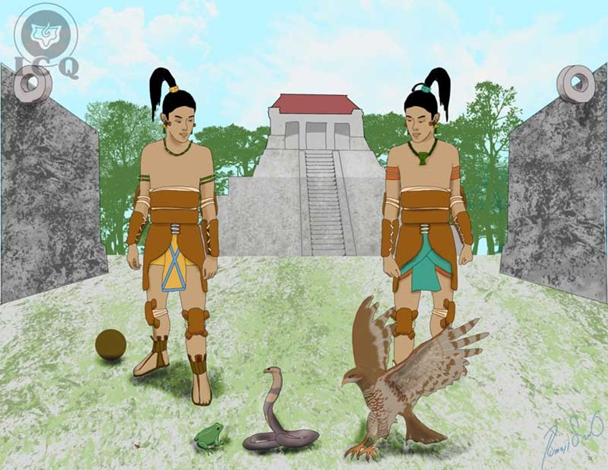
T
here are two types of teaching: the teaching for the eye and the teaching for the heart. We have followed the teaching of the eye (intellect, theories, reasoning, etc.) and only a few have followed the doctrine of the heart (comprehension, meditation, and internal knowledge).
“Soon after the Twins, Master-Magi (Hunahpu) and Little-Solar-Priest (Ixbalanque), went to play ball; they cleaned the fields on which their fathers used to play and soon enough, they started their game. It did not take long for the commotion to reach the ears of the Lords of Xibalba, and annoyed, they once again sent their messengers to notify them they should present themselves for a game of ball in the underworld, seven days after”
To walk back into the path is the most rewarding action we can take. Returning to enjoy of the lost teachings is what our essence longs-for and this, obviously, annoys our psychological aggregates. They immediately see their existence endangered and they will seek, as we could expect, to derail our efforts.
“The messengers of Xibalba arrived at the Grandmother’s house and because the Twins were away enjoying their game, they left the message with her. The Grandmother was devastated as this was the very same way her sons were called… and now her grandchildren were the ones invited to play. She sat down and cried, when a louse fell on her lap. The Grandmother asked the louse to deliver to her grandchildren, Master-Magi (Hunahpu) and Little-Solar-Priest (Ixbalanque) the message from the Lords of Xibalba”
The louse is a symbol of any of our many divine elements that attempts to catch our attention to help guide us. The louse is small, and so is the influence we have been allowing from our divine elements as we put ourselves so far away from them. These are the “gut feelings”, the calls from the consciousness, or “intuits” as the philosopher Emmanuel Kant referred to them. These come to us as attempts from our Divine Mother and our Being for us to receive guidance.
“The louse started walking towards the ball field to deliver the message, but he was not making much progress and on his way, it met a frog called Tzamul. The frog asked where he was going, to which the louse answered he had inside a message he had to deliver to the Twins. ‘You don’t seem to be making much progress’ – said the frog – ‘let me swallow you and once in my belly, I will take you there much faster’… and the frog Tzamul swallowed the louse and started running to go deliver the message”
The frog lives within the waters of life within us. These are the waters that carry the energy that brought us into existence and gave us life, and this water can be transmuted through the love of classical music, art, the wise use of the word, balanced exercise, taking walks in the forest, and by specific systems of transmutation for both singles, and married couples. These systems are a cornerstone of the Gnostic teachings.
When energies are transmuted it becomes then possible to increase our awareness to receive these messages from the Being and the possibility of these to reach the consciousness, increases.
“On his way, the frog Tzamul met the serpent Saquicaz and when the serpent asked where was he going, the frog answered he was carrying a louse in its belly that in turn, had a message for the Twins. ‘Allow me to swallow you… I can get there much faster’… and it swallowed the frog and from that moment-on, and not before, serpents started eating frogs”
The Maya, Aztec and Egyptians consistently allegorized the occult knowledge and for all of them, the serpent is a symbol of occult wisdom. Anyone who penetrates into the wisdom of the Being will develop a higher capacity to receive the Divine teachings.
Esoteric wisdom is not made of candles and tarot cards; the authentic occult knowledge is based on self-knowledge, which is the experiential knowledge we must discover as the only way become capable of receiving what our internal Mother and Father try to show us.
“On her way, the serpent met the Hawk Voc, and when the hawk asked where she was going, the serpent answered that on her belly she carried a frog that in turn, carried a louse, and the louse had a message for the Twins. ‘Allow me to swallow you. I can fly and I can get there much faster’, and thus the hawk swallowed the snake. And it was from that moment forward, and not an instant before, that hawks started swallowing the snakes they find on their ways”
The hawk Voc is a majestic creature and is representative of spirituality and transcendental mysticism.
Reuniting our transmuted energies (symbolized by the frog Tzamul), the occult wisdom (the serpent Tzaquicaz) and transcendental spirituality (the hawk Voc), is how the messages from the Spirit can start becoming one in us.
“And it came to be that the hawk Voc arrived at the ball field, where the Twins, Master-Magi (Hunahpu) and Little-Solar-Priest (Ixbalanque), were playing and yelled: ‘Voc Co!’ (here is the hawk!) and one of the Twins grabbed his blowpipe, and fired, causing an injury to one of the eyes of the hawk. The hawk fell, and as they approached to catch him they asked: ‘Why are you here?’ The hawk told them he had a message in his belly for them, but he needed to be healed first… to which the Twins took a bit of the resin that made up their ball, applied it to the hawk, and it was instantly healed”
Many times we receive messages from our consciousness in the form of hunches and we simply disregard them, underestimating the wisdom of the silent voice of the heart; as the mind intervenes we become blind to the signals from the Spirit.
The healing of the hawk’s eye is akin to us paying the necessary attention as we look within and listen to the wise voice of silence. When we do so we can steer our ship through the stormy waters of our existence.
“And it came to happen that the hawk Voc spat the serpent Tzaquicaz, and in turn she spat the frog Tzamul, and as much as the frog tried, he was unable to spit the louse. Crossed, the Twins kicked the frog, causing the hipbones of the frog to be displaced, and that is why frogs can no longer run but only leap, because of the Twins… and this was from that moment-on, and not before. Then they opened its mouth and noticed it had not eaten the louse, but that the louse was sitting at the corner of its mouth, and because of this is why frogs do not eat lice”
If the human being allowed themselves to be guided by the Voice of the Silence, from those messages that come from the higher planes of consciousness, we for certain would not live surrounded by so much misfortune. This is why the Popol-Vuh emphasizes so many allegories as a means for the teachings to reach deep into the consciousness.
“And the louse delivered the message and the youngsters returned home to find their afflicted mother and Grandmother, but they arrived only to part from, leaving behind two canes planted, one for each one of them… and these were not planted on fertile or humid ground, but at the center of the house, as an evidence of their existence. ‘If they dry then you can say: ‘They have died’, but if they turn green, then you will know we are still alive’ – said the Twins, Master-Magi (Hunahpu) and Little-Solar-Priest (Ixbalanque), as they parted to Xibalba”
The cane is a symbol of the spinal column of man. It is there where the spiritual grades are measured, and when it “dries”, it means we have become dead (lost all superior senses) for the matters of the spirit; and when it “turns green” is an indication that we are working on the vertical path, towards the conquering of our own Being.
CHAPTER 8
THE MOSQUITO XAN
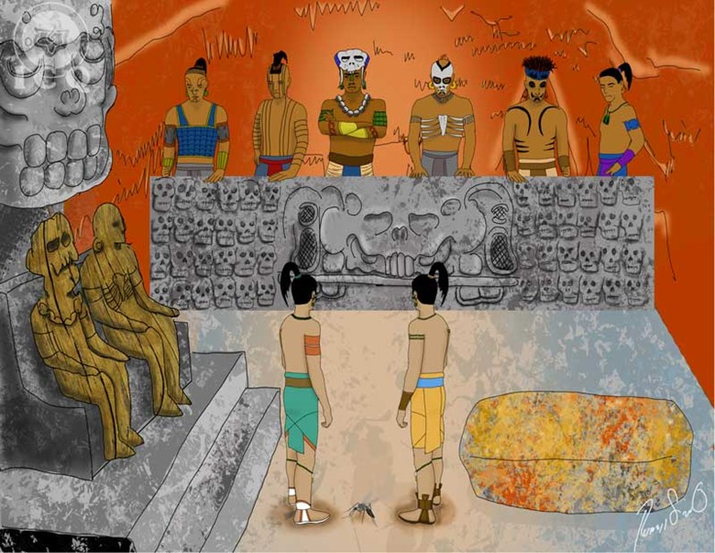
T
here are powerful keys that can lead us into the knowledge of ourselves. These keys are as old as humanity and have been taught by the greatest wise men who have walked the face of the Earth and at times, these have been delivered in symbols, with the intent of having the student discover its different meanings. The application of such effort is what gives so much more value to these keys, and that is the case of the Mosquito Xan.
“With each one of them taking their blowpipes, the Twins descended into the underworld, walking in as their fathers did through the rivers of boiling waters and blood, and using their blowpipes to cross them without their feet touching the waters. Beforehand, they already knew the black path led them to Xibalba”
When we truly seek inner peace and authentic liberation, it behooves us to comprehend our psychological defects. This is only possible when we descend to our own psychological depths to see how we truly are.
What we ignore about ourselves is itself a universe; we believe to have plenty of virtues and it happens we do not. There are defects-a-plenty that we carry within and that we ignore exist within us, and these are living as strong entities within our psyche.
The successful crossing of the rivers by Master-Magi (Hunahpu) and Little-Solar-Priest (Ixbalanque) making use of their blowpipes is a representation of the correct use of the sexual energy. When such energy is used to satisfy the animal passion, the inevitable consequence becomes the misfortune we experience in many aspects of our lives.
“They sent ahead of them, into the cave where the Lords of Xibalba waited, the Mosquito Xan, asking of it to bite each one of the rulers of Xibalba and to particularly listen for their names. And so the mosquito Xan flew into the cave and started biting, first the wooden effigies which made no noise at all, but then managed to start biting each of the other rulers. As they were bitten, each one yelped and called each other by their names; they asked each other what was happening… and the mosquito took note. And it was from that moment forward, and not an instant before, that mosquitoes started biting and sucking blood from their victims. Mosquito Xan was in reality a strand of hair off Master-Magi (Hunahpu)”
The mosquito Xan is a symbol for the sense of psychological self-observation, its flight path is the direction of our attention towards the inside (the inside of the cave) with the purpose of self-discovery. Normally we observe ourselves towards the outside, we pretend to know others very well, but there is plenty we ignore about ourselves.
Our defects manifest at will making use of our mind, our sentiments, our instincts, our habits, and the force of our sexuality. Their manifestation is blatant, because their presence is unknown to us, and they trick us in a variety of ways: behind the desire to work, lurks the defect of greed and under the cover of friendship lurk the desires of lust. That is why the Lords of Xibalba show first the wooden effigies before they can be seen. The effigies are a symbol of those sublime appearances the psychological defects project that lead us into error.
As we direct our attention towards our interior and when we divide our attention between the observer and the observed, we discover the fallacies of the ego, the many ways in which the ego confuses and tricks us, and the mechanisms of operation it employs. As we reach new levels of understanding of our defects, we slowly stop behaving as their puppet.
To know the names of each of the Lords of Xibalba (as narrated in the story) is akin to put our efforts into self-discovery. It is a representation of focusing our effort not only to identify the thousands of “I’s” or psychological defects we carry within, but to also learn about their structure, their transactions, what feeds them, what springs them into action, etc.
It is said the mosquito Xan is a strand of hair from Master-Magi (Hunahpu), which means that the work of self-discovery is individual and particular and no one can do it for us. It requires of great intimate super-efforts for us to route our attention towards the inside of our psyche to achieve self-knowledge.
“As they arrived to the cave, they were invited to pay reverence to the wooden effigies, but Master-Magi (Hunahpu) and Little-Solar-Priest (Ixbalanque) do not fall for it, and instead they started greeting each of the Lords of Xibalba by their names: ‘Greetings Supreme-Death (Hun-Came), greetings Principal-Death (Vucuc-Came)”… and later they called by name each of the ten princes, and all of the Lords of Xibalba were astounded”
When we discover the defects we carry within and the effort of studying them in our daily living – whether at home, school, work, etc. – gives us the necessary comprehension enables us to make use of a power superior to the mind that can eliminate them. This power within us, here and now and is our Divine Mother. Every defect eliminated through her intervention liberates a percentage of our consciousness and this repeated process leads us into living life in plenitude to eventually achieve true happiness.
Let us remember that among the ten princes were MAKER-OF-MISFORTUNE, MAKER-OF-TREASON and MAKER-OF-JAUNDICE. As we discover our defects, we start finding that through their consequences, we create our own misfortunes, our own problems and our own illnesses. Only through conscious work and conscious effort we can eliminate them. The answers to all our problems are inside of us, not outside.
“Because they were unable to trick the Twins, they invited them to take sit on a previously heated stone, so they would burn and thus, defeat them. But Master-Magi (Hunahpu) and Little-Solar-Priest (Ixbalanque) noticed their intent to deceive them, and easily avoided it”
The Lords of Xibalba invited them to take seat on the “bench of the great masters”, offering them a simulated honor, but in reality it was a heated stone.
This stone is the stone of stumbling, and rock of offence mentioned in the Bible, that when heated, represents the brutal animal passions our defects use to keep us subjected to their control, making us victims of their delinquencies. A good example of this is adultery, which has always brought Dantesque dramas into families and their homes.
In these times of crisis and bankruptcy of values we tend to believe that it is acceptable to give free rein to our vices and we tend to believe we are great personalities when we express such defects, yet we fail to realize we become a source of both suffering and pain.
However, when we remain alert, like the vigilant guard at times of war, we become capable of both, not identifying with and overcoming the temptations frequently taunt us throughout our lives.
“As the Lords of Xibalba were defeated, they invited the Twins to spend the night in the House of Darkness (one of the many traps they had set to defeat them), so they could rest. The next morning was planned the game of ball”
Our psychological defects are very crafty with their means to keep us within their domain. The Popol-Vuh not only shows us the dangers, but also the means for us to overcome the dangers themselves and overcome the temptations.
CHAPTER 9
THE HOUSE OF DARKNESS AND
THE HOUSE OF THE SHARP BLADES
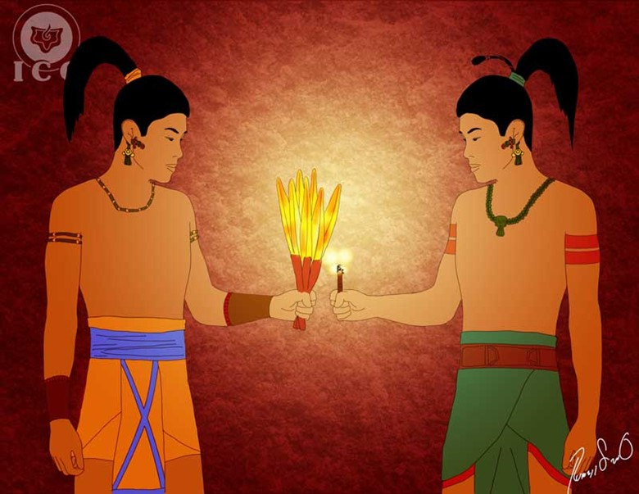
A
s we have seen, the Lords of Xibalba (our psychological defects) have six houses used to defeat their enemies: The House of Darkness, The House of Sharp Blades, the House of Coldness, the House of Tigers, and the House of Bats. These are all symbols of the systems and mechanisms used by the ego to invite us to quit our efforts towards transformation and liberation.

The House of Darkness (Quequma-Ha)
“The Lords of Xibalba ordered the youngsters to spend the night in the House of Darkness and feeling this was the first step towards defeating them, they took for each of them a cigar and a branch of ocote, requesting those were returned the next morning; but the Twins did not use them. Instead they placed some feathers of a macaw over the ocote and some fireflies in the cigar. The next morning, considering them defeated, the Lords requested their artifacts to find out these were intact”
Practically all of humanity is currently deep within the House of Darkness of Xibalba; most people are trapped within the labyrinth of theories and beliefs without having access to the light of Gnostic Wisdom, trapped within the darkness of ignorance. There are many others who would love to never again get drunk, but they lack the keys that would lead them to abandon the vice; many others would love to not be angry all the time, and they lack the adequate technique to achieve their goals.
Yet when the opportunity arrives for many to receive the light of wisdom, they develop a perception that the teaching or the practices are too difficult, and thus start becoming satisfied with illusory and transient teachings, like the fugacious light of the ocote that lights quickly, but just as quick burns out, leaving them back in the darkness.
The problem is that though some people want to change, the fact they lack the keys to effect a true transformation, leads the ego to promote its darkness hanging on to the abundance of pseudo-esoteric and pseudo-occult schools that promise the awakening of chakras, happiness, virtues, and other delightful ideas… yet people go through them and they remain the same.
Those who embrace the Gnostic teaching and who truly make a conscientious effort to work upon themselves, slowly start breaking out of their golden cages – the cages that lead the student down a path of illusions that leave him lost in the desert. They are false fugacious lights that only spark our excitement, but do not take the student anywhere useful.
“Feeling anger in their hearts, Supreme-Death (Hum-Came) and Principal-Death (Vucuc-Came) asked the youngsters from where they came from. The youngsters stated they did not know, and remained silent”
The statement of the youngsters ignoring their origin is representative of the innocence of a child; we must conquer our lost innocence and unlearn our intellectualisms and reasoning’s. We must become simple, noble and intuitive.
“Then they faced each other at the ball field. After discussing it, the Lords of Xibalba asked to play first with their ball, as they clutched their flint knives with the intent of killing the Twins, but the Twins noticed, and they made pretend they were leaving… and seeing this the Lords of Xibalba begged them use their own ball and stay. The Twins scored as they got their ball through the hoop of the Lords of Xibalba, and defeated them”
The religious ball field is where the human being holds their true battles between the spiritual and the sinister forces. This is the psychological gymnasium of life, where the ego attempts to eliminate the values of the soul; this is where the ego attempts to stop the manifestation of comprehension, humbleness, mercy, altruism, etc.
When we remain on a state of Alert Novelty and Alert Perception, we can effectively see when the Lords of Xibalba clutch their knives, meaning that we can effectively see when our defects attempt to take control of our mental, emotional, and willful processes.
We can finish our days victoriously, but only at the expense of an intensive state of self-vigilance. Our effort must be focused on defeating our own inhumanity every day.

The House of the Sharp Blades (Chayin-Ha)
“The second house where the Lords of Xibalba defeated their enemies was the House of Sharp Blades. In addition of having to spend the night in it, and to ensure they would certainly defeat the Twins, the Lords of Xibalba ordered the Twins to gather four small vessels and fill them with black, white, green and red flowers… but the only flowers available in all of Xibalba were from the garden of Supreme-Death (Hun-Came), so the Lords ordered a group of nocturnal birds to stand guard and to guard them closely, making the task practically impossible”
In addition to the four paths mentioned in this story, this task once again invokes the colors of alchemy disguised as the colors of the flowers. What this tells us is that in the effort to eliminate our psychological aggregates, there are tasks we must perform multiple times, each time at a higher level of consciousness.
When the colors of alchemy are associated with flowers, it refers specifically to the completion of a superior work, as many defects are so subtle in their nature they go unnoticed, yet their effects are just as catastrophic as of any other defect. To be able to detect and study these subtle defects, the practitioner is required to complete the same tasks again, but at a superior Level of Being.
“Even though the Lords of Xibalba wanted them dead, the Twins remained calm and enthusiastic, and they walked into the House of the Sharp Blades, where they found blades everywhere. The Lords of Xibalba wanted them to die immediately, torn apart by the blades; but as the Twins walked in they told the blades: ‘Yours will be the flesh of all the animals’, and they remained still”
The name of this house (Chayin-Ya) includes the Quichen-Maya word “Cha”, which means blade, spear, glass, but that also means “to speak” or “to say”, and this allows us to deduct one of the additional systems of the ego to derail the practitioner from the path of self-realization.
That system is the incorrect use of the word; when we help spread gossip, when we raise false testimony, when we curse, when we criticize our neighbor, when we insult others, when we utter morbid words, etc.
It may seem as if the incorrect use of the word, similar to when someone tosses a stone and hides their hand, were irrelevant, yet we must remember that since the beginning all of creation has been the product of the Word. It should suffice to say:
“In the beginning there was the Word,

And the Word was with God, and the Word was God”
The incorrect use of the word will always crystallize against us with situations and environments that will invite problems and that will keep us from working the internal path. The Master Moria also said: “Murmuring separates us from esotericism”.
So it comes to be that this is the meaning of the second house of torments of Xibalba; if we do not change our ways of speaking, if we are not careful with the use of the word, the wrong action will lead us into spiritual death (loss of superior senses). To the contrary, when we put all of our effort into the deep comprehension of every defect that invites us to make incorrect use of the word, we will naturally emerge victorious from the torment of the House of the Sharp Blades.
“And the Twins invoked the cutting ants (zompopos) so they would be the ones cutting off the flowers; and the nocturnal birds never noticed the presence of the ants doing their work and inclusive, the ants even cut off the feathers from the birds’ tails and wings, and in vain they screamed: ‘Ixpurpuvec! Punhuyu!’… and yet, no one was scared away with their screams”
Ixpurpuvec and Punhuyu are to this day the names the Maya use to name the owl, based on the noises these birds utter.
The cutting ants are a symbol of the esoteric work; the ants are consistent, organized and work with intent. In such a way is how we must carry our internal work so we can generate a transformation at every moment of our lives. The purposeful work is what allows us to fill our four vessels with flowers and defeat the Lords of Xibalba.
“The next morning the youngsters showed up with the four vessels filled with flowers and moist with morning dew. The Lords of Xibalba grew pale and called in the guardians of the flowers, and tore their mouths in punishment, and that is why to this day, owls have a broken beak”
The flowers are a symbol of the essence that remains trapped by our psychological defects; love is trapped in hatred, diligence is trapped in laziness, temperance is trapped in gluttony, altruism is trapped in greed, happiness for others is trapped in envy, and chastity is trapped in lust.
That is why Supreme-Death (Hun-Came) and Principal-Death (Vucuc-Came) have a garden full of flowers; the flowers (values) of our essence are under their custody (trapped in them).
The nocturnal birds represent the sinister forces of the ego and they are what keep us submerged within the sleep of the consciousness.
“Then they went down to the ball field, and playing two ponits, then ended it, agreeing to play again the next morning”.
The fight is incessant, day to day, against ourselves, we should not guard down, we should be ready to fight our interior Universe, against the evil forces that we have created.

CHAPTER 10
THE HOUSES OF COLDNESS, FIRE, TIGERS AND BAT
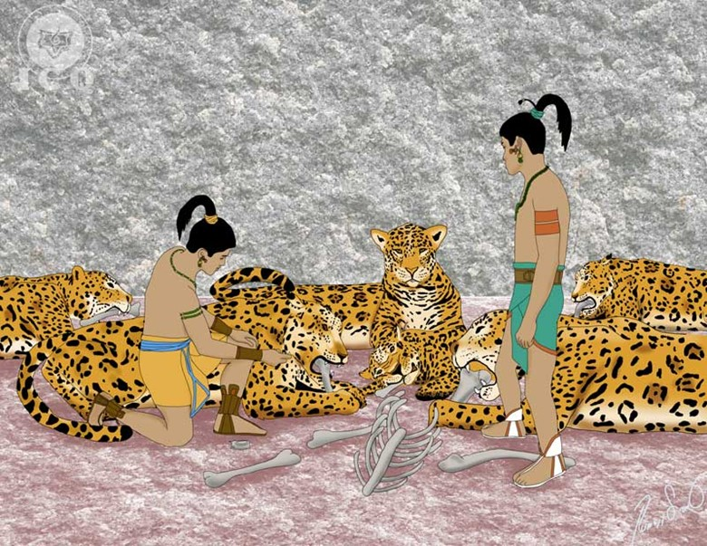
W
e normally think that the obstacles in life and those obstacles that exist for us to achieve perfection, are caused by others, maybe by our family, or the goverment, or maybe by our neighbours or those who we imagine, are willing to harm us, maybe because they envy us, etc., but the Popol Vuh is pretty clear when it tells us that our worst enemy is already within.

The House of Coldness (Xuxulim-Ha)
“And then they walked into the House of Coldness, and there was only cold and hail, but the Twins were not defeated as they used old trunks to dissipate the cold and survive. The next morning the Lords of Xibalba were perplexed as the Twins were still alive”
One of the favorite systems employed by the ego to separate the practitioner from the path of knowledge is the spiritual indifference (cold), the lack of mystical enthusiasm for the interior work and for the study of Gnosis.
It is common for the aspirant of wisdom to ‘cool off’ regarding their internal work; all of a sudden the teachings become arid, repetitive and tedious – a clear indication that the ego is working intently against the practitioner. When this happens, we are with no doubt trapped in The House of Coldness, where there is only hail present (the lack of a mystical longing).
Gnosis is as vast and profound as eternity, it has no beginning and no end, its limit is Divinity and there are no limits to Divinity. We could spend several of our existences studying without ever grasping its profound meaning, but when we walk into the House of Coldness, everything becomes monotonous and we simply walk away from the gnostic esoteric work.
The “old trunks” are a representation of what can sustain us in the practical application of the teaching; this is the actual experience of all things, the deep comprehension required by gnosis that goes beyond the limits of the intellect to penetrate into the heart. These old trunks show us the need of the direct mystical experience.
When we consistently experience the postulates of wisdom Gnosis teaches, we liberate ourselves from the spiritual indifference imposed by the ego.
Ineffable music, the happiness of the soul, love, infinite tenderness, consistency and order in our practices keep us away from the Lunar cold.

The House of the Tigers (Balami-Ha)
“Then they took the Twins to the House of the Tigers and left them there, hoping the tigers would devour them, but as soon as they walked in, the Twins told the tigers: ‘Don’t bite us, we have something that belongs to you’, and they gave them a bundle of bones. The tigers devoured the bones, and the sound of the gnawing reached the ears of the guardians of Xibalba. And they rejoiced as they thought the Twins had finally been defeated. Yet the next morning the Twins walked out intact. ‘From where do these Twins come from?’ – said the Lords”
The tiger has been considered a sacred beast by the majority of the cultures of the world. It is commonly associated with many internal aspects of the human being, such as wisdom, spiritual strength, courageous wildness to combat our weaknesses, etc., but the tiger has also been associated with temptation. Obviously it is the concept of temptation what is addressed by the House of the Tigers.
Temptation is a particular test, than when overcome, enables the emergence of a virtue, or a power, a gift. Temptation is fire, but overcoming temptation is light.
When we pray the PATER NOSTER (the Our Father Prayer) we do not ask for temptations to be taken away, instead we ask “lead us not into temptation”. Without the battle and without the contrast, if temptation were not present to be confronted with the rigorous esoteric discipline, virtues would not emerge.
The stronger is the temptation, if we defeat it, stronger would then be the resulting virtue. But to achieve that victory we must hand the bones of the animals; as we eliminate our defects associated to lust and we assume ownership of their “bones”, we become capable of keeping the tigers of temptation from devouring us.

The House of Fire (Hachi-Gag)
“Then the Lords of Xibalba ordered the Twins to walk into the House of Fire, where there only was an incessantly burning fire, but Master-Magi (Hunahpu) and Little-Solar-Priest (Ixbalanque) did not burn, only the embers and the logs burned. And the next morning the Twins walked out of the house intact, completely discouraging the Lords of Xibalba”
Among the Egyptians were always discussed the four trials of the elements, namely the tests of fire, water, air and earth. The successful completion of these tests was a requirement to enter into the schools of mysteries, as they qualified the morality of the candidate. The marvelous musical composition titled The Magical Flute of Mozart captures these facts.
Back in the ancient Egypt and yet today, serenity and sweetness of character are tested by the test of fire. The ability to face with serenity the different events of our daily lives is an essential trait of every aspirant of the light.
Yet those who delight in ire, those who respond violently to the different circumstances of life, and all those who are unable to remain serene, lamentably fail on the test, and are devoured by the flames of the House of Fire of Xibalba.
Master-Magi (Hunahpu) and Little-Solar-Priest (Ixbalanque) are not burnt in the House of Fire because – as they say in Egypt: they had “earned the lion claws of the sphinx”. They had the courage or the spiritual strength to exercise temperance and serenity. This is the key to emerge victorious from the test of fire.

The House of the Bat (Tzotzi-Ha)
“The last of the houses of torment of Xibalba is the House of the Bat. Only bats live in the house of the bat God (Camazotz), whose instrument to kill was a dry pointed spear which instantly killed anyone who stood before it. But the Twins safeguarded themselves inside their blowpipes; though the bats wheeled and shrieked ‘qulitz, qulitz’, the Twins remained inside their blowpipes”
The House of the Bat is an allegory very applicable at this present day.
We, as vampires, know very well how to act against our neighbor when we launch against them, turning them into our victims; not only do we consider our enemies our victims, we do the same to our parents and to our brothers and sisters, to vampirize their values.
An example of this is seen on those who regardless of the age of their parents, continue to live at their expense and at the expense of their vitality.
Ingratitude and betrayal are sisters; it is of utmost importance to become grateful, to show gratitude for the work and sacrifice of others, yet we are extensively selfish and living in ignorance.
“From the heavens descended the bat God (Camazotz) with the sole purpose of teaching the Twins how to overcome the torment of this house and to show them how to defeat the Lords of Xibalba. He suggested they should mimic an apparent death”
Among the Aztec and the Maya, Camazotz is the bat God, a great master who assists those who seek to confront themselves to recognize their own mistakes. This is the very first trial given to the candidate as they ready themselves to receive the light of wisdom. This is what is known as the test of the Guardian of the Threshold.
The Eagle Knights and the Tiger Knights of ancient Mexico were required to submit themselves to certain tests in the cave of the bat God (the Tzincalli). They were only able to reach the sublime grade of a Eagle- or Tiger-Knight only if they were capable of seeing themselves as they were and not as they thought they were; the tribulations they endured were meant to reflect the level of advancement they had achieved because of their internal work and only through this demonstration, they were able to transcend as authentic warriors of life.
“Then there was silence, and believing sunrise had arrived, Master-Magi (Hunahpu) peeked outside of his blowpipe. As he did that, he was immediately beheaded and by order of the Lords of Xibalba, his head was placed at the ball field”
The presence in the House of the Bat has a dual meaning; it also shows us that we must confront our own mistakes, as this is what leads us out of the darkness into the light. It emphasizes the work that must be endured within our own psychological darkness.

CHAPTER 11
THE WORK WITH THE ANIMALS
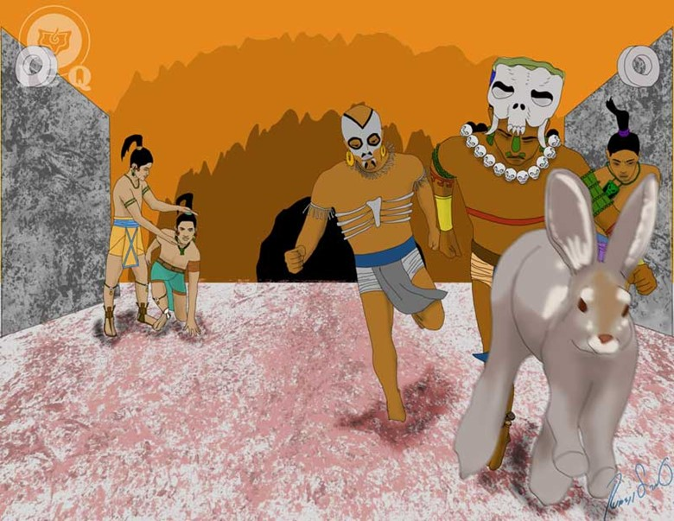
A
nimals have traditionally been a favorite element to convey ideas, virtues, defects, works, and those things intangible to our psychology. These faculties have been represented by particular characteristics of some animals and thus, including them in allegories has always been an instrument to impart teachings.

The Tortoise
“Then, Little-Solar-Priest (Ixbalanque) called upon all the big and small animals of the forest, so each one would select their food and finally, the tortoise arrived. Leading next to the body of Master-Magi (Hunahpu), it took the shape of his head and soon after, eyes were carved on it. Many wise ones descended from the Heavens, and from heaven the Heart of the Heavens (Hurakan) descended”
The animals of the forest represent both, the elemental forces of nature that concur to help they who know how to invoke them with their heart and soul, and also the virtues that must be put into practice on our daily lives.
The 3% of free consciousness we have is of no good to us unless we truly make use of it in our daily interactions. The Magi invoke all of the animals of the forest so they can choose what nourishes them, and that is a symbol that speaks to how we should work the values of what is left of our free consciousness.
The Tortoise, among the Maya, symbolizes the universe, but in this narrative it refers to the patience that must be upheld in the internal work that is necessary for our transformation. The radical change we must manifest does not happen overnight and it requires of both tenacity and patience.
This type of work is one that cannot be done simply by oneself, as any efforts will lead us into the consideration of self-sufficiency, conceitedness and the belief that we somehow are the center of the universe. We always need of a superior divine intervention as the one represented by the Heart of the Heavens (Hurakan). This is both our internal Father and Mother who constantly watch over us. We need to invoke of them, so they also partake on every action we start.

The Buzzard
“It took some time to shape his face, but the end result was remarkable, his hair turned out beautifully and the face could even speak; and because it was about that time for sunrise where everything was assuming a red hue, they told the buzzard: ‘Darken again, old man’; and again everything went into darkness, and just like that, in the freshness of dawn began his existence, it truly looked like his head. ‘The buzzard has darkened’ – is what people say today”
Putrefaction is mentioned in alchemy and is associated to the “black” of the crow, and in this instance it is symbolized by the buzzard. For virtues to crystallize within the soul of man, every aspect of our inhumanity, beyond dying, must also putrefy and degrade into nothingness. The buzzard represents the work we do with “the night”, with darkness, with Saturn. It is allegoric to those infra-human elements we would never suspect having within but that in reality, we carry with us.
At those critical times when events such as war, draught, floods, and famine manifest, we can easily see how those infra-human defects we would never think would exist flourish. Then we observe theft, arson, vandalism, violence, murder, etc.
We must work to eliminate from within not only the visible aspects of the ego, but also the invisible ones; and that is the work with the buzzard as it feeds itself off cadavers and carrion and these, in turn, are the most sordid and dark aspects of our internal psychology.

The Rabbit
“And they got into an agreement and Little-Solar-Priest (Ixbalanque) told Master-Magi (Hunahpu) to make pretend he was playing, but that he would take care of it all. Then he addressed the rabbit ordering him to be present at the ball game and to hide in the tree line. He was told to jump and run whenever the ball landed close to him”
The Rabbit represents the diligence of the work; no procrastination, not waiting until tomorrow, but action at present-time. It implies avoiding pretexts and justifications that would delay the internal transformation, leaving laziness aside and doing what is necessary to not be negligent. The illness we may face tomorrow is something that must be unearthed today. The focus of our effort must be here and now.
“And so started the ball game with the Lords of Xibalba, as they mocked the Twins thinking of themselves already victorious. The ball then landed close to where the rabbit was hidden and it leaped and ran taking the Lords of Xibalba with him. Then Little-Solar-Priest (Ixbalanque) took advantage of the distraction and replaced Master-Magi’s (Hunahpu) head on his body and the Twins rejoiced, and when the Lords of Xibalba returned, they were astounded. Lastly, Little-Solar-Priest (Ixbalanque) tossed a stone to the turtle that then hung where the head of Master-Magi (Hunahpu) used to be, and it fell breaking itself into pieces. The youngsters overcame all of their tests and defeated the Lords of Xibalba”
With patience (the tortoise), working to eliminate from within our deepest defects (the buzzard) and working here and now, with no delay (the rabbit) is how we can make progress on the death of our psychological defects.

CHAPTER 12
DEATH AND RESURRECTION OF THE TWINS
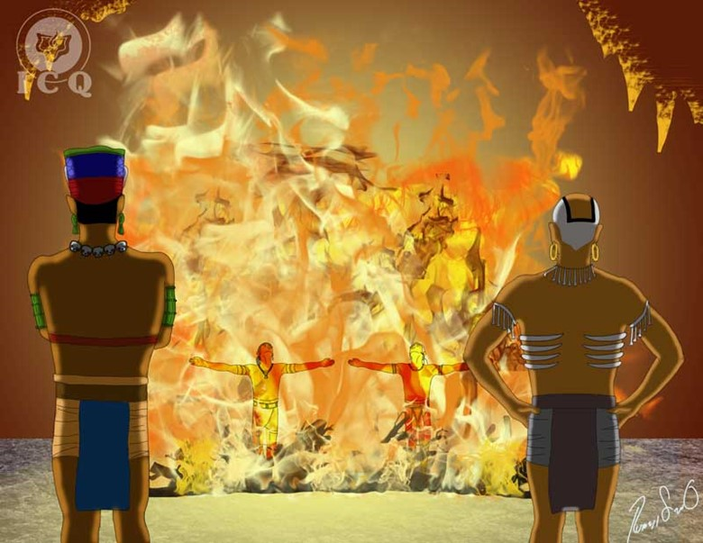
S
acred books, legends and myths of antiquity show the many meanings of “death”. At times it speaks to death as the lack of spiritual values, but it also refers to “death” as the need to shift away from everything that is illusory in nature, and to the elimination of the wickedness we carry within in hidden parts of our psychology that today we do not even consider exists.
“And the Twins did not die because of the torments or the ferocious animals of Xibalba. They invoked the sages and seers Xulu and Pacam, because they knew their death by fire was near. They asked the sages to answer ‘no’ when the Lords of Xibalba asked them if their bones should be thrown off a cliff or hung from trees: ‘no, as they would be reborn’; and to answer ‘yes’ if they were asked to have their bones thrown into the waters, but to request their bones to be milled on a stone, each one separately, and to pour them where the river is born so the waters would disperse them throughout all of the mountains, big and small”
If we seek for the elimination of our psychological defects, then we need of a series of procedures that can work and complement each other. We need of psychological self-observation, focusing our attention towards the inside of our psyche, but we also need of meditation to go deep into the analysis of the transactions and structure of our egos. Beyond that, we also need to work with the fire and the water.
Our many “I’s” have a tremendous power over us and we need of a superior force to destroy them. Fortunately we have that force, with us and in us, and it is symbolized by the fire of our particular Divine Mother. It is this superior force the one that can actually destroy our psychological aggregates, but only through the comprehension that comes from self-observation and meditation.
The maximum power that can be used for our Divine Mother to eliminate our defects comes from the work with the water – our creative energy. If we learn to channel and transmute those energies, we can make significant progress in this work.
“Then a great fire pit was set, with thick trunks to enliven the fire. The Lords of Xibalba sent their messengers to bring and burn the Twins. Master-Magi (Hunahpu) and Little-Solar-Priest (Ixbalanque), knowing of the proximity of their death, walked decisively down the path. The Lords of Xibalba wanted to have some fun with them, but as the Twins arrived, they faced each other, extended their arms, and voluntarily threw themselves into the fire”
Quetzalcoatl created a fire pit and immolated himself to later be transformed into Venus, the Morning Star. Hercules also created a fire pit on Mount Eta to incinerate himself.
This is all a clear signal on the path we must follow. For us to achieve the Buddhist Annihilation, we must rely on observation and deep comprehension to enable the fire of our Divine Mother to eliminate the elements that make up our inhumane second nature.
“And the Lords of Xibalba celebrated the death of the Twins: ‘We have finally succeeded’ – they said, and they addressed the sages and the sages replied with what they had been told. So the Lords of Xibalba milled the bones on a stone and tossed them on the river, but the remains did not travel far, as they settled at the bottom of the waters. And they transformed into beautiful youngsters, and they had the same faces as Master-Magi (Hunahpu) and Little-Solar-Priest (Ixbalanque)”
The Phoenix emerges from its own ashes, stronger, much glorious than before.
The Twins are first burned, showing us we must endure the death of all our defects; and when their bones are tossed in the waters, it shows us the work that must be done with the pure waters of life; those are essential elements for an authentic radical transformation. The bones are a symbol of death and being tossed in the waters is a representation of the use of our sexual force to battle our ego.
To complement all that has been said so far, the fire is the eternal masculine principle and the water is the eternal feminine principle. When these forces are wisely combined, in a matrimony, but without spilling these waters, we can open any door and become holders of a key that can open all empires.
This work invites us to return to become one with our Interior Being and recover our long lost inheritance. We must realize this physicality, though part of us, is not all. There is a spiritual realm of existence that we must strive to conquer and these writings from the Popol-Vuh give us the secret on how to achieve so.
CHAPTER 13
THE DEATH OF THE LORDS OF XIBALBA
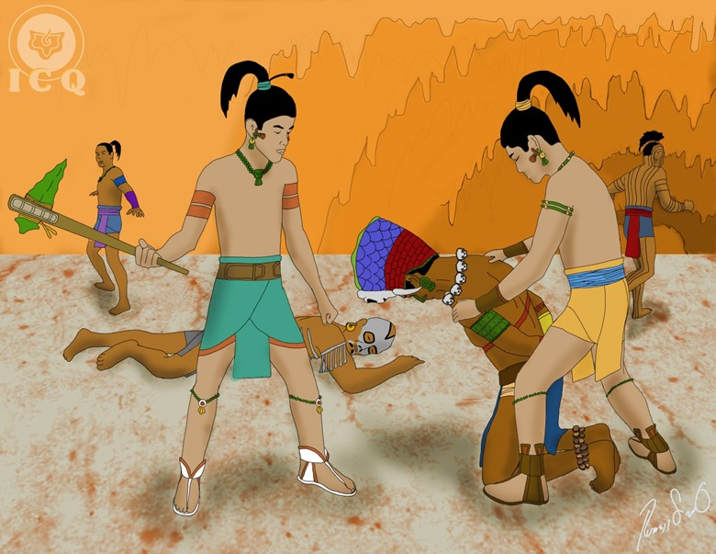
A
ll that has been shown in this book allows us to bring to an end our internal Babylon. These psychological defects we must eliminate are the Egyptian Red Demons of Seth and the 400 southerners spoken among the Aztecs in the myth of Huitzilopochtli. They are the source of our inhumanity.
“And on the fifth day they appeared, they were seen in the waters, and they had the aspect of mermen”
The Five represents The Law, the water are the creative energies, and their fish-like aspect is reflective of the intense work that we must realize with the waters throughout our lives as part of the Perfect Matrimony. We must learn to use our creative waters wisely, without spilling them (without eating of the forbidden fruit).
“The next day, two poor men appeared, their faces aged, their aspect miserable, and they were dressed in rags”
Humbleness is the door to reach wisdom and once reached, we then have to become even more humble. As long as we are “rich”, it would be impossible for us to walk into the Kingdom of Heaven (the superior states of consciousness); and we are rich in theories, concepts, prides, vanities, self-importance, and self-sufficiency.
One of the worst defects is that of mythomania. This pathological liar leads to the delirium of believing one is the reincarnation of or a savior of humanity, it brings the consideration of oneself being a great master, a very old soul, to be the selected one with a very special mission in life, etc.
The airs of grandeur, the belief that we are superior, believing that ‘at least I’m not like my neighbor’ or ‘not like my co-worker’, is a sure sign we are walking down the wrong path.
It is impossible to make a change if we already believe we are good people. Our first step must be the acknowledgement that we live in a very lamentable state of constant daydreaming and in a deep sleep of consciousness.
“The two homeless did not do much; they danced the dance of the owl, the dance of the weasel, the dance of the armadillo, the dance of the centipede, and the dance of walking on stilts”
Dancing has always been considered sacred and a means to transfer information directly into the emotional center. The purpose of the sacred dance has been to teach the great wonders of nature and the mysteries of the universe and the human being. It should suffice to remember the dances of the whirling Dervishes who imitated the travels of the planets around the Sun.
Yet for this to be effective, dance for such purpose must be performed inspired by the aroma of mystical longing, with no financial interest or a desire to profit from it; it should be done only out of love for humanity. Because as we put into practice positive emotion, we comply with the words of the Great Master Jesus when he said: “Love thy neighbor” demonstrating love with action.
They dance a variety of dances meaning the teaching must be delivered wholly, without taking anything away from it, as the truth, tough as it is at times, is our very best friend.
“And they performed prodigies; they burned houses and instantly restored them. They would kill each other and then resurrect. The Lords of Xibalba looked at their deeds with amazement”
Such prodigies, as the ones realized by the Great Master Jesus on the Holy Land, are the portent each human being possesses in potentiality. The liberation of certain percentage of trapped consciousness from within our defects enables us the capacity to perform miracles.
“These wonders reached the ears of Supreme-Death (Hun-Came) and Principal-Death (Vucuc-Came) and they called for them, but the Twins made pretend they did not want to go and the messengers dragged them by force. Once before them, they were commanded to ‘do their thing’ and their immediate action was to perform the different dances they knew; and all those from Xibalba gathered around and watched them”
It may seem that the work done uninterestedly for the benefit of others has nothing to do with the elimination of our defects, but that is an incorrect consideration. Uninterested service is a tool that helps both ways: the one who receives the help and the one who offers it, as the more is given, the more is received.
Superior intelligences, whether we call them angels, masters, or superior beings, will inevitably help on the internal work of anyone who generously helps others. These dances and prodigies (the sacrifice for humanity) enable receiving the necessary and sufficient divine help to help terminate the Lords of Xibalba.
“Then Supreme-Death (Hum-Came) asked for his dog to be sacrificed and then resurrected and the youngsters immediately agreed; they killed the dog and brought it back to life, and the dog was very happy to be back alive”
In Greek mythology there is a dog called Cerberus; he is the dog that accompanies the defunct to the Mictlan (the Aztec Hell). Cerberus and Supreme-Death’s (Hun-Came) dog represent the very sexual impulse that must be liberated from the sinister forces of the Ego. Giving it death means just that: liberation from the grasp of the Ego. Returning it to life is akin to putting that sexual energy to its right use – bringing an end to lust.
“Supreme-Death asked for the destruction of his house and everything within it and of course, to see it all restored immediately; and Master-Magi (Hunahpu) and Little-Solar-Priest (Ixbalanque) burned it, instantaneously restoring it and everything in it, inclusive of the people who were inside”
The house of Supreme-Death (Hun-Came) is our cold, lunar, ghostly body that serves as the realm of the Ego and what they use to manifest their desires from moment to moment. We must destroy these lunar bodies and to bring them back to life, means that we must transform them into bodies of splendor – into the Solar Bodies or the Wedding Garment of the Soul that enable the manifestation of the Innermost.
“Then they killed a man, removed his heart and raised it to the heavens; and with their dances and their magic they returned him back to life, and the man was very pleased”
The act of raising (or “offering”) a heart towards the heavens is a symbol that the work is not meant to be done intellectually; we must truly sacrifice the lower emotions of hatred, fear, vengeance, jealousy, envy, etc. The sacrifice of these emotions involves the willingness to endure serious emotional grievances.
“Finally, Little-Solar-Priest (Ixbalanque) killed Master-Magi (Hunahpu), removed his arms, his legs and his heart… and then resurrected him”
This last action is profoundly significant, as the revolution of the consciousness requires of us to terminate all attachments with those close to us. Our attachments cannot and must not be confused with the authentic love we must feel for them, to the contrary, authentic love will only emerge with the deep comprehension of the egos that develop our attachments to others.
As we study them closely, we learn that in our attachments we find egos of dependency, of self-love, vanity, fear, and dozens of others. Authentic, true love is completely disinterested; in it we find sacrifice: nothing is asked for self and everything is meant for the benefit of others.
“And so it came to be that the Lords of Xibalba felt the desire to experience the power of this magic for themselves: death and resurrection, and they asked the Twins to realize these prodigies in them. So Master-Magi (Hunahpu) and Little-Solar-Priest (Ixbalanque) decapitated Supreme-Death (Hun-Came) and Principal-Death (Vucuc-Came), and their bodies fell heavily onto the floor under the stares of an ecstatic audience that observed their masters bleeding to death… but the impassive Twins did not bring them back to life”
This is the radical death of all our defects as well as the death of the negative fire of animal passion that lurks within us. This is what RAMA (our essence) did to the RAKSASAS (the ego) in the RAMAYANA; this is what HORUS did to the Red Demons of Seth in the Egyptian Book of the Dead and what Huitzilopochtli did to Coyolxauqui (lust) and the other 400 Southerners (the innumerable defects) in the Aztec allegory.
And this is exactly what we must urgently do, this is our mission if we long to become one with the Sun, with our Being, to achieve the limitless happiness.
This is the true objective of our lives and that is what we are here for; not pursuing the internal work is inevitably a waste of time and any other path we undertake, not based on the elimination of our inhumane second nature via the death of all our defects, will lead us to failure.
“And the sons and servants of Xibalba fled to a cliff and took shelter on its precipice, and many ants came to dig them out and expose them, and they were defeated; only with a prodigy and a transformation were the Twins able to do so”
The disintegration of our “I’s” or psychological defects is a titanic task. The quantity of tenebrous entities we carry within our psyche is innumerable and throughout ages of existences we have strengthened them. They are submerged deep into our subconscious and for the most part, it is almost impossible to even notice them.
But the gnostic work represented by the ants – that consists on the actions of constant self-observation and the comprehension that emerges through meditation – can unearth these entities from within the sepulcher of our sub-consciousness so we can observe them, comprehend them, and disintegrate them.
Defeating our egos is possible through the prodigy of self-Gnosis: self-knowledge and the intimate transformation of every moment we live.
CHAPTER 14
THE ASSENSION OF THE TWINS
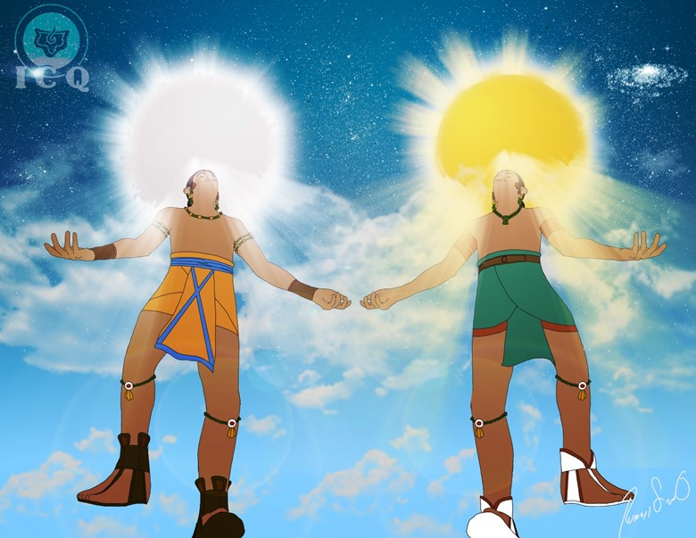
W
e see the same drama of death, resurrection and ascension lived by the Great Master Jesus in the Popol-Vuh, as this drama is of a cosmic nature. This tells us that the wisdom of the Maya, just as the teachings imparted by the Master of Masters, is not just historical, but a guide of what must partake within us, here and now.

The End of the Empire of Xibalba
“The Twins, Master-Magi (Hunahpu) and Little-Solar-Priest (Ixbalanque), revealed themselves and talked to who their fathers were, the ones who had been murdered on a ball game. ‘We are the avengers of the pain and the suffering of our fathers and as a consequence, we will terminate all of you… no one will escape’ – is what they said to those of Xibalba”
We must become the “avengers” of our internal Father and Mother; we must raise arms against our own selves and fight every passion, each and every psychological defect and not allow any of the ones from Xibalba to escape. This is the time to launch ourselves into battle against our own selves.
“And all those of Xibalba knelt and begged for forgiveness, because of the harm they had caused their fathers and because of the suffering they had caused. They were sentenced, they lowered their blood status, they were prohibited the ball game, and they were imposed into humble duties. They were only allowed to speak to the sons of weeds and to the desert. They were ordered to stay away from the children of the enlightened and from the civilized servants, and to never speak to them. They could only speak to the sinners, the perverse, the wretched, the ones who suffered, and those who surrender to addictions and bad habits”
This is the very same Doctrine of the Many studied by the Tibetans and the Egyptians; to realize that we are not individuals, but a collectiveness of defects. The sons of the enlightened and the civilized servants are those who truly seek for the Internal Wisdom, the ones who do not justify their mistakes. These are the ones who seek to amend themselves and their willpower is directed towards reaching Divine Perfection. Undoubtedly, these will not become victims of the Ego.
“And as so began their destruction and their lamentation. In times past, they had no power, they were not gods. Their only task was that of hurting men. Their faces were ugly, they were the enemies who incited wrongdoing, sin and discord. Those were the false of heart, black and white simultaneously, envious and tyrants. They used to paint and smear their faces. Such was their decadence and thus, the end of their empire”
We are living times when our internal defects have gained tremendous strength, they are being paid tribute and have led us to raise a false civilization based on that which is illusory and temporal. They are not rooted on Wisdom and not in the soul. These are demonic entities created by ourselves that lure us into being false, envious and tyrannical. Lust, greed and anger – as the wisdom of the orient states, are the doors to the AVITCHI (hell). In each one of us exists pride, vanity and arrogance and these invite discord. The thousands of our defects are the causes of illness, suffering, aging and death.

The Grandmother and the Cane
“As all these events unfolded, the Grandmother wept before the canes the Twins planted at the very center of the house, as these had dried when they had been burnt at the stake. But as they returned to life, her heart was inundated with happiness and she lit a fire and burned copal in their very memory. The canes were adored by the Grandmother and she called them ‘the center of the house’ and ‘the living canes of the flat land’”
The eternal feminine principle is always watching us at every instant of our lives. It knows of every thought, sentiment and action we experience and we drift away from its presence when we allow ourselves to be fooled by our own mistakes. We approach her whenever our actions are based on right action, right thought and right feeling.
One of the aspects of our Divine Mother is that of a special fire that remains dormant in the magnetic center (chakra) of the coccyx and in India, this fire is known as KUNDALINI. Awakening this fire is indispensable and it must ascend victoriously up the spine (symbolized by the cane), turning it into a Living Cane. This fire will never awaken without the magic of love and the merits of the heart the Twins earned by enduring all the torments, tests and tribulations imposed by the Lords of Xibalba.

The Twins Converted into the Sun and the Moon
“Then the Twins walked to the ball field where their fathers had been sacrificed, and their hearts rejoiced when they finally talked to them and said: ‘You will be invoked by the children of the enlightened and by the civilized servants, your names will not be forgotten’”
Undoubtedly, the fathers of the Twins: Supreme-Master-Magi (Hun-Hunahpu) and Principal-Master-Magi (Vucuc-Hunahpu), their reunion with their sons represents the integration of all of the different parts of our Being once they become self-conscious and perfect.
We have unfolded from that which has no name and no limit, and our duty is to reintegrate with the most superior parts of our Being.
“And the Twins were raised to the Heavens within a great light, one became the Sun and another the Moon, and they enlightened the firmament. The 400-many who were killed by Wise-Fish-Earth (Zipacna) accompanied them and they all became stars”
The 400-many killed by Zipacna (a story narrated on the first part of the Popol-Vuh) are the many faculties, virtues, abilities and laws we obtain as we work on the disintegration of our psychological defects. They come to show the total harmonious development of their internal faculties. The number “400” among the Aztec and Maya is a symbol of “innumerable”.
To become a Sun and a Moon is our mission in life; we must return to our origin which is the Divinity from which we have emerged. The Sun is our Eternal Masculine Principle (our Father who is in Secret) and the Moon is our Eternal Divine Feminine Principle (our Divine Mother). We must reintegrate with them and become one with them. This is the path of illumination taught by the Buddhists.
Yet we must not rely only on our good intentions. To convert ourselves into the Divine Twins is our duty and for that we must awaken our consciousness. If we are seeking for guidance to achieve this great work, the Masters among the Maya have left us the writing of the Popol-Vuh.
“Any attempt towards liberation as great as it may be, if it does not consider the need to dissolve the Ego, is condemned to fail” – Samael Aun Weor
This work is for titans and for the warriors seeking to earn everything, must be willing to leave everything in the battlefield. This work is for those who are willing to battle the world of false teachings and false beliefs, of expired social habits, the demon of our defects, and the flesh of our bestial passions.
Embark on the quest of the Divine Twins in your own heart, so they can manifest in your daily life through the magic of self-knowledge and thus, enable you to incarnate the secret teachings of the Popol-Vuh.

FIGURES
Figure 1. The Magi (Ahpu)
 |  | Padres de los Magos (Ahpú)
 |  | Ancient-Secret |  |  |  | Ancient-Concealer
 |  | (Ixpiyacoc) |  |  |  | (Ixmucané)
 |  |  |  | |
 |  | The Magi (Ahpú)
 |  | Supreme -Master-Magi |  |  |  | Principal-Master-Magi
 |  | (Hun-Hunahpú) |  |  |  | (Vucub-Hunahpú)
 |  | |
 |  | Wife Supreme -Master-Magi |  |  |  | Mother of the Twins
 |  | Bearer-of-Monkeys |  |  |  | The-One-of-the-Blood
 |  | (Ixbaquiyaló) |  |  |  | (Ixquic)
 |  | Master-Ape |  |  |  | Master-Magi
 |  | (Hunchouén) |  |  |  | (Hunahpú)
 |  | Master-Monkey |  |  |  | Little-Solar-Priest
 |  | (Hunbatz) |  |  |  | (Ixbalanqué)

Figure 2. The Lords of Xibalba
The Supreme Lords of Xibalabá
 | Supreme-Death |  | Principal-Death
 | (Hun-Camé) |  | (Vucub-Camé)

The Ten Princes of Xibalbá
 | Extend-Cripple |  | Maker-of-Abscess |  | Rod-of-Bones |  | Maker-of-Treason |  | Hawk-of-Blood
 | (Xiquiripat) |  | (Ahalpuh) |  | (Chamiabac) |  | (Ahalmez) |  | (Xic)
 | Gatherer-of-Blood |  | Maker-of-Jaundice |  | Rod-of-Skulls |  | Maker-of-Misfortune |  | Oppression
 | (Cuchumacuic) |  | (Ahalganá) |  | (Chamiaholom) |  | (Ahaltocob) |  | (Patán)

Figure 3. The Torment Houses of Xibalbá
 | The House of Darkness |  |  | The House of Sharp Blades
 | (Quequma-Ha) |  |  | (Chayin-Ha)
 | The House Coldness |  |  | The House of Fire
 | (Xuxulim-Ha) |  |  | (Hachi-Gag)
 | The House of Tigers |  |  | The House of Bats
 | (Balami-Ha) |  |  | (Tzotzi-Ha)

Figure 4. The Four Owls
 | Arrow-Owl |  |  | Giant-Owl
 | (Chabi-Tucur) |  |  | (Hurakán-Tucur)
 | Macaw-Owl |  |  | Owl’s head
 | (Caquix-Tucur) |  |  | (Holom-Tucur)

Figure 5. The Heaven’s Heart (Hurakán)
 |  |  | Lightning-Giant-Master
 |  |  | (Cakulha-Hurakán)
 | Footprint-of- Lightning |  |  |  | Splendor-of-Lightning
 | (Chipi-Cakulha) |  |  |  | (Raxa-Cakulha)

GNOSTIC GLOSSARY
“I” or Psychological Defect – is the inhumane second nature of the intellectual humanoid, combination of our mistakes, fears, and desires; it is multiple in nature and its multiplicity encompasses the seven main “capital sins”: Greed, Envy, Gluttony, Anger, Lust, Pride, and Sloth, each one expressed by its many faces.
Being – is the Spirit of the Human Being, the Innermost, and root of our existence; it is an immortal spark that emanates from that which has no name. Universal Gnosticism affirms each human being has its own Being.
Cabala – is the science of the numbers. Each number has its own profound meaning. Ancient books, doctrines, pyramids, teachings are all based on this universal language.
Chakra – is a magnetic center associated to a particular gland or nervous plexus. Once activated, it allows for the manifestation of dormant faculties and abilities within the human being, as to say: intuition, telepathy, etc.
Consciousness – Is the degree of wisdom or spiritual values awakened in a human being.
Divine Mother – God as Father is Wisdom, God as Mother is Love. The Being unfolds in the Divine Mother and each one has its own. She is a part of our Being that guides us in the path towards the unknowable Truth.
Ego – within Gnostic Wisdom, it is pluralized. It speaks to the thousands of negative energetic entities created by ourselves as a function of our lives and existences. Together they constitute Lust, Pride, Sloth, Gluttony, Envy, Pride, and Greed.
Essence – The most divine aspect of each one of us. The set of virtues and gifts of the human being. It is fragmented and trapped within the Ego. Typically a 3% of free Essence is present in a human being.
Gnosis – Experiential Wisdom. It is the knowledge that is found deep within the human being that is discovered with the effort of self-knowledge. It is the millenary wisdom that has been present in every Golden Age of each of the great cultures of the world.
Initiate – The title given to the person who walks into the sacred mysteries and who has walked the internal path. Initiation is the path that leads us to the Truth that in itself, is unknowable from moment to moment.
Karma – Sanskrit word meaning ‘cause and effect’. It is a cosmic law that governs all of creation. Everything we do, whether good or bad, carries an effect and each effect in turn, because a new cause. When our actions are in favor of others, we earn good karma; when our actions are not constructive, edifying or dignifying, we earn negative karma.
Master – In Gnosis, Master is that individual who has reached certain level of progress in the path towards achieving perfection; it is one who has eliminated a significant amount of their psychological defects.
Meditation – Is the active seeking of information, disconnected from the mechanical associations and the reasoning of the mind, when the mind achieves complete silence.

MAYA GLOSSARY

The Maya language is abundant in homonyms (each of two words having the same pronunciation but different meanings, origins, or spelling). The reader must rely on their intuition – and not their vane intellect – and apply to them the most relevant meaning, based on the practical application the Popol-Vuh represents in our life.

Ahpu – can be translated as “Magician”, understanding “Magic” as the ability to create influence over our own nature, just as the one who is capable of a radical self-transformation is capable of the dominion of their own nature. Another suggested definition if “shooter” (as in of a blowpipe or blowpipe). The blowpipe, just as the flute in Mozart’s composition, has the same meaning: the creative force of the first instant.
Hunahpu – HUN is one, master, supreme; AHPU is magi, thus Master-Magi. He who has the capability to perform a radical self-transformation.
Ixbalanque – IX means small; BALAN means jaguar, magi, sorcerer, protector; QUIH means Sun. The academics of the Popol-Vuh have translated it as “little sorcerer”, yet we have chosen to translate it as “Little-Solar-Priest” as the reader will capture the essence of his name with more clarity.
Popol-Vuh – POPOL means council or community; WUJ means book. Popol-Vuh is The Book of the Council or The Book of the Community, alluding to all (in the council or community) to feel as one Being.
Quiche – (K’iche) is the language of the Maya in which the Popol-Vuh was written. QUI or QUIY means many; CHE is the land of the many trees.
Xibalba – XIBIL is to disappear as a mirage or as a ghost. It is also translated as demon or deceased. These are our psychological defects as well as the underworld that has its equivalent within our subconscious.
Voc or Vac – the Hawk. The Maya used to call animals based on the sound or noise they articulated. Voc or Vac is similar to the sound of the hawk.

SAMAEL AUN WEOR AND THE POPOL-VUH
To further satisfy the needs of the avid reader, find below a transcription of what Master Samael Aun Weor has written in relation to the Popol-Vuh.

Chapter 2, Tarot and Cabala
The sacred book of the Maya, the Popol-Vuh, states God created man from mud and then of wood (the Atlantean Race), but they forgot their “Fathers and Mothers”, they forgot the “Heart of the Heavens”, and later a great deluge lead to their destruction and death; they took shelter in caverns yet these crumbled (referring to the submergence of Atlantis). Thus each one has its very own and sacred Father and Divine Mother. In the Father and in the Divine Mother Kundalini we see the columns of the temple JACHIN and BOAZ.

Chapter 3, Tarot and Cabala
The Celestial Mother, in the material plane, means Material Production; in the spiritual plane means Spiritual Production. Deeper analysis reflects something very interesting: the Number 1 is the Father who is in Secret, the Monad from there the Divine Mother Kundalini is born, the Duality. This one in itself unfolds into the Number 3 which is the Father, Mother and Son, this is the immortal and Divine Spirit of every living being, and the three of them Osiris the Father, ISIS the Mother and Horus the Son, constitute what the sacred book of the Maya, the Popol-Vuh, calls “The Heart of the Heavens”. The Son itself unfolds into the Soul each one carries within.

Chapter 33 (The Winged Serpent); The Perfect Matrimony

THE FLYING SERPENT
In the Popol Vuh of the Maya, the Bird and the Serpent feature as sexual creators of the universe. Tepeu and Gucumatz sent a sparrow hawk to the immense Ocean of Create Life to bring the Serpent, whose marvelous blood they kneaded into the yellow and white maize. The Popol Vuh says that with this dough of white and yellow maize mixed with the blood of the tine God Tzacol formed the flesh of man. The Bird represents the Universal Spirit of Life. The Serpent represents the Sexual Fire of the Third Logos. The blood of the Serpent represents the Waters of Genesis, the great universal sperm, the Ens Seminis or Christonic semen, in whose waters is the germ of all life. These waters are the blood of the Earth according to the Mayan philosopher. The Goddess Coatlicue is the mother of life and death (the Ens Serninis).
Really, the Sexual Fire of the Third Logos makes the Waters of Life fertile to bring forth the universe.
In Mayan theogony, two Gods intervened in creation; one who gives life and form to man, and the other who gives him consciousness. The Third Logos makes the Waters of Life fertile and when these have been fertilized, the Second Logos intervenes, infusing consciousness into every organism. The ineffable Gods are the vehicles of action for all the forces of the Logos.
The sparrow hawk H’ch’uuy, the macaw Mo, the kestrel X’Cen Cen Bac, the tapir, Tzimink, Aax and the Serpent Can are the basic components of the Mayan geogenic myths. These symbols are used exoterically and esoterically. In the exoteric or public field they symbolize tribal facts, historical incidents etc. In the esoteric or secret aspect, the questionis highly scientific, profoundly philosophical, sublimely artistic and tremendously religious.
Amongst the Maya, the terrestrial paradise is Tamoanchan, the sacred place of the Serpent Bird. Tamoanchanes are in fact the Initiates of the Serpent. The myth of the Tarnoanchas is the myth of the Serpent bird. The Tarnoanchas are descended from the Toltec, Olmec and Maya.
The Aztecs, after much hardship reached the lake of Texcoco, symbol of the Christonic semen, where they found the Bird and the Serpent, the Eagle and the Snake. The Aztecs are the ones who have the high honor of having founded the Great Tenochtitlan based on the Wisdom of the Serpent.
The Feathered Serpent clearly represents the Serpent Bird. The Feathered Serpent was identified with Quetzalcoatl, the Mexican Christ. Quetzalcoatl is always accompanied by the sacred symbols of the Eagle and Serpent. The Feathered Serpent says everything. The Eagle of the Spirit and the Serpent of Fire transform us into Gods. The Quetzal of the Maya is the Feathered Serpent, the Serpent Bird.
Monograph #14 – Secret Teachings of the Nahualt; The Bat God; Aztec Christic Magic
In the Popol-Vuh (The Bible of the Maya) the bat is an angel who descended from the heavens to decapitate the first Maya men made of wood. The celestial bat who advised Ixbalanque and Hunahpu on the actions to take to emerge victorious from the trials of the House of the Bat.

Description of the Serpent, Mayan Mysteries
Identical writing to that of the book The Perfect Matrimony.

The Bat God, Mayan Mysteries
Identical writing to that of the book Aztec Christic Magic.

RECOMMENDED BIBLIOGRAPHIES
This book is based on the teachings of Samael Aun Weor and to further into the context of each of the topics expressed in each chapter, we recommend the following bibliographies:

Chapter 1 – The Origin
Aun Weor, Samael. Tarot and Cabala. Arcana 1 and 2.

Chapter 2 – The Death of the Magi
Aun Weor, Samael. Secret Doctrine of Anahuac Chapter 10 – Gnostic Anthropology

Chapter 3 – The Virgin Ixquic
Aun Weor, Samael. The Great Rebellion, Chapter 15: Kundalini.

Chapter 4 – The Grandmother and the Young Ixquic

Aun Weor, Samael. The Three Mountains. Chapter 11: The Sacred Cow

Chapter 5 – The Birth of the Twins

Aun Weor, Samael. The Great Rebellion. Chapter 23: The Intimate Christ

Chapter 6 – The Finding of the Ball

Aun Weor, Samael. The Great Rebellion. Chapter 20: Concerns

Chapter 7 – The Louse, the Frog, the Snake and the Hawk

Conference: Learning How to Listen, Samael Aun Weor

Chapter 8 – The Mosquito Xan
Aun Weor, Samael. Revolutionary Psychology. Chapter 13: The Observer and the Observed

Chapter 9 – The House of Darkness and the House of Sharp Blades
House of Darkness. Aun Weor, Samael. The Great Rebellion. Chapter 11: Darkness
House of Sharp Blades. Conference: “Why do we judge others?”, Samael Aun Weor

Chapter 10 – The Houses of Coldness, Fire, Tigers and the Bat
House of Coldness; Aun Weor, Samael. Perfect Matrimony. Happiness, Music, Dance and Kiss
House of the Tiger; Aun Weor, Samael. Aztec Christic Magic. The Sacred Tiger

House of Fires; Aun Weor, Samael. Perfect Matrimony. The Initiation
House of the Bat; Aun Weor, Samael. Aztec Christic Magic. Camazotz

Chapter 11 – The Work with Animals

Aun Weor, Samael. Igneous Rose

Chapter 12 – Death and Resurrection of the Twins

Aun Weor, Samael. Tarot and Cabala. Arcanum 20: The Resurrection

Chapter 13 – The End of the Lords of Xibalba
Chapter on the Dissolution of the “I”. Christmas Message of 1964-65, Samael Aun Weor

Chapter 14 – The Ascension of the Twins

Aun Weor, Samael. Tarot and Cabala. Arcanum 22: The Return

All these books and lectures can be studied from the Quetzalcoatl Cultural Institute’s webpage (ICQ for its acronym in Spanish): www.samaelgnosis.net

BIBLIOGRAPHY

- Abreu Gómez, Ermilo. (1944) El Popol Vuh. (Advertencia y selección de Ermilo Abreu Gómez). México. Secretaría de Educación Pública.
- Abreu Gómez, Ermilo. (1965) El Popol Vuh. (Versión y prólogo de Ermilo Abreu Gómez). Ediciones Oasis, S.A. 1ª Edición.
- Aun Weor, Samael. La Gran Rebelión. (Edición digital del portal www.samaelgnosis.net consultado en 2014)
- Aun Weor, Samael. Psicología Revolucionaria. Web. www.samaelgnosis.net. (2014)
- Aun Weor, Samael. Tarot y Cábala. Web. www.samaelgnosis.net. (2014)
- Aun Weor, Samael. Matrimonio Perfecto. Web. www.samaelgnosis.net. (2014)
- Aun Weor, Samael. Magia Crística Azteca. Web. www.samaelgnosis.net. (2014)
- Aun Weor, Samael. Las Tres Montañas. Web. www.samaelgnosis.net. (2014)
- Aun Weor, Samael. Misterios Mayas. Web. www.samaelgnosis.net. (2014)
- Barrera Vázquez, Alfredo. (1980). Diccionario Maya Cordemex. Mérida Yucatán México. Ediciones Cordemex.
- González Torres, Yólotl. (1999). Diccionario de Mitología y Religión de Mesoamérica. México: Larousse.
- Raynaud, Georges. Popol-Vuh o Libro del Consejo de los Indios Quichés. Traducción de la versión francesa del profesor Georges Raynaud, director de estudios sobre las religiones de la América Precolombina, en la Escuela de Altos Estudios de París, por los alumnos titulares de la misma Miguel Ángel Asturias y J. M. González de Mendoza. (Edición digital del portal www.samaelgnosis.net consultado en 2014)
- Recinos, Adrián. (1978). El Popol Vuh. (Las Antiguas Historias del Quiché). Costa Rica. Novena Edición. Editorial Universitaria Centroamericana.
- Saravia E., Albertina. (1966). Popol Wuj. (Antiguas historias de los Indios Quichés de Guatemala). Segunda Edición. México. Editorial Porrúa.
Note: the text redacted between quotes (“ “) is not a textual versión from the Popol-Vuh, but an interpretation of the authors.

TABLE OF CONTENTS
Chapter | Title | Page
 | Introdution | 2
1 | The Origin | 3
2 | The Death of the Magi | 8
3 | The Virgin Ixquic | 12
4 | The Grandmother and the Young Ixquic | 15
5 | The Birth of the Twins | 17
6 | Finding the Ball | 21
7 | The Louse, The Frog, The Snake, and The Hawk | 24
8 | The Mosquito Xan | 27
9 | The House of Darkness and the House of Sharp Blades | 30
10 | The Houses of Coldness, Fire, Tigers and Bat | 34
11 | The Work with the Animals | 38
12 | Death and Resurrection of the Twins | 41
13 | The Death of the Lords of Xibalba | 44
14 | The Ascension of the Twins | 48
 | Figures | 50
 | Gnostic Glossary | 53
 | Maya Glossary | 54
 | Samael Aun Weor and the Popol Vuh | 55
 | Recommended Bibliographies | 57
 | Bibliography | 58

Original Text

Enseñanzas Secretas del Popol Vuh
(The Secret Teachings of the Popol Vuh)

Authors

Jenaro Ismael Reyes Tovar
María Guadalupe Rodríguez Licea

Art

Rubén Soto Orozco

Translation

Ricardo Santana Laracuente

© Copyright Reserved

Instituto Cultural Quetzalcóatl de Antropología Psicoanalítica, A.C.
www.samaelgnosis.net www.samaelgnosis.org
www.samaelgnosis.us www.samaelgnosis.fr

