The Birth of the
Left-Handed Hummingbird [Huitzilopochtli]
A didactic to achieve spiritual liberation

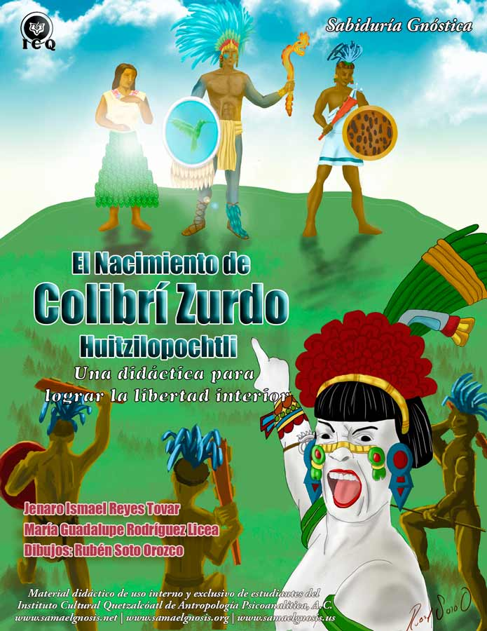

Text and Pictures
Jenaro Ismael Reyes Tovar and
María Guadalupe Rodríguez Licea

Cover and Pictorials
Rubén Soto Orozco

Translation
Ricardo Santana-Laracuente

© All rights reserved.
Registry Number: 03-2016-030110164500-01

Didactic material for the exclusive use of the students of the
Quetzalcoatl Cultural Institute (ICQ) of Psychoanalytical Anthropology, A.C.

Table of Contents

INTRODUCTION 5
Chapter 1 - “The Left-Handed Hummingbird” [Huitzilopochtli] 7
The Mexica and Mexico 7
The God of War 9
God of the Sun 9
Left-Handed Hummingbird 9
Death, War and the Hummingbird 10
Chapter 2 - The Initiation 14
The Hill of the Serpent [Coatepec] 14
The Land of Tules [Tollan or Tula] 15
The One with the Skirt of Serpents [Coatlicue] 15
The One Adorned with Rattles [Coyolxauhqui] and the Four-Hundred Southerners 16
Chapter 3 – The True Penance 18
Fine Feathers 19
The Anger of the Four-Hundred Southerners 20
Chapter 4 - The Interior War 22
The Voice of the Silence 23
Dressed for Battle 24
Chapter 5 - The State of Alert Novelty 26
The Attack of the Southerners 26
Psychological Self-Observation 29
“The Rows of Heads” [Tzompantitlan] 29
“The Sands of the Serpent” [Coaxalpan] 30
The Slope of the Mountain 31
At the Top of the Mountain 32
Chapter 6 – The Birth of Huitzilopochtli 34
The Shield of Feathers 35
Earrings 35
Sandals 36
Darts 36
The Crown of Feathers 36
Chapter 7 – The Serpent of Fire [Xiuhcoatl] 37
Chapter 8 – The Death of the Ego 41
Chapter 9 – The Liberation of the Essence 44
Chapter 10 – The Cult to the Left-Handed Hummingbird [Huitzilopochtli] 48
Divine Origin 48
Veneration 49
Sacrifices 50
Honor and Service 52
Tribute and Cult 52
Appendix – A 54
The One with the Skirt of Serpents [Coatlicue] 54
Appendix – B 64
The One Adorned with Rattles [Coyolxauhqui] 64
Decapitated and Dismembered 65
The Woman 66
Serpents 67
Adornments 68
Claws 69
Skulls 70
Bibliography 71

INTRODUCTION

When we long with all of the strength of our soul to discover the way that can take us to the experience of the Truth, we tend to find paths that are complex, akin to the labyrinths of times long past when the aspirant sought the way; the difference today being such complex paths are made up of numerous contradictory theories.

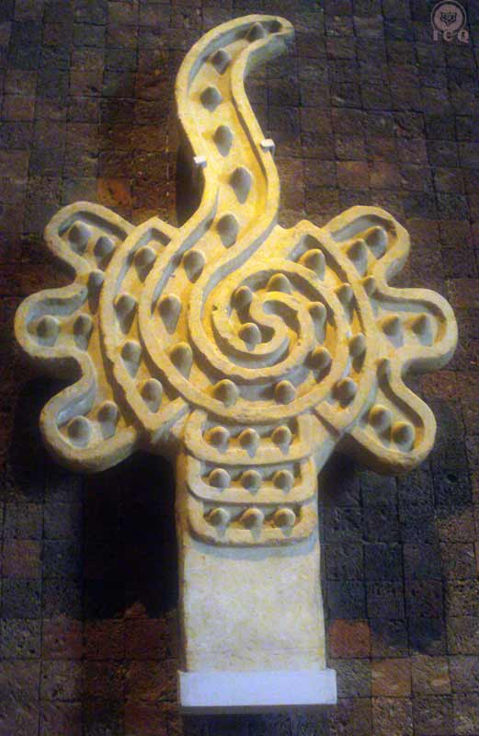
In these very conditions and considering we are in the midst of an age of spiritual ignorance, it becomes difficult to find the path that leads to the light of immortal wisdom and it has become highly complicated to find the keys that can lead us to redemption and transformation.
Figure 1 - ALMENA CARACOL. Cross-sectional rendition of a seashell; symbol of Venus, the Morning Star and symbol of love. (Museum of History and Anthropology, Mexico)

The number of schools and philosophies that promise their offering of the Truth abound as weeds and because of this, it is common for many, as they continue their search, to end up disillusioned not finding what they have for so long sought-after. Luckily, there is something we can hold-on to within this intricate storm of opinions.

The one thing that can show us the correct path to follow is found in the wisdom left behind by the great masters and captured in codices, papyruses, sacred scriptures, pyramids, legends, myths, ancestral stories, and millenary sepulchers.

In the words of the great master Jesus:
“For those who have eyes to see, so they can see…”

Which is exactly where we should spend our effort to discover the path into the light of wisdom. All the wisdom has been left behind as millenary teachings, just as is the case of the birth of the “Left-Handed Hummingbird” [Huitzilopochtli] of the ancient traditions of Mexico. Fortunately we find this myth in the Florentine Codex.

The myth narrates the miraculous origin of the “Left-Handed Hummingbird” [Huitzilopochtli], conceived by a ball of feathers that descended from the heavens and that was safeguarded in the bosom of “The One with the Skirt of Serpents” [Coatlicue]. It speaks to the life-threating dangers they overcame from the Four-Hundred brothers who were led by Huitzilopochtli’s older sister, “The One Adorned with Rattles” [Coyolxauqui], and culminates with the defeat and death of them all.

In a single myth we can find multiple teachings majestically intertwined and disguised under the veil of mystery, so that only those who have the understanding – as stated by the great master Jesus – would understand. Here is this wisdom.

“The Left-Handed Hummingbird” [Huitzilopochtli] is the sun, “The One Adorned with Rattles” [Coyolxauqui] is the moon and the Four-Hundred Southerners, the stars; and they embody a narrative of ancient cosmogony.

Simultaneously, the story is also the narration of the internal work that must be practiced by every human being who strives to achieve the heights of the self-realization of the Being and in that sense, we must make an effort to find each of the characters in this myth, not as part of a story from a remote past, but at this very instant of our lives and within our own selves.

This is a story we must bring into our lives and into our flesh, as it is the key that leads to true happiness, to the experience of interior liberation and to acquire the real peace that only divinity can offer. In these writings we have found a concrete didactic for the elimination and death of our psychological aggregates.
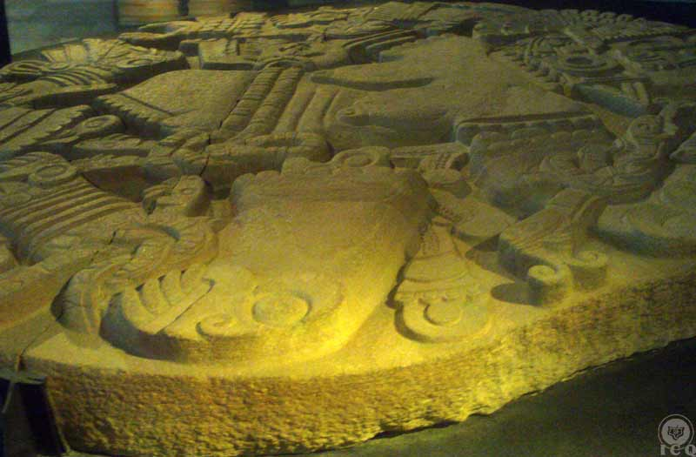
The secret path of liberation is a core longing of every human being and these millenary teachings indicate just how to find it. Join us as we unearth these sacred mysteries and drink of an initiatic wisdom that, as you will see, has always existed within your own consciousness.

Figure 2- "The One Adorned with Rattles" [Coyolxauqui] (Museum of the Major Temple, Mexico)

Chapter 1 - “The Left-Handed Hummingbird” [Huitzilopochtli]

The God of War and the Sun, called “The Left-Handed Hummingbird” [Huitzilopochtli], does not belong to a remote past, and neither will we find him in a sacred monolith nor in the codices, nor the legends that with so much veneration mention him. For us to find him, we must seek deep within our heart.

We find the following passage in the Florentine Codex:

“The Mexica’s truly honored Huitzilopochtli, they knew of his origin, and his beginnings were as such…”

The Mexica and Mexico
To grasp the meaning of these words, we must first know who the Mexica are. They are known as the founders of Mexico-Tenochtitlan and without a doubt, there is a hidden meaning we must comprehend.

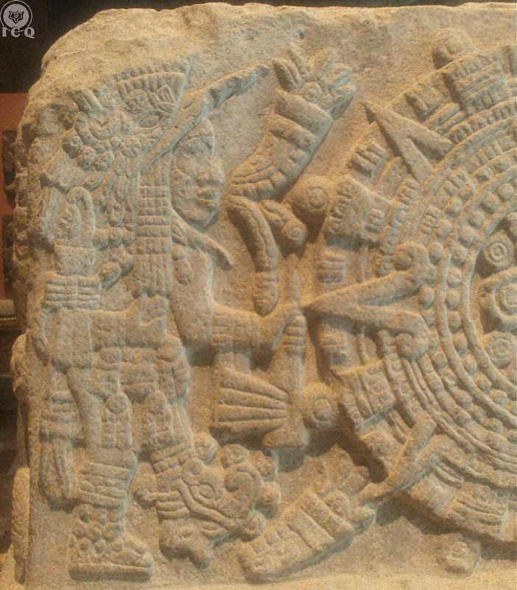
Because there are various ways to translate the name of Mexica and Mexico, we will make use of the most interesting ones because of their eminent gnostic character which are METZLI (moon) and XICTLI (navel or center). Mexico could be translated as “the city that lies at the center of the lake of the moon”.

This magical name emerges from the long and arduous pilgrimage that led to finding the location where Mexico would be founded, an event that took place when an eagle (symbol of the Holy Spirit) was found devouring a snake (the Divine Mother), while standing on a Nopal (symbol of willpower), all these on a rock, in a lake of pure waters (the waters of life or the energy that brought us unto the tapestry of existence).

Such travels took place because of the order of “The Left-Handed Hummingbird” [Huitzilopochtli] and it was not until after a series of hardships that it was possible to find, in the middle of a lake (the Lake Texcoco), the symbol that was promised of the eagle devouring a snake, beside a series of esoteric emblems as the frog, a white willow and others, resulting in the “city that lies at the center of the lake of the moon”, or Mexico.
Figure 3 - "the Left-Handed Hummingbird" [Huitzilopochtli]. Detail from the Stone of the Temple [Teocalli] (Museum of History and Anthropology, Mexico

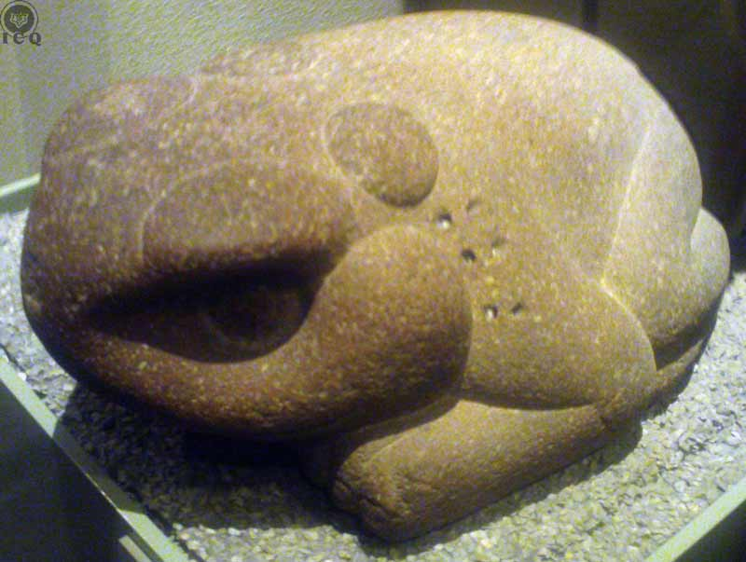
There are other places on Earth where we find esoteric definitions that are similar to this one, as in Cuzco, Peru because Cuzco means “the navel of the world”. No one can deny these are very special localities charged with magnetism, spiritualism, and they are filled with magic; it is obvious such names point to something that is inherently profound, and their ancestral authors make an effort to deliver a message that we must make an effort to comprehend.
Figure 4 - Frog (Museum of History and Anthropology, Mexico)

The wise elders want us to receive some intuition on the spiritual transcendence that we must carry today, they want us to hold the guidance of the moon (in this case understood as love, compassion and empathy) at the very center of our daily activities, because the sun is associated to the Truth, wisdom and severity. On this perspective, the sun and the moon as masculine and feminine attributes of divinity.

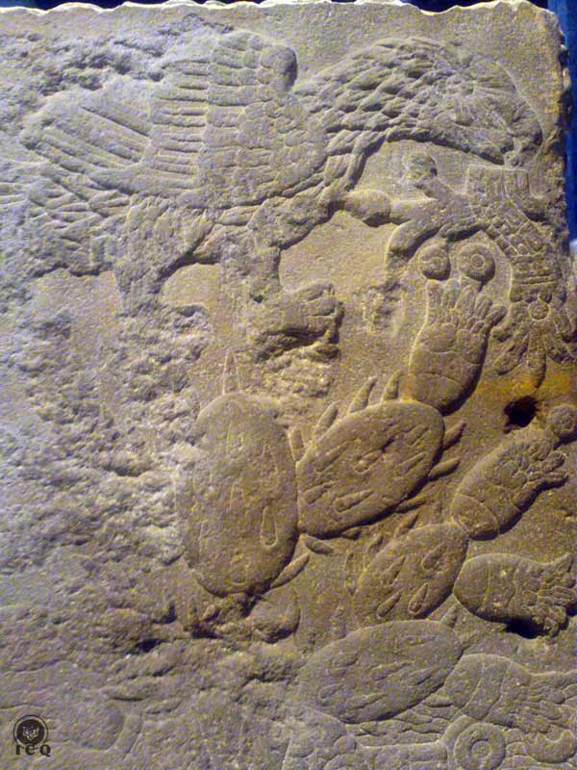
Being “the navel of the moon” or Mexica, suggests that we must be comprehensive, that we must have as our foundation the love for humanity, that we must learn to place ourselves on the footsteps of others and feel what our brothers feel. It also suggests the interpretation of he who has enabled his internal eagle of the Holy Spirit to devour the serpent of his own Divine Mother by the efforts of their willpower with the work of transcendental sexuality.

The name “Aztec” also carries deep meaning as “an inhabitant of the Aztlan”, a paradise found in the fourth dimension of nature or “the place of the herons”. The whiteness of the heron is a symbol of the purity of the spirit.

All that has been stated regarding Mexica and Aztec, within the content of this myth, does not refer to anyone in any particular geographical location, but esoterically refers to the person who makes an effort to purify themselves, seeking self-realization by walking the path that can ultimately lead us to the Truth. They are the only ones with the true capacity to honor and venerate our Lord “The Left-Handed Hummingbird” [Huitzilopochtli], but who is he..?
Figure 5 - The Foundation of Mexico. Detail from the Stone of the Temple [Teocalli] (Museum of History and Anthropology, Mexico)

The God of War
“The Left-Handed Hummingbird” [Huitzilopochtli] is considered the God of War, which would make no sense at all only when interpreted literally; we cannot consider a giver of wisdom, mercy and compassion that at the same time rules over the hatred of war. Anything said about such deity would become incomprehensible if we do not know of the mysteries of gnosis.

The war referred-to is not the bellicose destruction perpetrated by human machines on this afflicted humanity. It refers to the war that must be fought internally, the combat we must sustain against the tenebrous forces of pride, laziness, lust, gluttony, etc., which we ourselves have created.

God of the Sun
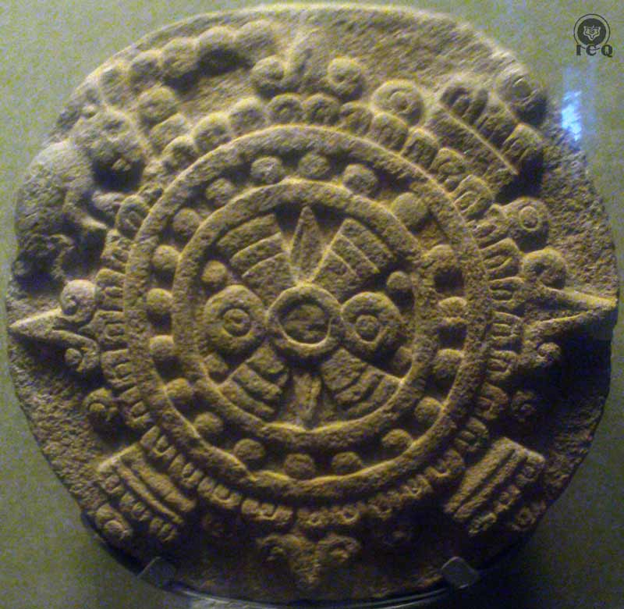
Another one of his attributes is being the God of the Sun. From very ancient times the sun has been associated with a universal force, one that has given origin to creation itself. Such cosmic energy is known as the CHRIST.

We must understand the CHRIST is not a person, but an eternal principle; a force that is found at the very core of every star and every atom. The Christ is COSMIC (from Greek kosmos "order, good order, orderly arrangement”) and thus known as the COSMIC CHRIST.

Such marvelous energy has its exponent in a very part of our Being: The Intimate Christ. Ancient axioms state that we must not look outside of us that which we have within; its main attribute is love, as the sun illuminates all that exists, with no distinctions of any kind.
Figure 6 - Solar Disc (Museum of History and Anthropology, Mexico)

Left-Handed Hummingbird
An extraordinary process had to be realized for the soul of the deceased to transform into beautiful birds, like the hummingbird; a symbol of the virtues of the soul that we must develop through the elimination of our psychological defects.

“Left-Handed” because OPOCHTLI means “left-handed”, and must be translated as “he who tosses spears with the left hand”.
Samael Aun Weor

When relating to the masculine and feminine attributes of divinity, the right side represents the sun: wisdom and severity; the left side represents the moon: the mother, love, compassion. Both right and left pillars are necessary as we must rely on wisdom, severity, love and compassion to emerge victorious from the tribulations and tests of life.

“Tossing spears with his left hand” invites the use of the faculty of creative comprehension, the type used when we strive to truly understand a psychological aggregate so it can be eliminated. If we for example we suppress our anger, we are effectively empowering it; and if we set it free, then in grows in geometric proportions. It is only through the effort of creative comprehension how we make ourselves able of having the complete understanding of a defect that will allow us to eradicate it from within.

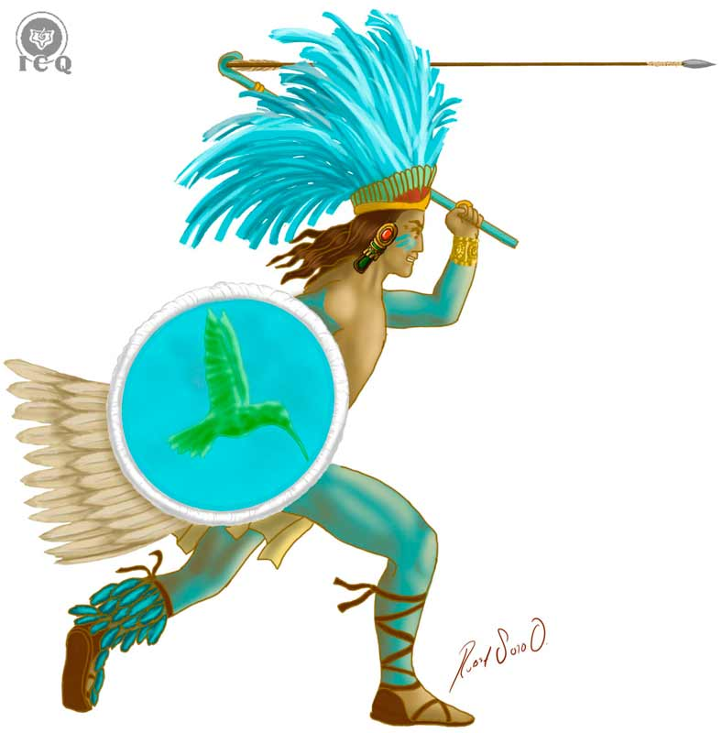
This superior comprehension allows us the ability to study its mechanisms, its relationships with other defects, its structures, transactions, roots, and its harmful consequences at all the levels of the mind.
Figure 7 - Huitzilopochtli, tossing spears.

“Tossing spears” is akin to “guiding” or “directing” the electrical force that gives origin to life; and the left-hand is associated to our “receiving of the comprehension”, so we can become successful in the great work of eliminating our passions and defects.

Whenever we hear the Mexica adored “The Left-Handed Hummingbird” [Huitzilopochtli] and that they knew of what was his origin, what these ancient teachers sought was to provide the populace with the necessary keys to experience the birth of “The Left-Handed Hummingbird” in each one’s individual and particular internal universe. Their teaching is meant to provide the opportunity for us to experience the manifestation of the superior values and attributes of the spirit. These values are the manifestation of the “Intimate Christ”.

Death, War and the Hummingbird
This extract from a beautiful Nahuatl poem transcribed by Master Samael Aun Weor in his book, The Secret Doctrine of Anahuac, helps us better understand why Huitzilopochtli is represented with a hummingbird and considered the God of War:

“How many died at war, or at the altar of sacrifice, they departed to the house of the sun. They all were united in an immense prairie. When the sun is going to appear, when the time of its rising is near, they then start launching cries of war, and make the rattles they carry in their ankles resound while beating on their shields.”
Samael Aun Weor

Those who experience death in their interior war (the altar of sacrifice or sacred office), are those who are able to discover hidden aspects of themselves and identify their mistakes in the daily happenings of life. The master Gautama Buddha stated that it is in the internal combat and through the most gruesome battles, that the practitioner dies within:

“Regardless if a man defeats a thousand men a thousand times in battle, the greatest warrior is he who defeats himself.” – The Dhammapada

To reach the house of the Sun is to return to the house of the Internal Father, which is to reach the realm of our own internal profound Being, and the only way to achieve this is by the elimination of all of that which keeps us separated from Him. We must eliminate the many psychological defects we carry within and “die” in our internal war.

"If their shield is pierced by two or three arrows, through those openings they can contemplate the sun, but those whose shields have no openings, cannot.”
Nahuatl Epic

It is through this battle against oneself, against the darkness of our ignorance, errors and fanaticisms that we can effectively approach divinity, the Truth.
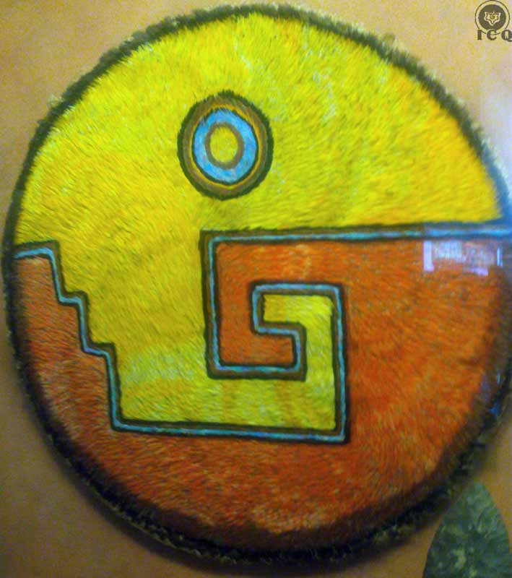
The harsh battles are what allow the internal warrior to make progress in this path, so if their shield has not been perforated by the arrows (i.e. insults) of their enemies, if they are not capable of making the most out of the psychological gymnasium of life with all of its painful details, and we do not take advantage of those adverse circumstances to comprehend and disintegrate our psychological defects, it would become more than impossible for us to enjoy the bliss of seeing the shining light of our own Being.

The teachable point is that we must make an effort to stop complaining of all that happens to us and instead, make the effort to make the most out of the adversities we face. Each adversity hands us an opportunity to discover our psychological defects and any defect that is discovered must then be comprehended, disintegrated and eliminated. This is the path that leads to the birth of new virtues, powers and abilities.
Figure 8 - Shield of Feathers (Museum of History and Anthropology, Mexico)

"How many were killed among magueys and cacti, among thorny acacias; and those who have offered sacrifices to the gods, may behold the sun, they can reach it.”
Nahuatl Epic

To fall dead before agaves (magueys) and cacti is a symbol similar to the crown of thorns worn by the Master Jesus, as well as for the Cloth of Veronica; these speak are to the amount of THELEMA (willpower) that is necessary to achieve this work. This is not something anyone can make happen; this is not for those who are inconsistent, superficial, or those who are skittish or fickle. We need of the discomforting motivation that comes sharp tip of the thorn to invite the work and the internal battle.

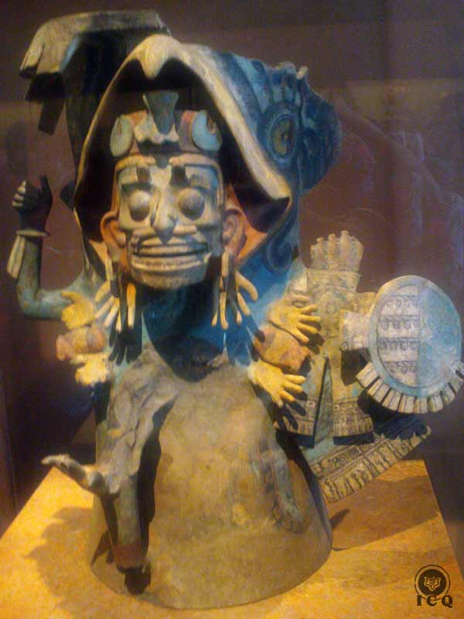
Only those who achieve the second death, the total elimination of that which is false and illusory, the ones who earn the right to contemplate the Sun, the Being, Divinity and even more; and if they continue their path of perfection, they will eventually reach Him.
Figure 9 - Brazier of the Dead Warrior (Museum of History and Anthropology, Mexico)

"When four years have passed, they turn into beautiful birds, namely, hummingbirds, fly-birds, golden birds with black holes around their eyes or into shining white butterflies, or into fine fur butterflies, or into large and multicolored butterflies, such as the drinking glasses, and sipping they walk there in the place of their rest, and usually come to earth and sip in blood red-colored flowers that resemble: the erythrin, the paisentía, the carolinea, the caliandra.”
Nahuatl Epic

It would take “four years” for the soul of the deceased to experience different trials in the regions of the netherworld (the MITCLAN) before they would be liberated and transformed into birds like the hummingbird. After “four years”, meaning once the four bodies of sin (the physical, astral, mental and causal bodies) where the thousands of psychological defects take manifestation are eliminated, they could transform into beautiful birds; all of them symbols of the human soul that the warrior has incarnated: all the virtues, attributes, powers, and faculties gained in the harsh battles, as they fought the eternal enemy of the night.

To become a hummingbird is to have reached the pinnacle of powers, abilities and virtues that emerge once we are dead to everything that is illusory within the battlefield of life.

“The Left-Handed Hummingbird” [Huitzilopochtli] is an illuminated master in the likes of Buddha, Hermes, Jesus Christ, etc., and he is also the representation of the highest spiritual values the human being could incarnate.

“The Left-Handed Hummingbird” [Huitzilopochtli] is a marvelous, living symbol of the Inner Christ whose realm is the Heart Temple. Every human being has been given the mission to incarnate him and that is why we have come unto life; incarnating him is the only one thing of true importance.

Now we can comprehend why he is the God of the Sun, why he is the Intimate Christ, love, God of the War fought against oneself, and his name “hummingbird” translates as a representation of the virtues that we must crystalize so that incarnation becomes possible.

Chapter 2 - The Initiation

The initiation is that collection of events in the path of life that when wisely and tenaciously managed, can lead us into the true light of immortal wisdom. Master Samael Aun Weor states:

“Initiation is your own life. The one who receives initiations is the Innermost. Thus, initiation has nothing to do with those fantastic tales which are so abundant in certain books. Thus, nothing is given to us for free. Everything has its price. Whosoever has not earned anything cannot collect anything. Initiations are payments that the Logos gives to human beings when the disciples have sacrificed themselves for humanity. Those who only preoccupy themselves with their own spiritual progress and do not work for others achieve absolutely nothing. Whosoever wants to progress must sacrifice the self for others. Initiation is this same life intentionally lived with rectitude and love.”
Samael Aun Weor

The Florentine Codex continues:

“In Coatepec, on the way to the Land of Tula, a woman of name Coatlicue had been living. She was the mother of the Four-Hundred Southerners and these had a sister, whose name was Coyolxauhqui.”
Florentine Codex

The Hill of the Serpent [Coatepec]
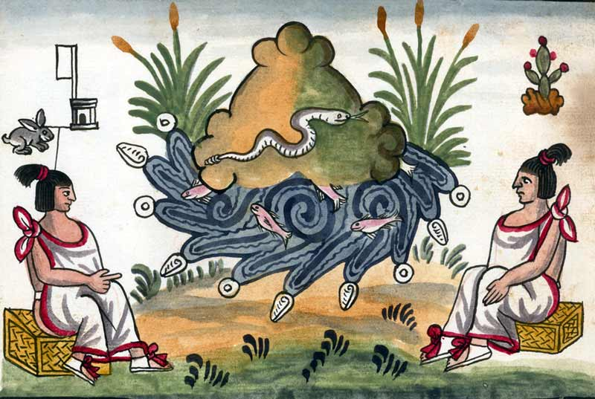
This narration takes place – or perhaps should take place – in the “Hill of the Serpent” [Coatepec] that exists deep within our own selves.
Figure 10 - "The Hill of the Serpent" [Coatepec] (Tovar Codex)

Coatepec is composed of two words COATL (serpent) and TEPEC (hill), thus “Hill of the Serpent”, and we find these two symbols used in other cultures and under the same context. The mountain (or hill) is a symbol of initiation and a symbol of the work that must be performed to reach degrees of perfection. As a simile, it is also the spiritual path because it is as arduous as the effort to climb a mountain. When we climb the mountain of initiation (life) we are faced with hazards and the danger of falling, and we must apply the necessary efforts and precautions to prevent a fall.

In addition, the “hill” or “mountain” is also combined with the symbol of the serpent, an allegory of esoteric knowledge and internal wisdom among the Aztec, the Maya and the Egyptians; also a symbol of the individual and particular Divine Mother of each one of us. It would be enough to remember the words of the Master Jesus when he sent off his disciples to share the wisdom and He asked of them to be “gentle as doves and wise as serpents”. So it is the “Hill of the Serpent” [the Coatepec] the initiation itself, it is the path of life and the associated efforts that are necessary to return to the light.

The Land of Tules [Tollan or Tula]
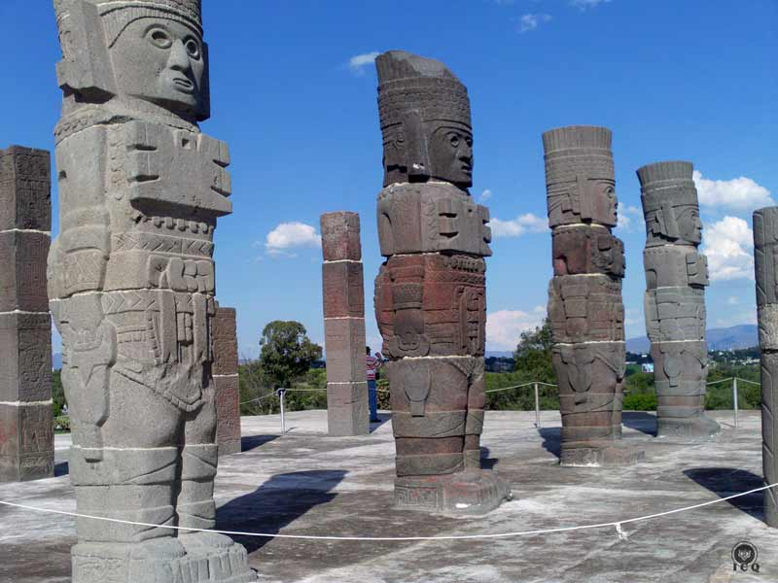
When the Codex states “on the way” to the mystical and sacred city of the “Land of Tules” [Tollan or Tula], it amazes with the reference to the very Isle of Tule so much spoken-off by Don Mario Roso de Luna. This is the fourth dimension, the Garden of Eden, the paradise described on the Genesis of Moses, the land of our elders, the ASGARD or land of the Nordic gods.
Figure 11 - "The Land of Tules" [Tollan or Tula]. Hidalgo, Mexico

“Tula” relates to the mysteries of the path of internal purification, to reaching the threshold of the “Garden of Eden” or all that is eternal and divine.

The One with the Skirt of Serpents [Coatlicue]
COATL means “serpent” and TLICUE means “skirt”.

She is the goddess of the Earth, mother of all that exists, is and has been born, and where everything manifests its life; she is a clear designation of the Eternal and Divine Feminine Principle. God as the Father is Wisdom and God as Mother, Love.

All that is divine can express itself through the woman, shown clearly by the mother who cares with devotion for her child, at times giving her own life for her children. It is important for us to understand that within each and every one of us, the divine feminine principle exists, but individualized.

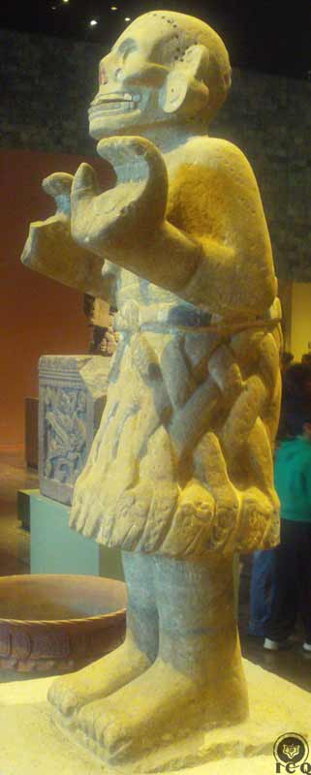
“He who does not know of the laws of the Mother, will never reach the Father. Coatlicue is nothing else than the Blessed Mother, Goddess of Death.”
Figure 12 - "The One with the Skirt of Serpents" [Coatlicue] (Museum of History and Anthropology, Mexico)
Samael Aun Weor

We all have our own particular Divine Mother and that is one of the greatest mysteries the student must discover within themselves; whenever we are faithful to our Divine Mother, she will guide us, care for us, protect us, and illuminate us.

In addition of the serpent being a symbol of occult knowledge, it is also an emblem of the creative force, thus the statement “The One with the Skirt of Serpents” [Coatlicue] is simultaneously a symbol of the sexual creative force, origin of all that is, has been and will be.

The One Adorned with Rattles [Coyolxauhqui] and the Four-Hundred Southerners
The number “400” amongst the Mexica was equivalent to “infinite” or “innumerable”, because their number system was based on the number 20 and 20-times twenty is Four-Hundred. From a cosmic perspective this number is related to the innumerable stars in the firmament, but in the psychological universe of the human being, it is a representation of the innumerable psychological defects we carry within.

“The One Adorned with Rattles” [Coyolxauhqui] is the oldest sister and the rattles painted on her countenance are a symbol of desires and appetites (voluptuousness). Every sincere gnostic student knows the most difficult defect to eliminate is lust; she is an emblem of this psychological defect.

The narrative states these are the children of “The One with the Skirt of Serpents” [Coatlicue], not meaning these are the children of the Divine Mother; we must understand these defects are intimately related to the sexual fire, because the thousands of psychological defects we carry are born and strengthened with the incorrect use of our sexual energy. In this case the “serpent” must be understood to be the sexual fire, but the one we mismanage whenever we allow ourselves to be carried away with animal passion.

“We are not exaggerating in any way when we emphasize the basic idea that the “I’s” that later emerge on the scene of existence are formed in the abdomen. Such psychological ideoplastic entities can never come into existence without the sexual agent.”
Samael Aun Weor

All symbols carry particular meanings, according to the subject matter in question. This is why the teaching can never be interpreted literally with the use of the intellect. It becomes imperative to make use of more superior faculties, as is intuition, so that we can understand these mysteries with the faculties of the heart.

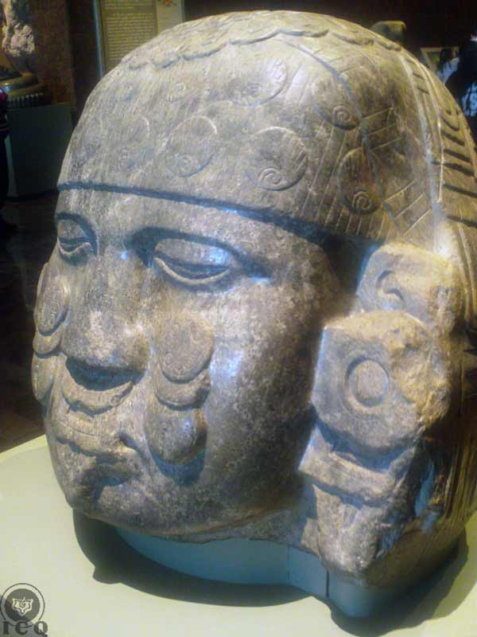
Figure 13 - "The One Adorned with Rattles" [Coyolxauhqui] (Museum of History and Anthropology, Mexico)

Chapter 3 – The True Penance

The efforts we would realize with the purpose of satisfying divine principles could be austerities, discipline, penances, etc., lamentably many of those practices today tend to separate us more from that which has no name, instead of bringing us closer…

“And Coatlicue made penance, she swept because her duty was to sweep, and that is how she made penance in Coatepec, the Hill of the Serpent. And at a certain time as Coatlicue was sweeping, a plumage descended over her as a ball of fine feathers. Coatlicue promptly picked them up and placed them on her bosom, and as she was done with her sweeping, she looked for the feathers on her belly, and did not find them. It was at that moment that she had become pregnant.”
Florentine Codex

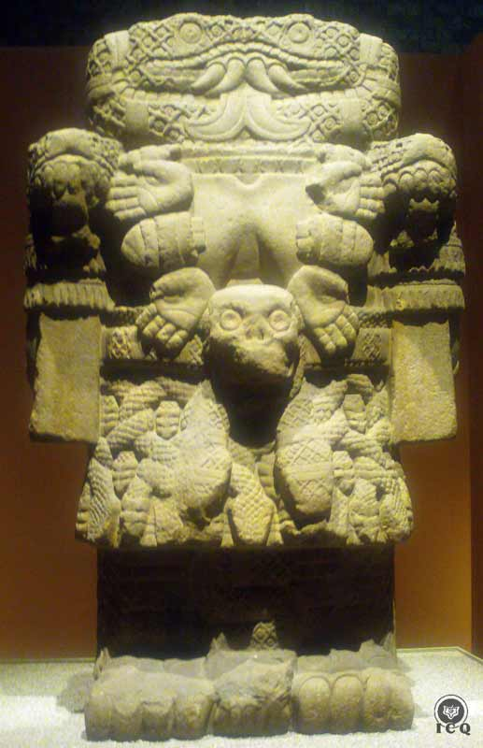
“The One with the Skirt of Serpents” [Coatlicue], our individual and particular Divine Mother was making penance in the Hill of the Serpents [Coatepec]; she was walking the path of initiation, sweeping her internal impurities which is how penance is done.
Figure 14 - "The One with the Skirt of Serpents" [Coatlicue] (Museum of History and Anthropology, Mexico)

In modern times we have an incorrect concept of “penance” and we mistakenly think that which has no name and we refer-to as “God”, would like to see us mutilate, bring pain or harm our bodies; that is the thinking of a degenerated humanity.

In the Bhagavad Gita [the Chant to the Lord], Krishna (the Christ) solemnly states there are some penances or austerities that must not be done:

“Not recommended by the scriptures, but from ostentation and selfishness; those who are bonded and lustful, deprived of reason, torture the organs of the body and torture me, because I dwell in the body. Know them! Their intent is demonic!”
Bhagavad Gita

Divinity is only interested in the penance of the work that leads to our purification: the sweeping of our psyche of all that is wicked and gross and the elimination of the inhumanity that dwells within us. This effort is only possible walking the path of initiation (the hill of the serpent) and with the help of our internal Divine Mother (The One with the Skirt of Serpents [Coatlicue]), as there is no other way to eliminate our psychological aggregates. The only force that can help us is that of our Divine Mother, and she is a part of our own Being.

The specific work that corresponds to us in this is that of comprehending our defects. It is only once this requirement is satisfied, that our Divine Mother can then sweep, clean and disintegrate the defect that we have integrally comprehended at all the levels of the mind.

Fine Feathers
Those who sincerely dedicate their lives to the work of cleansing their psyche of all the undesirable psychological aggregates and who truly know how to take advantage of life itself, who celebrate the opportunity to discover a defect and dedicate the effort of rigorous meditation to comprehend it, are rewarded by their Divine Mother with its disintegration. In Gnostic wisdom this is known as DEATH.

But when the seeker of the path works simultaneously in their “Hill of the Serpent” [Coatepec] alluding to the other two factors that enable the revolution of the consciousness, he then works with superior forces. On one hand the serpent is a symbol of the electric power of love that can be wisely transmuted when we, instead of approaching our spouse with animal passion, sincerely love them and seek the channeling of the creative forces that flow at the time of the connection of the man and the woman. In Gnostic wisdom this work is known as BIRTH.

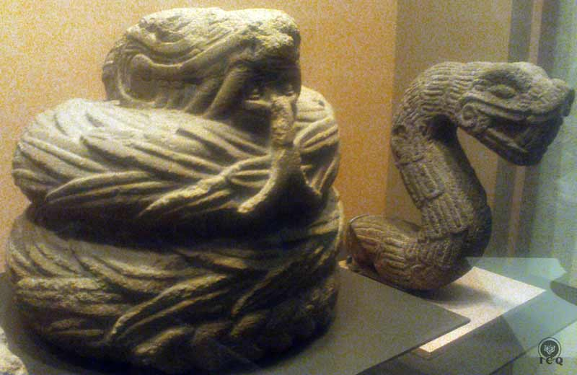
Figure 15 - Feathered Serpents (Museum of History and Anthropology, Mexico)
The very “hill” is indicative of the work that leads to initiation, which is the reward for the sacrifices endured. Any and all selfless help we provide humanity is known in the Gnostic wisdom as SACRIFICE FOR HUMANITY.

Those who are able to sustain such level of internal work can receive the rhetoric ball of fine feathers from above, which among Christians, is the equivalent of the descending of the dove of the Holy Spirit, the arrival of the Condor amongst the Inca or the arrival of the vulture amongst the Egyptians.

The event of the feathers speaks to the possibility of experiencing the birth of the Internal Christ in our heart; just as Jesus was born out of Mary, as the divine twins of the Popol Vuh were born off the virgin Ixquic, and as Horus was born off Isis. These are symbols of the event that can take place within our internal universe.

“Regardless if the Christ were born a thousand times in Bethlehem, if he is not born in our hearts, it is of no use.”
Samael Aun Weor

This is the internal myth represented by “The Left-Handed Hummingbird” [Huitzilopochtli] which is made possible by the intervention of the Holy Spirit (the ball of fine feathers), an event that can only take place when we live a life of penance, sweeping off or cleaning our psyche from all our inhumanity.

The Anger of the Four-Hundred Southerners

“The Four-Hundred Southerners angered when they learned their mother was pregnant, exclaiming ‘who has done this to her? Who has impregnated her? This is an insult and a disgrace’.”
Florentine Codex

The Four-Hundred Southerners symbolize the innumerable psychological defects we carry within and they are commanded by the Head of the Legion: Lust. Lust itself is represented by “The One Adorned with Rattles” [Coyolxauhqui] and the Four-Hundred Southerners rebel before the possibility of facing the birth of the Internal Christ. This is an event they cannot forgive because the birth of the The Left-Handed Hummingbird [Huitzilopochtli] threatens their existence.

We must understand that psychologically, we are not an “individual”. We are a Legion and our psychological defects are innumerable. Each defect has its own mind, believes itself to be the sole owner of the human machine and yet they associate amongst themselves, they trade and share ideas and make fools of us.

Whenever someone makes the effort to awaken their consciousness, the ego sets its resistance; it makes its effort to stop us, defeat us and convince us to renounce of any internal work. It makes use of all possible tricks to reach its goal, among them the false reasoning that leads to errors and a self-deceits that come as constant fallacies of the Ego.

The work is not easy, which is why the Buddha has said:

“Like a frontier fortress, guarded inside & out, guard yourself. Don't let the moment pass by.
Those for whom the moment is past, grieve, consigned to hell.”
Dhammapada 22:10

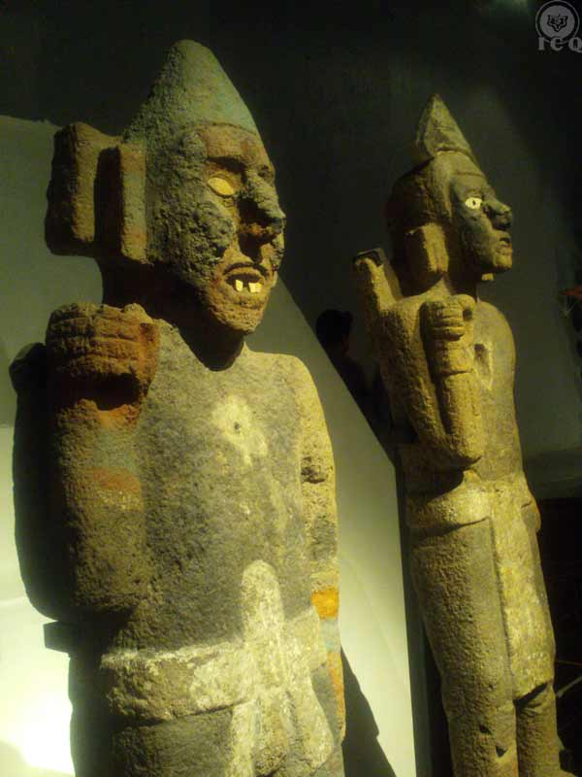
Figure 16 - Warriors (Museum of History and Anthropology, Mexico)

Chapter 4 - The Interior War

The most terrible war we must face is that against our own selves; against our own fears, selfishness, passions, angers, etc. Only the few who are capable of executing this type of war are the ones capable of achieving liberation.

“And their sister Coyolxauhqui told them: Brothers, she has dishonored us. We must kill our mother, the perverse one who is now pregnant. Who fecundated that, which she is carrying in her womb?”
Florentine Codex

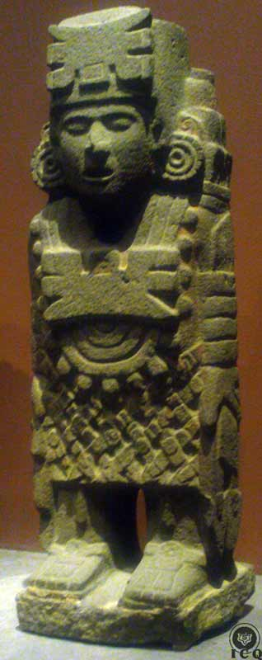
The moment someone attempts to start the awakening of their internal faculties is the moment the Ego multiplies its power to keep us in the deepest sleep of the consciousness.

“As soon as the wretched intellectual animal awakens, even if it is only for a fleeting moment, and opens his eyes before the harsh reality of life, immediately the formidable hypnotic power of the terrible serpent of the abyss returns to the charge with multiplied strength and the unfortunate victim falls asleep again, dreaming that he is awake or about to awaken.”
Samael Aun Weor

The thousands of psychological aggregates we have created and developed within our psyche through countless lives, are reluctant to let go of its prey and will continually feed off the energies that gave them life. This is what happens in each and every one of us, every time we make a mistake, or whenever we identify with the events that take place inside and outside of us. Existing egos strengthen or new ones are created, adding to the countless others we already carry within.

The Doctrine of the Many that has been taught by the Egyptian and Tibetan cultures is real. We are not “individuals” as we have been guessing; within the psyche of each human being exists a multiplicity of “I’s”, they are many and that legion of internal demons seeks to perpetuate.
Figure 17 - Atlantean-Aztec Warrior (Museum of History and Anthropology, Mexico)

The Voice of the Silence

“Scared was Coatlicue as she learned of this, and she was very much saddened. But her son Huitzilopochtli, who was still in her womb comforted her by saying: ‘Do not be afraid as I know what I must do’. And having heard the words of her son Coatlicue was comforted, her heart was consoled and she felt at ease.”
Florentine Codex

It is easy to become demoralized whenever finding out there is a legion of demons plotting within and knowing this enemy is not outside, but inside. Thus we must know that just like on a game of chess, there are black and white pieces that are necessary to play the game. The black pieces in this case are the psychological aggregates that make up the Ego. The white pieces are the various parts of our Being (the positive values of our Spirit). It should not be difficult to visualize there is an army of innocent children within each and every one of us that is arduously working for us to find the path that leads to the light and immortal wisdom. That army of beautiful children are the various parts of our Being and they strive, at every moment of our lives, to heal us, guide us, illuminate us, and console us.

In their efforts to make contact with our human personality, they rely on hunches; Immanuel Kant called those “intuits” and the Helena Petrovna Blavatsky referred to it as “the Voice of the Silence”.

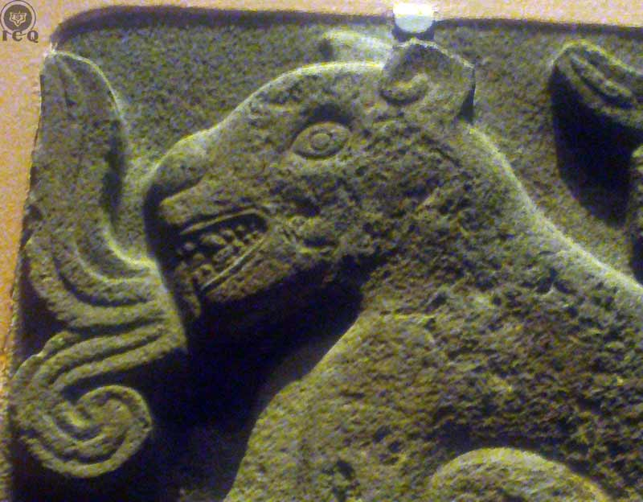
Whenever we are afflicted, demoralized, when we do not know which path to take, or when we feel imprisoned because of the circumstances of life feeling there is not even a ray of light we can reach-out for comfort, we need to resort to that “army of children” that is represented by The Left-Handed Hummingbird [Huitzilopochtli], who is in the very womb of our Divine Mother. We may have not incarnated him yet, but from within our Divine Mother he makes it a point to help us.
Figure 18 - a Jaguar with a glyph of the word emerging from its mouth. The Jaguar is the Innermost and the glyph, the "Voice of the Silence". (Museum of History and Anthropology, Mexico)

He knows exactly what he must do; he has the maps that show the way and he knows of the work that we must perform to make our way back to the source of the Light of Wisdom. He can guide us in every instance of our lives, whether those activities associated with our daily routines or the internal work. But for all this to happen, our personality must be passive (what corresponds to the external world, to the realm of the senses) and the consciousness must become active (in the spiritual work).

We can achieve this if we make it a daily habit, just before beginning our day as well as before going to bed, to relax our bodies and our minds to set ourselves in a state of “remembrance of self”. Such a state allows us to remain present from moment to moment and remembering the different parts of our being that exist within us. As we develop this superior habit, the Voice of the Silence will guide us and comfort us. We will know which are the right actions to take and as we lead our life through the guidance of that voice, we will not err on our way as we walk the path. The voice of the Innermost will manifest itself through hunches, thoughts and intuits that will emerge when the chaotic ocean of the mind becomes silent.

Dressed for Battle

“Meanwhile the Four-Hundred Southerners came to a common agreement and decided to bring death to their mother, as she had dishonored them. They were angry; they were irritated and their hearts palpitated as if wanting to come off their chests… and Coyolxauhqui taunted them, and she enlivened their anger so they would kill their mother. And the Four-Hundred Southerners made themselves ready, and they dressed up for war…”
Florentine Codex

The Ego is negative energy and a poison to the body. It always strives to waste any spiritual powers and prefers hatred, vengeance, ill will, conflict, and all kinds of negative emotions before love and comprehension. The “I” is chaotic, disordered, anarchist, restless, and anxious.

What this segment of the narrative tells us (in symbols) is that Coyolxauhqui (the force of lust) is the one that taunts the Four-Hundred Southerners (our Egos) to kill their mother (shut the Voice of the Silence). In reality, whenever we give free reign to our lust and we fail to control it, what comes afterwards is the upheaval of all our other defects and as a domino-effect, the suppression of all the superior aspects of the human being.

This is why Jesus tells Peter:

“…thou art Peter, and upon this rock I will build my church”,

Because Peter (the Patron of the Great Work) is PATAR, or “the stone” which provides for a solid foundation. This PATAR or “stone” is a superior aspect of sexuality; one that is edifying, dignifying and based on true love. This superior type of sexuality is outside and beyond any of the many types of infra-sexual behaviors we engage-in such as adultery, fornication, sadism, pornography, acts of violence against nature, etc.

Perhaps we could correspond fish in the sea with the psychological aggregates and lust, they are both sustained because of the inherent living force of water.

PATAR (Peter) is the stone of supra-sexuality. This is better explained in the Book of Matthew:

“Therefore whosoever heareth these sayings of mine, and doeth them, I will liken him unto a wise man, which built his house upon a rock. And the rain descended, and the floods came, and the winds blew, and beat upon that house; and it fell not: for it was founded upon a rock.”
Matthew 7:24-25

The Apostle Matthew clearly teaches that (whether single or married) when we transmute and channel our creative energies, we keep the ego from building its strength and from holding control over our senses; otherwise these internal demons will bring death to the few virtues that may still exist in us.

“…and these Four-Hundred Southerners were as captains; they twisted and tangled their hair, they fixed their hair as warriors for battle.”
Florentine Codex

This is our reality and the Four-Hundred Southerners are a symbol of how our aggregates are not only autonomous, but how they come together and associate to put into use their structure and execute their transactions.

Each psychological aggregate has its own mind and acts with its own intelligence to assume control over the human machine. They act as warriors in a battlefield, they are deliberate and measured in their actions and they work with each other seeking of that energy which can feed them and strengthen them.

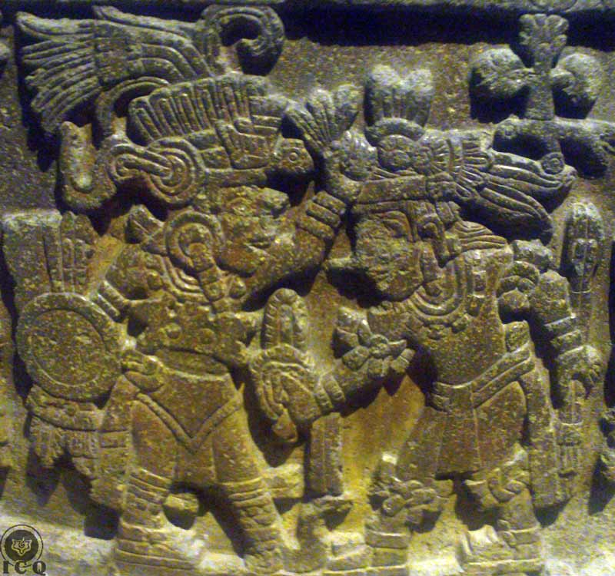
This is how we must see this legion of demons that lurk within our internal universe. These are tenebrous warriors of the darkness and they make themselves ready, from moment to moment, to attack our sublime principles and finish off our spiritual strength. What is worse is that these are the creations we have carried for many lives and they are a product of our own incorrect way of living.

This happens within the psyche of each and every one of us and yet, none of us suspects this is happening. We are truly ignorant of the events that take place within our interior realms.

Figure 19 - Details from the Stone of Montezuma (Museum of History and Anthropology, Mexico)

Chapter 5 - The State of Alert Novelty

The only way we can discover our psychological defects is by directing our attention inboard, into our psychological space. We must be as the lookout during the time of war, but not to observing others, but our own selves.

“And one of name Cuahuitlicac made use of his words for falsehood. All that was said by the Four-Hundred Southerners, he carried over and told Huitzilopochtli. And Huitzilopochtli in turn would reply: “Be careful and remain vigilant uncle of mine, as I know very well of what I must do.”
Florentine Codex
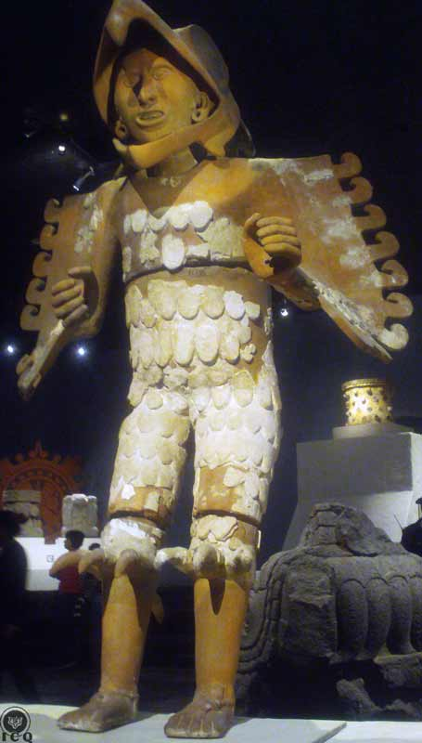
Our ignorance about the high level of activity of our ego serves to the ego’s own advantage. All of this activity takes place within us and what we get to perceive, is a mere fraction of all it does.

This is why we must cause the emergence of “The Standing Eagle” [Cuahuitlicac] – one of the Four-Hundred Southerners – within us. He was the one aware of all of the dark plans of his brothers and also the one who went to the “Left-Handed Hummingbird” [Huitzilopochtli] to warn him, though he was still in the womb.

We must not think “The Standing Eagle” [Cuahuitlicac] is just one more psychological aggregate. The teaching invites us to develop the superior discipline of self-observation, in such a quality that we create the impression that we stand right next to our aggregates as we observe them. This effort requires of our total attention into our mind and to what is perceived by our senses, which is why Gautama the Buddha said:

“Glory to him who makes the effort and remains vigilant, who is pure in his conduct, considerate, self-controlled, who lives a life of righteousness, and who is capable of holding an ever-growing attention.”
Figure 20 - An Eagle-Knight (Museum of the Major Temple, Mexico)
Dhammapada

The Attack of the Southerners

“And when they had managed all to make their mind, the Four-Hundred Southerners were resolute, and they went off to kill their mother. They were led by Coyolxauhqui.”
Florentine Codex

The vast majority of the activities we hold on a day-to-day basis are inclusive of the involvement of our psychological aggregates (our individual and particular Four-Hundred Southerners) and these are the ones that manifest aspects like ambition, envy, pride, laziness, self-worth, etc., and frankly all it takes is a little self-observation to realize that many of them are driven by lust. They are led by our internal “One Adorned with Rattles” [Coyolxauhqui].

But we have become so accustomed to the false gratification of these manifestations that we fail to realize they are resolute to destroy those aspects which are truly divine and real; kindness, compassion, love, and all other superlative virtues. In other words, for as long as we do not work towards their elimination, we are then also conspiring to destroy that which is sacred. And today we do not stop to reflect; meanwhile our remorse continues fading away and we continue to live our lives thinking that these defects are just part of ourselves, so we justify our mistakes assuring we have committed no wrong.

“They wore their rugged attire for warfare; they distributed amongst themselves their paper garments, their anecuyotl, their nettles, their adornments of colored paper, they tied handbells around their calves – handbells called oyohualli. Even their spears had serrated tips.”
Florentine Codex

It is almost impossible to enumerate all our defects. Vigil, the poet of Mantua wrote:

“Even if we had a thousand tongues to speak and a palate of steel, we would still be unable to enumerate all our defects.”

Our defects are rugged and their level of complexity is such that we can find them behind the totality of our actions, our sentiments and our thoughts.

Their means of manifestation are intricate and imperceptible because of the deep sleep of our consciousness, and yet, deep within our psyche they are dressed in their war attires and ready to fight for the elimination of our superior values that are of a transcendental nature.

They are experts creating distractions as they confront us in the internal battle, which is symbolized by the Southerners dressing up with their paper attires, the wearing of animalesque adornments on their heads (the anecuyotl), the distractions of their nettles, the handbells on their calves [oyohualli], and the spears with serrated tips; these are all allegories to the many distractions by which the ego deceives.

How many times have we not tried to end a vice or a bad habit, to find that our individual and particular Four-Hundred Southerners dress up for war and create internal distractions that lead us to failure? In most instances that happens without us even realizing what has taken place and thus, we fall back into creating justifications for our incorrect attitudes and continual changes of mind.

“For example, if we are cruel with our wife, children, relatives, etc., we ignore it… The worst thing is that we allow this situation to continue, especially because we like it, and because it is so easy; and if someone accuses us of cruelty, we will probably smile, thinking they do not comprehend our righteousness, mercy, and infinite love... We are caught in the horrifying coils of the great serpent, yet we believe ourselves to be free.”
Samael Aun Weor

Then they got moving, they went in order, in a row, in orderly squadron, guiding them Coyolxauhqui.
Florentine Codex

The many thousands of defects we carry within are in constant movement, their strategies are much defined, they intertwine with each other, and they are never alone. In many instances these defects will allow for the manifestation of lesser defects that go undetected, and when we least expect it, these have created associations with other much perverse and harmful, taking over control over our human machine.

We live in the midst of all of this, without ever thinking not even for an instant, these events are taking place; we are victims of our own creations and much worse, we do not even understand the complexity of the chaos we have created.
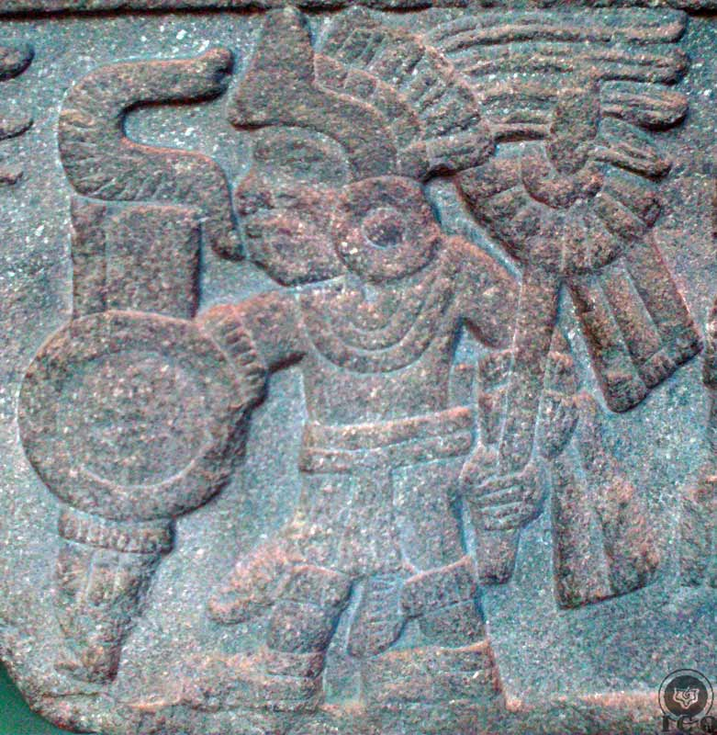

Figure 21 - A warrior. (Museum of History and Anthropology, Mexico)

Psychological Self-Observation

“And Cuahuitlicac rushed up the mountain to speak from there to Huitzilopochtli and said: ‘They’re coming’.”
Florentine Codex

Not everything is lost because within each human being exists not only the causes of their own sufferings and misfortunes, but also the very capacity to overcome them.

The secret is allowing “The Standing Eagle” [Cuahuitlicac] to manifest within us; the eagle represents a superior state of alertness and it is shown standing to emphasize the urgency behind the mystical quest with all of its attention focused on the internal realms. The eagle is a symbol of that part of ourselves that can thrive on self-criticism, because

“He who criticizes others is weak, while he who criticizes himself from moment to moment, a colossus.”
Samael Aun Weor

“The Rows of Heads” [Tzompantitlan]

“Huitzilopochtli asked: ‘Where are they coming from?’. Cuahuitlicac answered: ‘They are already by Tzompantitlan’”.
Florentine Codex
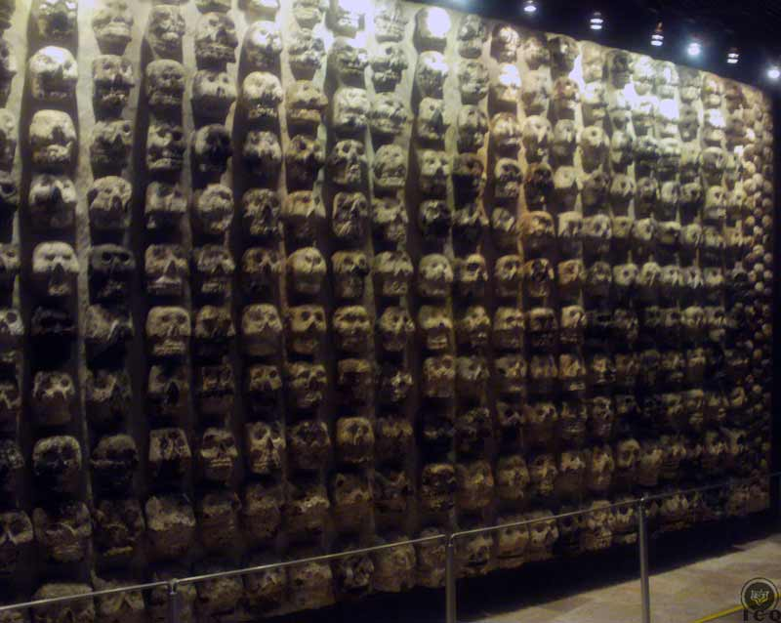
Figure 22 - The Wall of Heads [Tzompantli] (Museum of the Major Temple, Mexico)
The Four-Hundred Southerners had already reached the heights of the place known as “the rows of heads” [Tzompantitlan]. This is the place where the craniums of enemies defeated in previous battles were set on stakes and arranged in rows.

Our ego is the root cause of all our illnesses, our sufferings and our death. This is why the Southerners are seen walking “between the rows of heads”, because the heads of the enemies symbolize our pain and suffering and the Southerners, the ego in manifestation.

The instruction from our internal Christ called “The Left-Handed Hummingbird” [Huitzilopochtli] is that of observing where are our psychological defects, to understand what harm they are causing us, what harm they are creating to our neighbor, and how much more damage they can effect if they were to remain in existence.

“It is very clear and not difficult to comprehend that when one seriously begins to observe oneself from the point of view that the “myself” is not “one” but “many,” one then really begins to work on all that is carried within.”
Samael Aun Weor

“The Sands of the Serpent” [Coaxalpan]

“And yet again Huitzilopochtli asked: ‘Where are they now?’ and Cuahuitlicac replied: ‘They have reached the Coaxalpan’.”
Florentine Codex

Sand, rocks, stones and serpents are all symbols of the sexual creative power.

It becomes of vital importance for us to know “where are they coming from” so we can comprehend our aggregates as they manifest through our habits, our intellect, our emotions, our instinct, and our sexuality. As we observe ourselves, we can find out that a naïve friendship with someone from the opposite sex could manifest as a beautiful ideal in the mind, as love in our emotions, and with certain morbidity in our sexuality. In many instances we even experience adultery within the mind and all of this, without noticing.

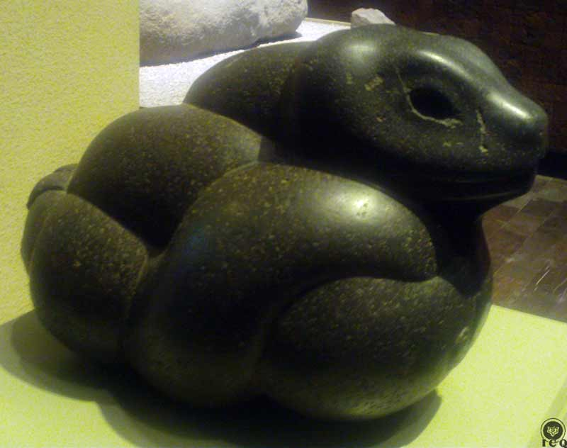
Figure 23 - Knotted Serpent. (Museum of History and Anthropology, Mexico)

The Hillside of the Mountain

“And then again Huitzilopochtli asked Cuahuitlicac: ‘Observe where they are coming from’. Cuahuitlicac replied: ‘They have reached the hillside of the mountain’.”
Florentine Codex

Not all our defects are horrendous; many of them present themselves so subtly that they even manage to become part of the most sincere longings that are part of the internal work, meaning that even the most sincere, experienced, practitioners of the internal work will find defects as they climb their individual mountain of initiation.

It is vital that we maintain a state of alert novelty and alert perception to what takes place in our mind, because it is common to see those who walk into these studies who forget to remain “observant of where they are coming from” and as time goes by, they start thinking of themselves as the reincarnation of someone famous, or they start feeling realized and spiritually successful, or perhaps start calling themselves an “old soul”; when deep inside those expressions are no more than pride and obviously, their efforts derail from the path.

“Hindrances, obstacles, stumbling blocks for the work of intimate Self-observation, such are the following psychological defects:

“Megalomania: delusions of grandeur, to believe that one is a God.

“Self-worship: belief in a permanent “I,” adoration of any type of alter-ego.

“Paranoia: the know-it-all ignoramus, self-sufficiency, vanity, thinking oneself infallible, mystical pride, a person who does not like to see another person’s point of view.”
Samael Aun Weor

Huitzilopochtli is clear: “Observe where they are coming from”. Our internal state of alertness must be intensified for all our activities, during each one of our meals, at work, at the time of study, even when having fun. It is when we are interacting with others that we can see where our psychological defects “come from”.

But observation is only part of the effort. We must observe our own observations, which is only possible through the effort of deep and profound meditation of that which we have discovered. Anyone who chooses to start working upon themselves will inevitably begin the effort of self-discovery.

It is more than impossible for us to eliminate what we do not know exists, so in our efforts, we must strive to discover the very roots of the defect we wish to eliminate. Until there is no comprehension, there cannot be elimination.

“It is not enough to intellectually comprehend the psychological defect. It is necessary to submerge ourselves into profound inner Meditation in order to catch the defect in all the levels of the mind.”
Samael Aun Weor

At the Top of the Mountain

“And yet once again asked Huitzilopochtli: ‘Observe where they come from’. Cuahuitlicac replied: ‘They have reached the top of the mountain… they are here… Coyolxauhqui is leading them’.”
Florentine Codex

Sivananda refers to this path as “the path of the double-edged blade” because it offers dangers up, down, inside and out. In this work we cannot afford to not remain vigilant and let off our guard, because whenever we are thinking we are doing well, in reality we are not. The sentiments of “doing well” are specific to any one ego that has assumed control of our mind and our heart.

Our defects can disguise themselves with the masks of the most profound longings and take us straight to hell, as it has been written:

“The path to hell has been paved with the cobblestones of good intentions.”

This is why it becomes of utmost importance to keep an eye on the Four-Hundred Southerners that are led by the destructive fire of lust, and to know where they are coming from at every moment.

“The “I” is always perverse; sometimes it adorns itself with beautiful virtues and even wears the robe of sanctity.

“When the “I” wants to cease to exist, it does not do it in a disinterested and pure manner; it wants to continue in a different manner; it aspires for reward and happiness.”
Samael Aun Weor

In the Eastern doctrine, the wise ones say that we must be very attentive towards our own selves, just like the cat is watchful over the mouse and the hen over her eggs. This intensified state of alertness is what enables the emergence of “The Standing Eagle” [Cuahuitlicac] in each one of us.

“Vigilance and lucidity are the paths to immortality. Those who remain watchful stay alive. Negligence is the path of death. Those who are negligent are as good as dead.”
Buddha

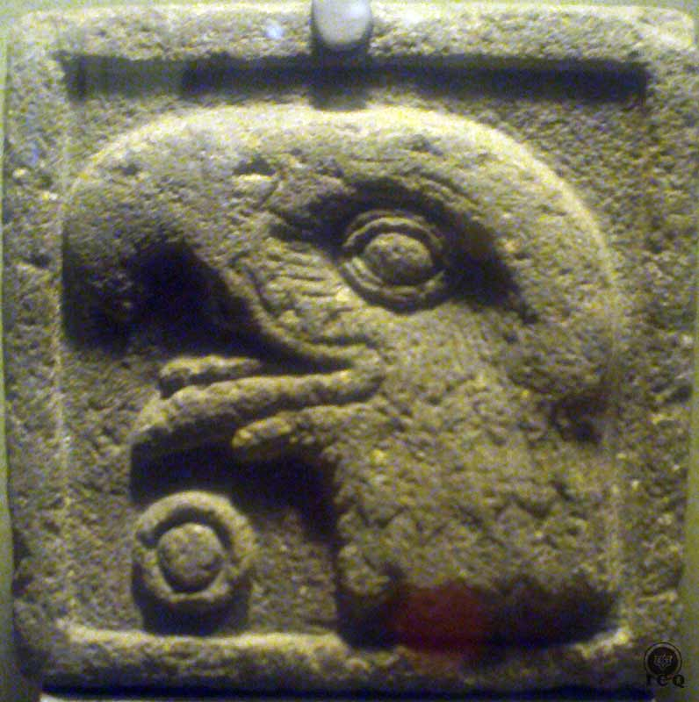
Figure 24 - (Number) One-Eagle. (Museum of History and Anthropology, Mexico)

Chapter 6 – The Birth of Huitzilopochtli

The birth of Huitzilopochtli is a transcendental event that must take place within the inner realms of each one of us. This very same event is represented by the birth of Jesus on a December 24th, just like is the birth of the Persian God Mithra and the Nordic God Freyr; they all take place around the winter solstice.

“And at that moment Huitzilopochtli was born, and he dressed up in his battle garments and bore his shield of eagle feathers, his darts, his blue dart thrower also known as his turquoise dart thrower. He adorned his face with diagonal stripes of ‘the color of children’. And over his head he placed a crown of fine feathers and his earrings. His left foot was skinny and he wore a sandal covered in feathers, and both of his legs and his arms were painted blue.”
Florentine Codex

It should be of no surprise to see the birthdate of the “Left-Handed Hummingbird” [Huitzilopochtli] to take place, according to the chronology of the Mexica, the last day of the fifteenth month of the Nahuatl calendar (the “day of the rising of the flags” [panquetzaliztli]), which corresponds to December 19.

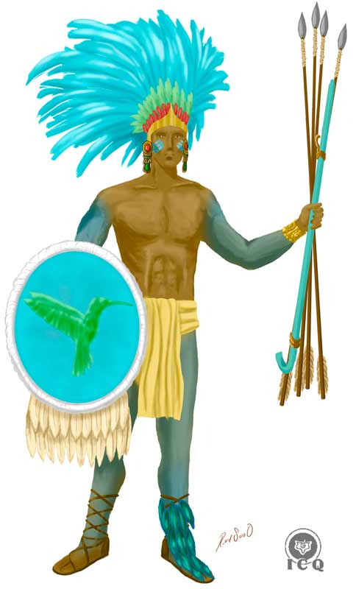
There is a marvelous coincidence behind these dates and it is because the Christ has always been associated to the Sun; the ancient Christians used to say “Our Lord Jesus Christ the Sun” and Huitzilopochtli is the God of the Sun.
Figure 25 - "Left-Handed Hummingbird" [Huitzilopochtli]

It so happens the wise elders intelligently related the event of the spiritual birth with the cosmic event of the winter solstice where, precisely on this day, the sun stops its travels south and starts its return once again towards the northern hemisphere; a symbol of birth. Solstice means “the sun” (sol) “stops” (-sticio). The winter solstice allegorizes the birth of the Christ to impart life to all that is, has been and will be.

This cosmic event in both the gnostic and esoteric traditions, corresponds to the Venustic Initiation, when the internal Christ is born in the heart of the human being. This magnus event is only achievable by the truly noble souls who have exercised a previous sacrifice for humanity and who have achieved a superior spiritual development.

This is why at the time he was born, he immediately donned his battle gear and garments, as these correspond to the solar bodies, special vehicles that are necessary for the manifestation of our Spirit (our Being) because the ones we have today are of a lunar nature and unsuitable for the Being to manifest. It is only possible to create the solar bodies by the intense work of the transformation of our creative energies and truly loving our spouse.

“In order for the Savior to be born, the event of Bethlehem has to be repeated; such an event is very profound and at the same time symbolic. The town of Bethlehem which the Gospels refer to is very allegorical. It is said that this small town did not exist in the epoch of Jesus of Nazareth. If we analyze the word Belen (which is Bethlehem in Chaldean), we have Bel-En. Then, we see that Bel in Chaldean terminology signifies “tower of fire.” When is this tower of fire attained? This is attained when one has created the superior existential bodies of the Being, when the sacred fire has reached the superior part of the brain. This is how the advent of Bethlehem occurs.”
Samael Aun Weor

The superior Level of Being that must be achieved by the practitioner to become worthy of experiencing the Christmas of the heart is symbolized by each of the elements that make up Huitzilopochtli’s garments and his battle gear.

The Shield of Feathers

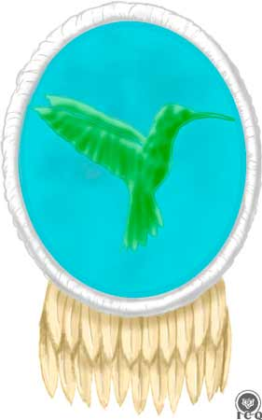
The shield of eagle feathers is the means to be protected against external negative forces and this is only possible through the power of love, the most powerful force in the universe. But the shield being made specifically of eagle feathers is quite meaningful, because the eagle among the Aztecs, is equivalent to the dove of the many European traditions representing the Holy Spirit – which is at the very root of our sexual energy. This shield shows the close relationship between the power of love and the wise use of the sexual energy.

Earrings
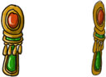
The earrings are a stamp that demonstrates the student has learned to listen to the voice of the Father and that he leads himself by the Voice of the Silence that comes from his heart. This is a symbol of they who place all of their attention to the will of the Father who is in secret.

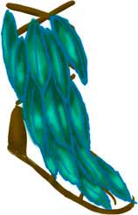
Sandals
The sandals adorned with feathers are a symbol of humbleness; for as long as we continue to carry our pride, our self-importance, self-sufficiency, our conceitedness, prepotencies, and selfishness, any progress on these efforts is nevertheless impossible.

Darts

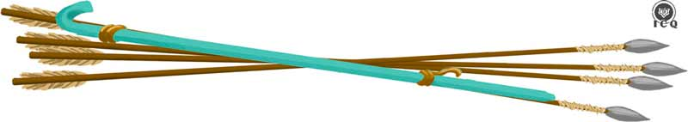
The darts and the turquoise dart-thrower are of particular interest because arrows, spears and darts are a common cross-cultural symbol of the electric, sexual force. The color turquoise shows this force is put to use in both harmony and balance with the spiritual longing and an intelligent magical power awakens.

The Crown of Feathers
When the crown rests on the head (associated to the mind), they emphasize the importance of the dominion of the mind; we must make an effort to exterminate our terrestrial mind, which has become the shelter of our desires, and allow for the development of a mind that can be put at the service of the spirit. Helena Petrovna Blavatsky has said:

“[…] the mind is akin to a mirror; it gathers dust even as it reflects. It needs of the gentle breezes of the wisdom of the soul to remove the dust of our illusions. Strive to fuse your mind with your soul.”
Helena P. Blavatsky

Huitzilopochtli dyes his arms, legs and part of his face with a hue of blue, and Master Samael Aun Weor is quoted in the book The Revolution of Beelzebub stating: “[…] will irradiate a blue light which is that of love”, and this explains the color. Huitzilopochtli is the Intimate Christ and his primary attribute is precisely that of love; which the practitioner must truly develop if they are to incarnate him.

It is nothing but impossible to experience the birth of the Christ in our hearts if these characteristics are not but fully developed within.

“Christmas is a cosmic event that must be realized in each and every one of us.”
Samael Aun Weor

Chapter 7 – The Serpent of Fire [Xiuhcoatl]

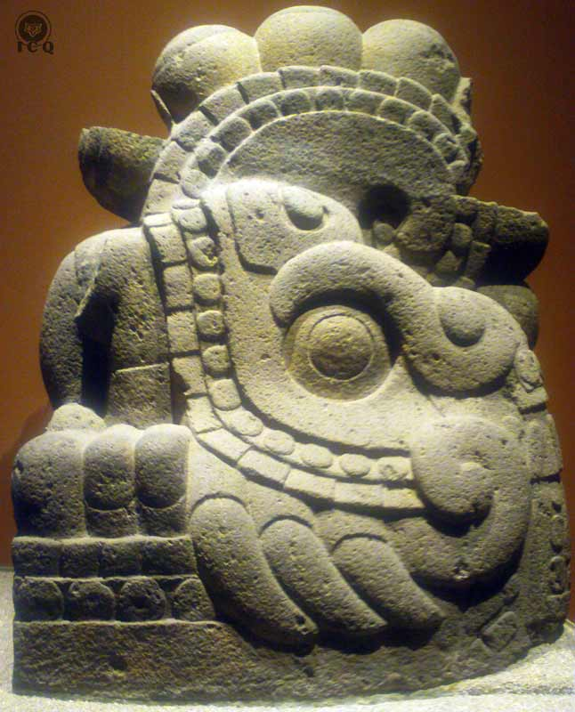
Figure 26 - "Serpent of Fire" [Xiuhcoatl] (Museum of History and Anthropology, Mexico)

From the most ancient times all of the great cultures of the world have worshipped fire, but it must be noted that the worship is not to be taken literally as a worship to the fire that can be used to prepare a meal, or perhaps to the fire that comes with lightning but rather, the fire that exists in potentiality, in a latent state within our occult anatomy.

“And the one whose name was Tochancalqui set fire to a serpent made of firebrands called Xiuhcoatl, which obeyed Huitzilopochtli.”
Florentine Codex

By now the story has transitioned into an important aspect of the internal work, which is the use of the sacred fire or the “serpent of fire” [Xiuhcoatl] to increase our capacity to exterminate the ego.

There are significant similarities between the Kundalini serpent of the Hindis, the Winged Serpent of the Egyptians and Xiuhcoatl, the serpent of fire of this story.

This is a very special fire that is associated to our individual and particular Divine Mother, “our venerated mother” [Tonantzin], “mother of the Gods” [Teteoinan]. Our Divine Mother manifests in five different ways and one of them is her expression as the fire contained within the chakra of the coccyx, known as the Chakra of the Foundation or MULADHARA. She appears as a serpentine fire and this is why various cultures represent it in the same way.

This is a fire that can only be awakened by practicing the superior ritual of the magic of love within the bond of matrimony, which is why there is a need for an additional, active character in this myth: Tochancalqui or “the one who inhabits our dwelling”. It is this one “who inhabits in our dwelling” [Tochancalqui] who lights the serpent of firebrands, meaning that it is only in our home, in matrimony, when we truly have learned to love, that this fire will awaken.

This is why the path of the Revolution of the Consciousness is also known as the “Path of the Domestic Hearth”; it is in our home where we find the secret to liberation.

Those who are capable of awakening this sacred fire and who learn to control it, can direct it against the very psychological aggregates and destroy them – provided the right efforts have been made to comprehend them. Our defects are of a strong and robust nature and a superior power is required to disintegrate them. Fortunately this power exists in potentiality within every human being.

“And with it he hurt Coyolxauhqui and beheaded her, and her head was left abandoned along the hillside of the Coatepetl. Her body tumbled down the hill and became dismembered; her hands, her legs and her body fell apart and landed everywhere.”
Florentine Codex

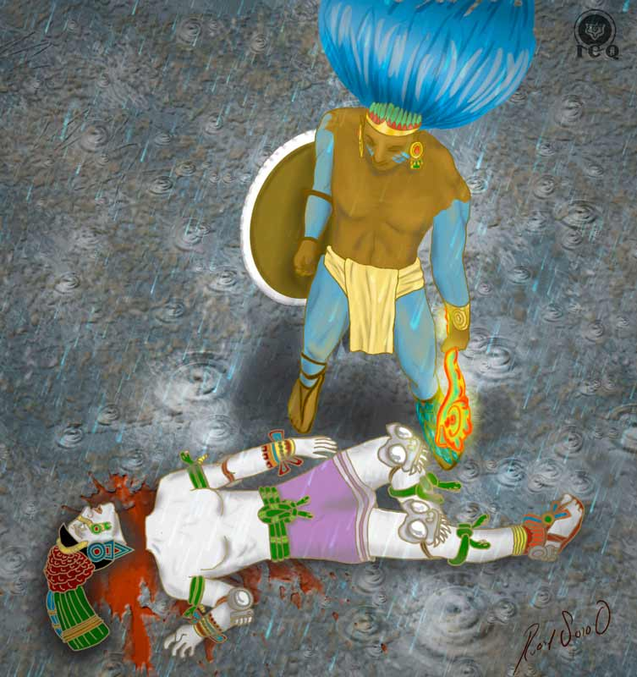
Figure 27 - Huitzilopochtli defeats Coyolxauhqui, "the one adorned with handbells"

The Egyptian Book of the Dead gives some indications on how to project the sacred fire against our psychological aggregates:

“Flee you crocodile-faced demon, your abode is in the West! Know thee that the Spirit-Serpent NAAU dwells within my chest and I will release it against you! So your fire cannot affect me.”
Egyptian Book of the Dead

At this point in the story we find both the positive fire of the “Serpent of Fire” [Xiuhcoatl] and the negative fire of “the one adorned with handbells” [Coyolxauhqui]. When they are present simultaneously they represent the Serpentine Binary, the battle of the forces of good against evil within us.

This positive fire is also symbolized by the Serpent of Bronze that healed the Israelites in the desert and the negative, by the tempting serpent in the Garden of Eden.

In the Gnostic tradition, the positive fire receives the Sanskrit name of Kundalini and the negative fire, is the Kundabuffer; “lini” is an Atlantean word that means “the end of” and “kunda” refers to the fatal negative fire.

Even the wise Solomon left us a prayer known as “The Conjuration of the Four” where it says:

“Writhing serpent, crawl at my feet, or be tortured by the sacred fire and give way before the perfumes that I burn in it!”
Conjuration of the Four of the Wise Solomon

And this is a reference to the two contrary forces that dwell within us. Solomon coincidentally associates them with both, a serpent, and with fire.

“Let us distinguish between the tempting serpent of Eden and the bronze serpent that healed the Israelites in the wilderness, between the horrifying Python that writhes in the mud of the earth and the irritated Apollo wounded with his darts and the other one entwined, ascending around the rod of Aesculapius, the god of medicine.

When the igneous serpent of our magical powers ascends along the spinal medullar canal of the human body, it is our Divine Mother Kundalini. When the igneous serpent descends downwardly projected from the coccygeal bone towards the atomic infernos of humans, it is the abominable Kundabuffer organ.”
Samael Aun Weor

The Gnosis of Samael Aun Weor is emphatic in the destruction of the negative fires of our animal passions, origin of our most bestial desires and “original sin” mentioned in the bible, which is symbolized here by “the one adorned by handbells” [Coyolxauhqui].

It is only possible for us to destroy that fatal fire by wielding our “Serpent of Fire” [Xiuhcoatl] once it has been lit by “the one who inhabits in our dwelling” [Tochancalqui], meaning that with the true and authentic love that emerges from the wise use of our creative energies and in a matrimony that knows to hold respect for the cosmic and sacred equanimity of the home, our aggregates can be destroyed.

Once this is achieved, the sincere practitioner who seeks self-knowledge can then direct their sacred fire against the various elements that make up our animal passions and decapitate them. Doing so will result in the fatal end of our individual Coyolxauhqui: dismembered, she will tumble down the hillside of our “Mountain of the Serpent” [Coatepec].

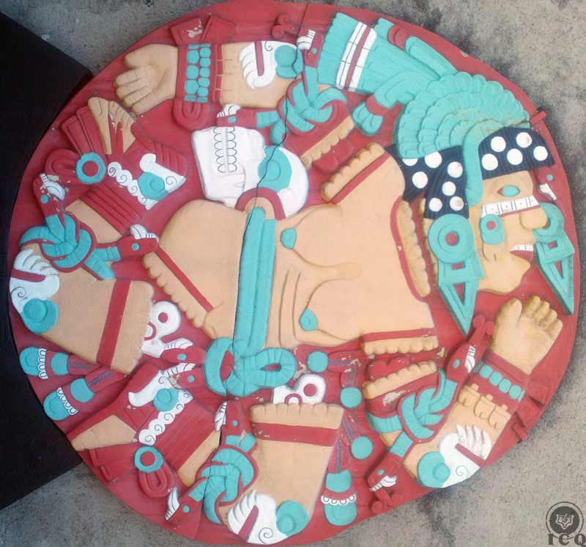
Figure 28 - "The one adorned with handbells" [Coyolxauhqui] tumbling down the hillside of the "Mountain of the Serpent" [Coatepec] (Museum of History and Anthropology, Mexico)

Chapter 8 – The Death of the Ego

The elimination of our many defects (those “Four-Hundred Southerners”) is a major task that can only be accomplished by the true warriors of life.

“Then Huitzilopochtli stood and chased the Four-Hundred Southerners, he taunted them and made them disperse down the hillside of the Coatepetl, the mountain of the serpent. And once he got them to the foot of the mountain, he taunted them again and again chased them, as if hares, again up the mountain. Four times he did this.”
Florentine Codex

Eliminating our defects is not a trivial task. Fortunately there are superior spiritual forces willing to lend us a hand in this difficult work. Beethoven’s Choral Fantasy for Piano and Orchestra, Opus 80, says:

“If a spirit is encouraged, a choir of spirits always echoes for him.”
Choral Fantasy, Op. 80

These spirits are the masters of the White Brotherhood that we may as well refer to as Angels; they diligently aid those who work intensely upon themselves in a sincere effort to reach an internal revolution.

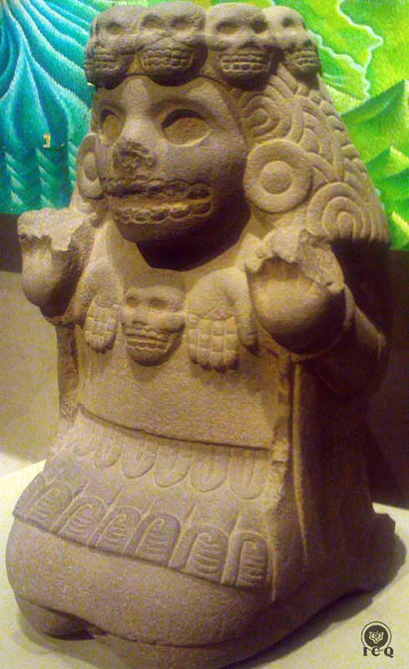
But there is also help that comes from within, as there are parts of the Being that aid the sincere aspirant as he works upon himself; these are the Divine Mother and the Intimate Christ, who the Mexica’s referred to as “the left-handed hummingbird” [Huitzilopochtli].

The Intimate Christ will aid anyone who sincerely works in the effort of disintegrating their psychological aggregates, but in those who become capable of incarnating it, it will become the sole owner of their will, emotional and mental functions. They will experience a divine-human symbiosis that effectively intensifies the work in the elimination of the practitioner’s psychological defects, or “Four-Hundred Southerners”.

“The Intimate Christ emerges from within during the work that seeks the dissolution of the psychological aggregates. Obviously the Inner Christ only arrives at the peak of our voluntary sufferings and intentional efforts. The arrival of the Christic fire is the most important event of our lives. It is then that the Internal Christ assumes ownership of all of our mental, emotional, motor, sexual, and instinctive processes. Without a doubt, the Internal Christ is our internal, profound savior.”
Figure 29 - The Goddess of War [Cihuateotl] (Museum of History and Anthropology, Mexico)
Samael Aun Weor

“And all efforts against him were in vain, in vain they revolted against him as they rattled their handbells and clashed their shields. There were able to do nothing, they achieved nothing, and they could not defend themselves. Huitzilopochtli taunted them, chased them, destroyed them, killed them, and annihilated them. And even so, he did not stop and many of them pleaded and begged: ‘Enough!’.”
Florentine Codex
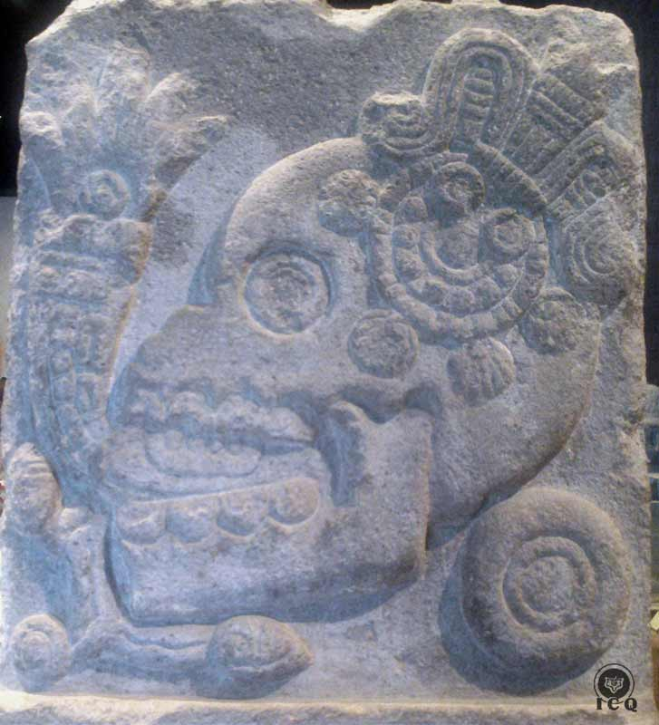
Figure 30 - Cranium, symbol of the death that takes place in battle and out of its mouth, a symbol of burnt water. (Museum of History and Anthropology, Mexico)
Medieval Alchemists speak about the three purifications of iron and fire that must be endured as a means to show the depth of the work that must be realized. These are the three works where we seek the mystical death; the three negations that Peter expressed before the rooster crowed.

There are three levels of internal work: we must first eliminate the all of the psychological aggregates on the visible side of our psychological moon, these are the most easily visible defects anyone can see that with a bit of observation, we can also discover. These are aggregates like those of vanity, pride, anger, conceitedness, laziness, etc.

The rest of the work has to do with those many other aggregates that exist within the depths of our sub- and infra-consciousness – in the dark side of our psychological moon – because these also exist and they nourish themselves from our creative energies without us knowing about it.

The Twelve Works or Labors of Hercules (Roman name for the Greek divine hero Heracles who is a representation of the Christ) show the processes through which our dark psychological aspects must be brought to death.

“Heracles (the Cosmic Christ), the son of Jupiter (IO Patar) and Alcmene, performed the Twelve Labors:
- Capture and death of the Lion of Nemea (the strength of the uncontrollable instincts and passion that devastates and devours everything).
- Destruction of the Hydra of Lerna (the psychological defects of the sub-consciousness).
- Capturing the stag of Cerynitia and the boar of Mount Erymanthus (the lower animal passions).
- The cleaning of the Augean stables (the submerged depths of the sub-consciousness).
- Killing the birds of the lake of Stymphalian (witch-like psychic aggregates from the depths of the unconsciousness) with arrows.
- The capturing of the bull of Crete (passionate, thoughtless sexual impulses, infrahuman elements).
- Capturing the mares of King Diomedes (passionate, infrahuman elements that are profoundly submerged in our own unconscious abysses).
- He eliminated the giant thief Cacus (the evil thief that squanders the sexual center in order to satisfy his animal passions).
- The conquest of the girdle of Hippolyta (the feminine psychic aspect of our own interior nature).
- The conquest of the cattle of Geryon (related to detachment).
- The stealing of the golden apples from the garden of Hesperides.
- The taking of the dog Tricipite (Cerberus) from the realm of Pluto (the guide dog, the sexual instinct).

Heracles, the instructor of the world, has to perform the Twelve Labors, a complete work of pacification, each time that he comes. The Cosmic Christ practices what he preaches. When he is little, the tenebrous serpents of evil come to attack him, Herod persecutes him, etc.”
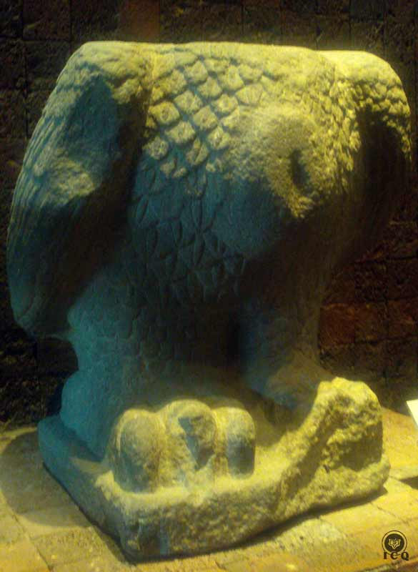
Samael Aun Weor

Yet, even farther along there is the germ or seeds of the ego; which means that we must never underestimate the work that is required for self-discovery. The effort on this labor is not only magnificent, but demanding and permanent.

And this is why we see all over the world “death” as a symbol in the foundation of any work relevant to spiritual advancement; whether it is a throne carved as a skull, or monks like St. Francis of Assisi with a skull on his table, or walls in sacred temples showing carvings of skulls. It is all an invitation to embrace psychological death.
Figure 31 - A decapitated eagle, symbol of the Death of the Ego. This particular symbol shows the need to stop the incorrect use of the mind. (Museum of History and Anthropology, Mexico)

Chapter 9 – The Liberation of the Essence

The Essence is that which is truly divine and dignified within the human being, it is the collection of the values of the soul, virtues that must naturally manifest in each one of us. Lamentably this divine material is trapped in the confinements of the Ego.

“But Huitzilopochtli was not satisfied and with his might he continued to attack them. Only a few of them were able to escape, as they managed to free themselves from his grasp.”
Florentine Codex

The work on the death of the ego must be consistent and persistent, it is not meant to be superficial work or an effort expected to take a few months or perhaps a few years. This is an initiative that takes life itself and we must never become complacent.

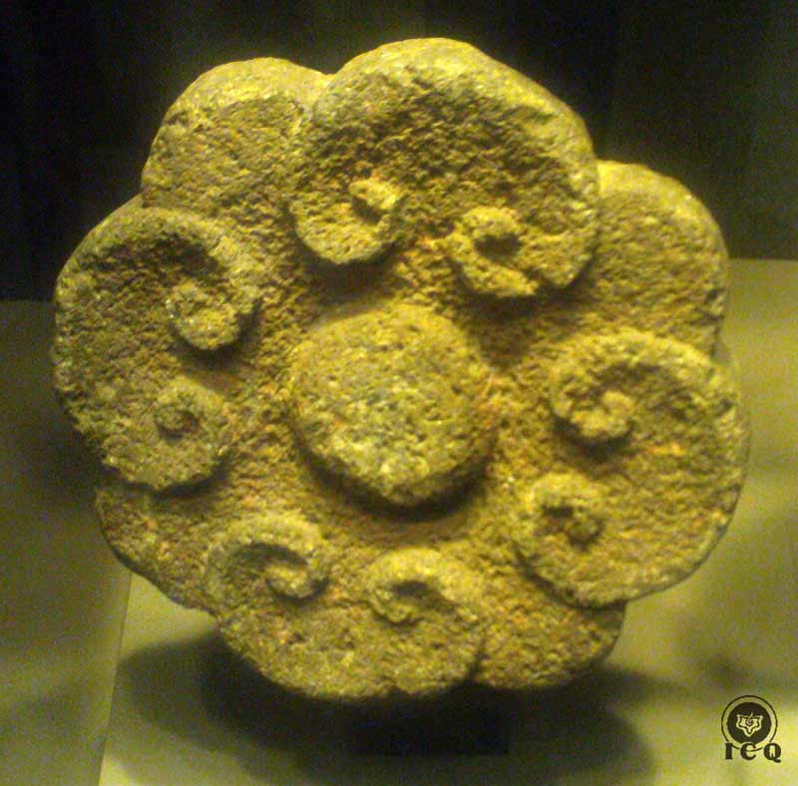
Figure 32 - A flower, symbol of the Essence (Museum of History and Anthropology, Mexico)

The narrative states that a few of the Southerners were able to escape certain death, which means that for us, there is always the possibility of repeating certain mistakes and falling back into temptations we may think we have overcome. Thus we must consistently remain vigilant and assume the posture that this type of work is for life, and that life, is the work itself.

To emphasize, let’s remember that throughout all of the mystical traditions, in all of the cultures, there are always stories of “fallen angels”, of beings who were once illuminated and who had achieved high levels of mastery, and yet they failed as they gave themselves into temptations. If the allegories show that has been the case with ascended masters, what could be said about ourselves?

Mozart’s Requiem masterpiece states:

“A book, written in, will be brought forth
In which is contained everything that is,
Out of which the world shall be judged.
When therefore the Judge takes His seat
Whatever is hidden will reveal itself.
Nothing will remain unavenged.
What then shall 1 say, wretch that I am,
What advocate entreat to speak for me,
When even the righteous may hardly be secure?”

No doubt there is much work to be done, but without falling into our mental creations; we cannot afford to consider ourselves superior because we think we have made much progress, or that we are doing now so much better than before.

“And they few who escaped ran Southbound, and because they ran south is why they are known as Southerners.”
Florentine Codex

Duality and the eternal battle between the powers of light and darkness, are expressed in various ways. The Codex states they “ran south” because this is a symbol of the sinister path, just as much a symbol of our psychological aberrations. The fact they escape the hands of Huitzilopochtli and run south is a reminder that this work of the elimination of the ego does not end; the ultimate goal is “divinity” and THE ALL has no limits. This is work that can only be done by each one of us as practitioners, as the many Southerners that exist in each one of us, are our own children.

“And as Huitzilopochtli brought them death, as he released unto them his fury, he took from them their battle garments, their adornments, their anecuyotl, and he wore them; he made them his own and incorporated them into his own destiny, he made insignias out of them.”
Florentine Codex

The Four-Hundred Southerners or the psychological defects we carry within are millenary creations we have developed throughout our many lives and because of our inhumanity. Slowly but surely, these defects capture the values of our consciousness and they imprison the potential for the development of superior powers, virtues and abilities.

The soul is the totality of those transcendental values that exist imprisoned within each of our psychological defects; thus we find that Pride has made Humility its prisoner, just as Laziness keeps Diligence trapped; the same with Greed as it traps Altruism and Lust that has trapped Chastity. Gluttony imprisons Temperance and Envy, Charity.

“Sleeping Consciousness...
How different thou would be if thou would awaken...
Thou would know the seven paths of happiness,
The light of thy love would shine everywhere,
The birds would rejoice within the mystery of thy forests,
The light of the spirit would gleam, and happily in chorus the elementals would sing verses for thee.”
Samael Aun Weor

In this Dark Age of the Kali Yuga, or Iron Age of Humanity, the resulting decadence has submerged 97% of our values into the darkness, leaving only a 3% of our positive values awakened. This is why the Great Master Jesus the Christ says: “By your patience possess your souls.” [Luke 19:21, 1599 Geneva Bible], because we have no soul; the values of the consciousness have been absorbed by the Ego and the very values the Ego has absorbed are the very adornments worn by the Four-Hundred Southerners.

It is difficult to admit that some of us only have 2% of awakened consciousness, while others barely have 1% of these awakened values. It does not take much observation to realize our behaviors have become worse than that of animals.

We find this very same narrative in many of our children’s stories. We are no strangers to the drama of the Prince (who represents the Innermost) who goes through unmentionable ordeals against the forces of evil represented by dragons, witches, sorcerers, and villains (our psychological defects) to liberate a Princess in distress (the soul). In this narrative, the Florentine Codex presents Huitzilopochtli (the Innermost) killing the Four-Hundred Southerners (our defects) and adding into its destiny [Tonalli] all of their adornments (the positive values of the consciousness) which in their totality make up the soul.

Each psychological defect that is disintegrated liberates certain percentage of consciousness (or Essence) which in turn calls upon itself a corresponding percentage of the Human Soul from the superior planes of consciousness and all these, incorporate into our life and thus, our destiny.

This is why the Tibetan tradition refers to us humans as “intellectual animals”, because for us to achieve the title of Man it becomes necessary to have a soul and the only way to crystallize the soul is by defeating our particular Four-Hundred Southerners and “stealing the light” or taking from them their adornments. It becomes necessary for us to return to the path of the Tiger-Knight Warriors of ancient Mexico and take arms against our own selves.

“The tiger is different, and this is known by the ‘tiger-knights’, those jaguars of the Gnostic movement who as authentic felines of revolutionary psychology have launched themselves against their own psychological defects.”
Samael Aun Weor

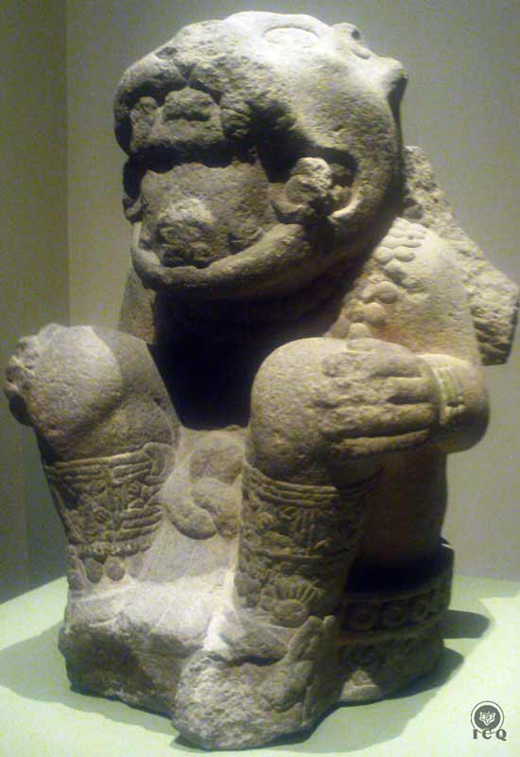

Figure 33 - Tiger-Knight Warrior (Museum of History and Anthropology, Mexico)

Chapter 10 – The Cult to the Left-Handed Hummingbird [Huitzilopochtli]

We have parted ways with all things divine. We not even suspect there is a divine, immortal spark deep within our depths, meanwhile the Great Master Jesus the Christ says:

“Cut wood, I am there;
Lift stone, I am there.”
The Gospel of Thomas

“And it was said this Huitzilopochtli, was portentous, because off a fine feather that found the belly of his mother Coatlicue, he was conceived. No one ever showed or claimed to be his father.”
Florentine Codex

Divine Origin
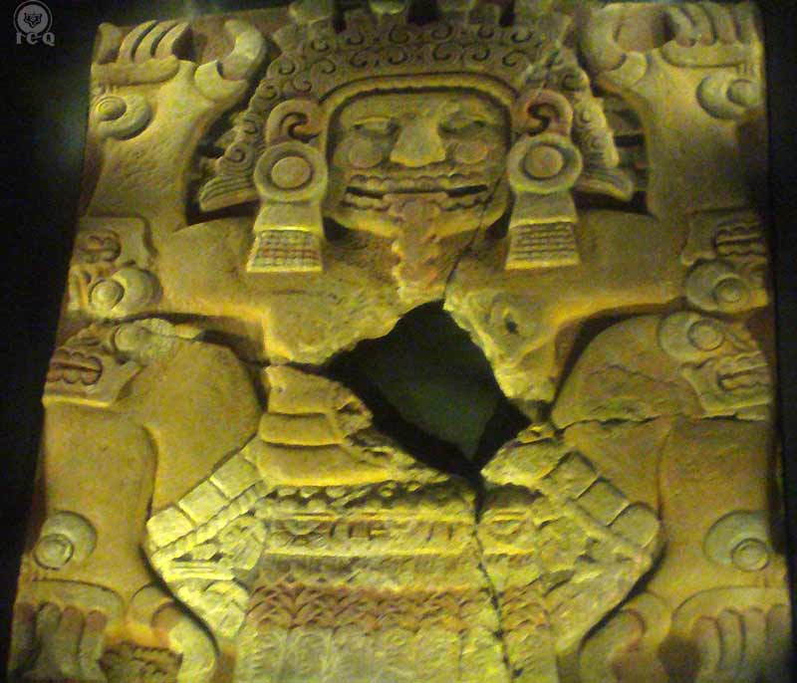
The origins of Huitzilopochtli are similar to that of Jesus the Christ and similar to the origin of the divine twins of the Popol Vuh, because the Intimate Christ has its origins in that which does not belong to time.

The Hindi traditions offer many references to the divine and timeless character of the Inner Christ [in the form of Krishna] and there is neither a reference to anyone who claimed him as their child. This comes to show us the Inner Christ must be one item with that which has no name, no limits and which exists beyond time and beyond space.
Figure 34 - Mother of the Earth. Origin of all that has been, is and will be. (Museum of the Major Temple, Mexico)

The Inner Christ, Huitzilopochtli, is a fragment, a spark that emanates from the Universal Fire.

“Have you heard this term ANUPADAKA? In its most rigorous meaning it stands for “born from no parents”. Osiris is the father who is in secret, the particular Monad of each one of us. Isis is its duality, the feminine aspect and Divine Mother Kundalini. Horus is the Innermost, our divine Spirit. [Altogether] The Triad. It is easy to understand when Horus emerges victorious from the battles with the red demons (the psychological aggregates), and then he proceeds to swallow its own soul. After the banquet the father, the mother and the son: Osiris, Isis and Horus, the three divine fires with their diamond souls, fuse together and create a single flame: an ANUPADAKA. The occult father, deep within the Absolute and deep within the undefinable and never-ending bliss, the ANUPADAKA, cannot emerge from parents, because it exists by itself and is One with the Universal Spirit of Life.”
Samael Aun Weor

Veneration

“He was venerated by the Mexica. They offered him sacrifices, honored and served him. Huitzilopochtli gave retribution to all who acted in such ways.”
Florentine Codex

The veneration of divinity is expressed in the most diverse ways across all traditions, yet what is most common amongst them is the lighting of fire and the burning of resins, as the burning of Copal, Myrrh or Frankincense on hot embers. These are representations of the alchemical transmutation of the creative powers. Lamentably we tend to confuse the “thing itself” of the symbol with what it represents, so it becomes necessary to apply the teaching to our daily living to grasp its true meaning.

Those who choose to work in the Great Work must have as a basis the veneration of the Intimate Christ and this must reflect in all the actions that take place in practical life. With Christ being “love”, we must demonstrate respect to the life of all creatures whether animals, plants or flowers of our great mother nature; we must demonstrate this love as we apply it towards the sacred teachings of the great masters, as well as in the love expressed for parents and children, the love between the couple, the love for all of humanity, and the love for everything that exists.

“Parents and teachers of schools, colleges, and universities must teach the new generations to respect and venerate their elders.

“That which has no name, which is Divine, which is the Reality, has three aspects: wisdom, love, and Word.

“The Divine as Father is cosmic wisdom, as Mother is infinite love, as Son is the Word.

The father of a family is the symbol of wisdom. The mother of a home symbolizes love; children symbolize the Word.”
Samael Aun Weor

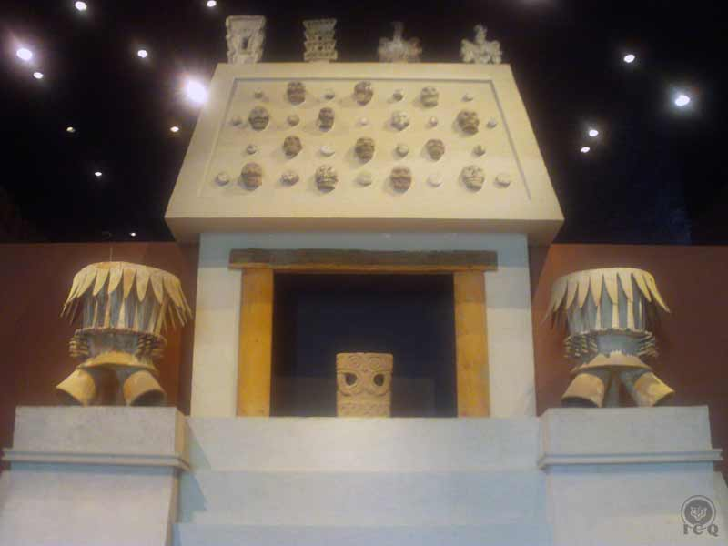
Figure 35 - Adoration site with braziers (Museum of History and Anthropology, Mexico)

Sacrifices
The sacrifices offered to our lord Huitzilopochtli are in no way the decrepit mental projections our mind can think of, but they are sacrifices of an internal nature. The sacrifice of the “human hearts” is associated to the sacrifice of our negative sentiments, for example anger. Anger as a negative sentiment must be sacrificed, transmuted into compassion, and manifested as love for thy neighbor.

It is certainly not easy to rein in our negative emotions, what is typical amongst us humans is to give ourselves into identifying and fascinating with the various dramas of our daily life. So offering the sacrifice of the hearts to the gods is truly the effort to sacrifice our negative emotions, so that out of the transmutation of such forces we allow the light to emerge.

The observance of the art in this and other codices, as well as the carvings made by both the Maya and the Aztecs, will show scenes of self-sacrifice; in some instances we will see the carving of a person forcing a spear through their tongue and in others, a thread of needles of Agave through the tongue as well, and this must not be taken literally. Because this teaching is based on love itself, there is no invitation to become violent against our own bodies. What these engravings teach us is of the great sacrifice that we must make to end the damage we create with the power of the word with our calumnies, our gossip, and our lies, and transmute our words into words of wisdom and love. These are actions that can only be performed by the true warriors of the gnostic philosophy as they embark to battles each one with their own self.

There are many other carvings and engravings that show others piercing their ears, as a reminder that we must transform the words of hatred, criticism and insults we hear instead of reacting with anger; we must learn to sacrifice our negative sentiments into comprehension and love for others. These efforts comprise the system of the Transformation of Impressions, where the practitioner uses his consciousness as a filter before the impressions can reach their mind.

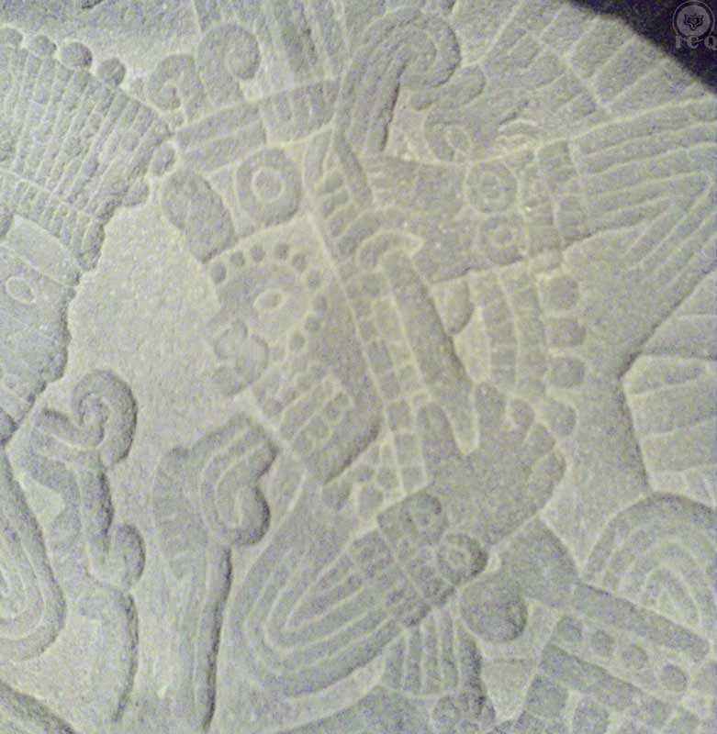
Figure 36 - A scene of self-sacrifice where an ear is pierced; detail from "Jaguar-Jicara de Aguilas". *Museum of History and Anthropology)

Honor and Service
It becomes indispensable to honor and serve our Inner Christ and we do that when we practice actions in favor of those who suffer, when we are capable of bringing comfort and the very teaching of gnosis as the precious balm that can heal the wounds of all of humanity.

“We need the conflagration of Love to transform the world, we need of the fire of Love to illuminate society. The cold, insipid and complicated codices do not change anything and neither transform anything. The very best social projects become useless, just as useless are the best political principles if they are not written with the fire of Love. The true Revolution is the result of transformation and only the tempests of Love can transform both the individual and society.”
Samael Aun Weor

The Intimate Christ rewards with wisdom, illumination, protection and guidance to those who act in accordance with its will, because they demonstrate with their actions, right action, right thought, and right feeling.

Tribute and Cult

“And his cult was brought from Coatepec, the mountain of the serpent, just as it used to be practiced in the most ancient of times.”
Florentine Codex

We must offer cult to our Intimate Christ through tangible actions. If Huitzilopochtli, our Inner Christ has as its ultimate attribute the marvelous force of love, then we need of men and women with a willpower of steel to reflect in all their actions kindness, compassion, and pure love without expecting anything in return. All these things are impossible for as long as we continue to carry within the negative sentiments of resentment, anger, hatred, and revenge.

“The time has come to put into practice the charity taught by the masters and priests of all times. The words uttered with the mellow cooing of doves and below the sacred thresholds of the temples must now become a tangible reality.”
Samael Aun Weor

The true cult can only be demonstrated with tangible actions and this is only possible when we do it from the Mountain of the Serpent, the Coatepec, which is our walking of life as the path to initiation.

This cult has no beginning and has no end. From the most ancient times tribute has been offered to the Intimate Christ; this has been seen as the cults to Zeus, Krishna, Jesus and Quetzalcoatl. He is the sacred fire of the Persians and has been present on all lands and throughout all of the history of mankind.

When we learn ourselves to walk in the shoes of others, when we become capable of feeling and thinking what our neighbor feels and thinks whether it is our spouse, or our children, friends or enemies; when we truly do something to help remedy the suffering of others which is, in turn, our own suffering, it is then when we demonstrate the true tribute and cult to our lord Huitzilopochtli.

Seek of the Left-Handed Hummingbird within your internal universe, feeling all those around you as if they were you and you were them; loving and helping all of humanity, and you will achieve the great event of receiving him and experiencing his birth within your heart.

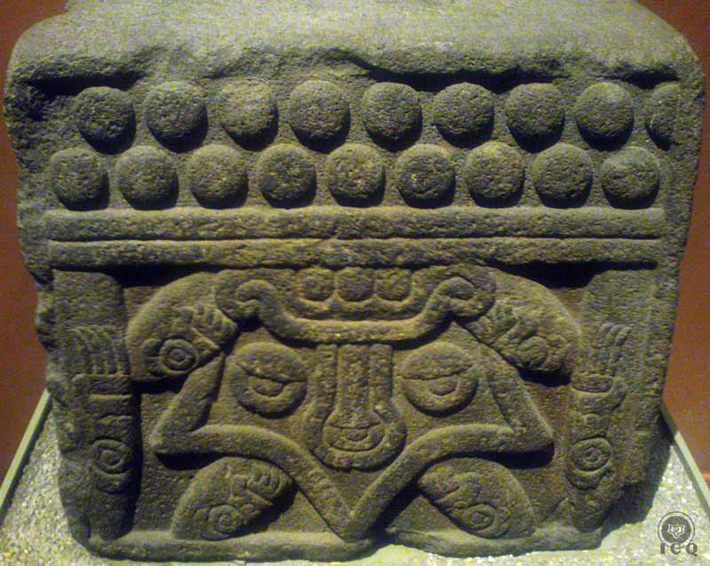
Figure 37 - Chest of Stone [Tepetlacali] dedicated to Venus. Fraternal love is represented by Venus. (Museum of History and Anthropology, Mexico)

*****

Appendix – A

The One with the Skirt of Serpents [Coatlicue]

To allow the reader the opportunity to penetrate deeper into the teaching, we transcribe the work of Master Samael Aun Weor from his Monograph #10 of the book Aztec Christic Magic. The writing is specific to the monolith displayed in the Museum of History and Anthropology in Mexico City.

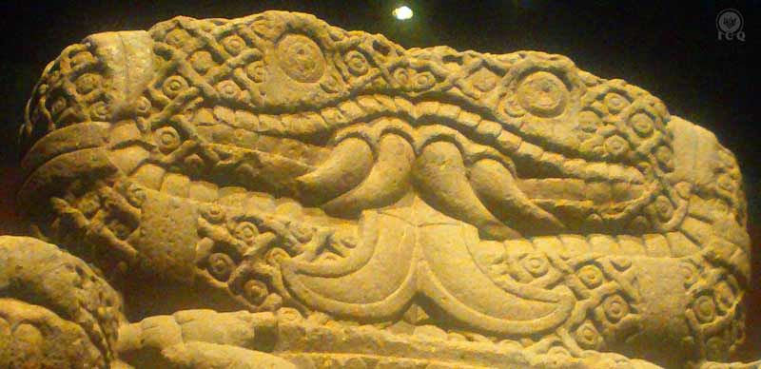

“In the Museum of Anthropology and History in Mexico City, there exists a monolith with an impressive tetra (4) significance: On the apex of it, all the way through the ring of its entangled body, protrudes a precious and great two-headed serpent, which can be seen on the front and on the back like the God Janus of the Greco-Roman religion. The two-headed serpent’s eyes are round and penetrating; from their half-opened jaws (located under the four superior, curved, sharpened, protruded fangs) hang great and bifid tongues

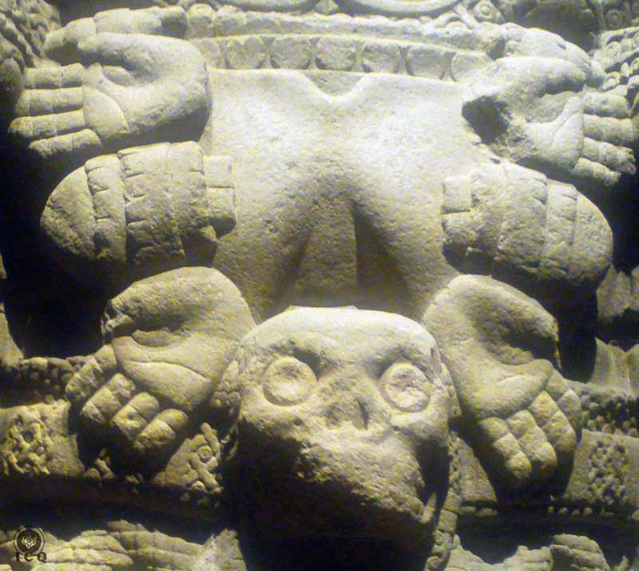

“From its chest hang two flaccid breasts. From shoulder to shoulder, this deity wears a leather necklace that is decorated with hearts, and is located in the middle of four outstretched hands. At the height of the navel there is a cranium that completes the necklace.

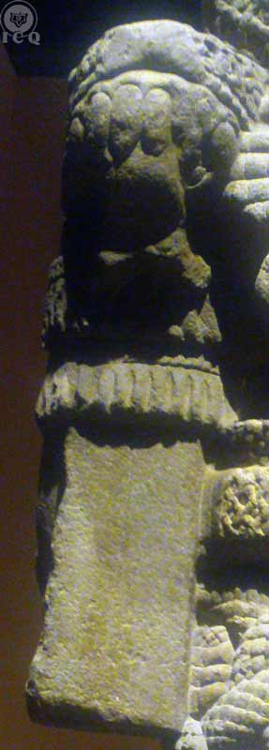

“Its arms are stiffly located at each side, with forearms bent. Underneath its hands there appear superior, fang-like paws, which are actually heads of precious serpents with half-opened jaws. There hang smooth and geometrically cubic rectangles with a vertical line in the center of each one of its faces. All of this is a symbol of perfection of the deeds of its hands.
It has tiger paws and eagle eyes on its shoulders and elbows.

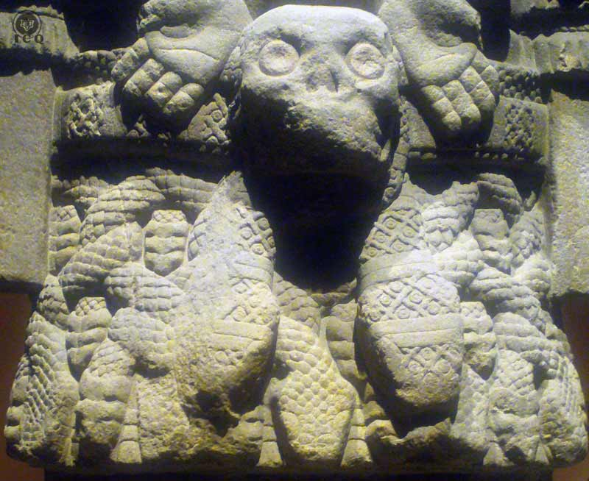

“Its short skirt is made of intertwined serpents with their heads pointed downward. The skirt fits together at the waist by means of a wide belt made out of precious serpents that are tied underneath the cranium (whose wide open eyes possess a threatening sight). On the belt, the serpent heads hang towards the front like two ends of a tie without a knot. This symbolizes that everything that exists in the universe is the outcome of the sexual fire.

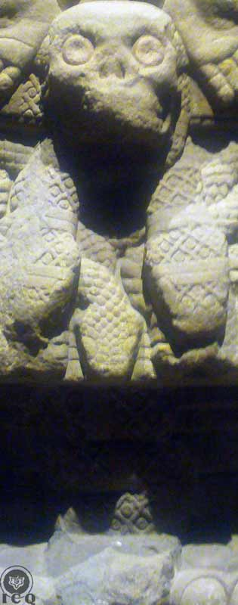

“Nevertheless, the cranium at the navel of this deity is neither the final touch of its necklace nor the brooch of its belt, it is rather Coatlicue, the devourer of men, the Goddess of earth and death, whose body projects from between the thighs of the deity towards the front and from the lower abdomen until the feet.

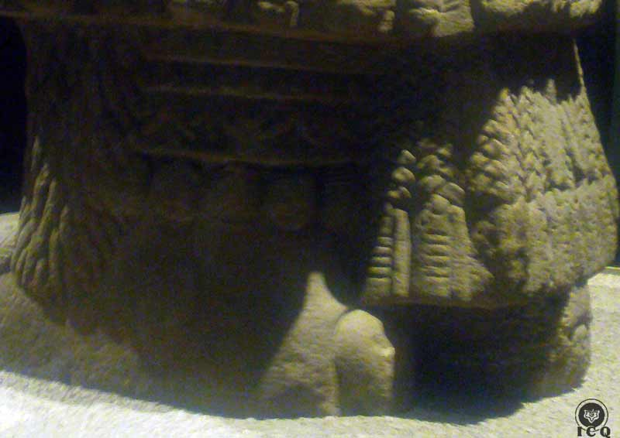

Many hearts and two streamers made of quetzal feathers adorn the sides of its underskirt that descend to its ankles and end in a wide fringe made of intertwined feathers. These feathers are adorned with badges from which sixteen long rattles hang.

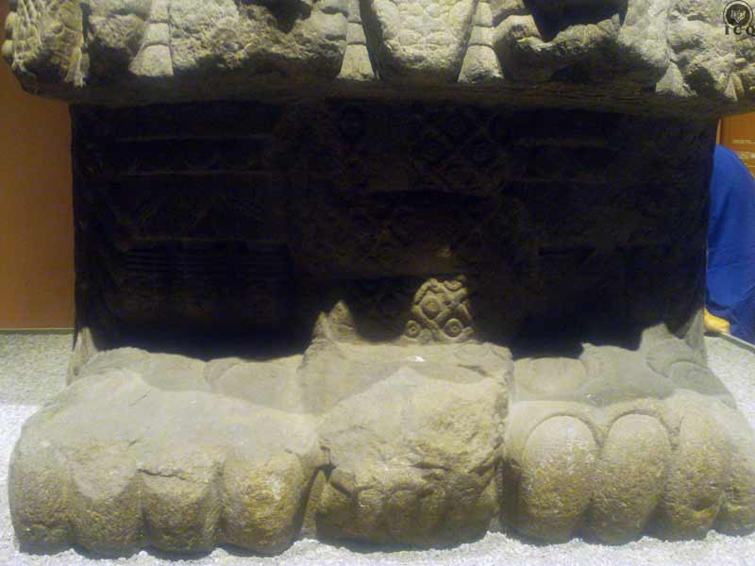

“A sinuous and thick serpent shows off its jaws with superior fang-like paws between the four paws of each one of the feet of this deity, and upon each one of its feet on a bas-relief are two eagle eyes that try to see towards the infinite.

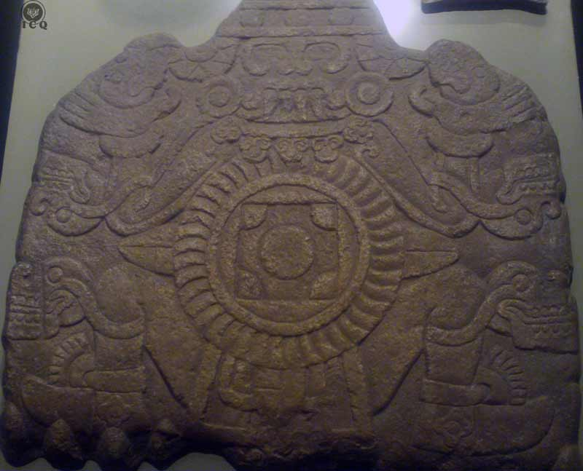

“In the lower part, at the base or support of the sculpture, in bas-relief, we find Mitclantecuhtli with arms and legs opened as in the cross of Saint Andrew.

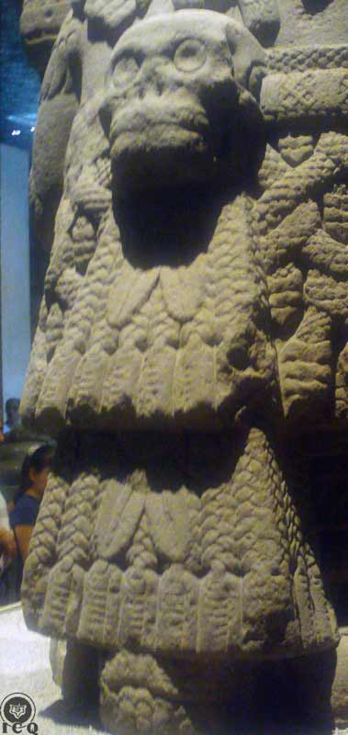

“In the posterior part, between its thighs, the creative fire protrudes downward from the lower abdomen. The mouth of the abyss is opened at its navel.

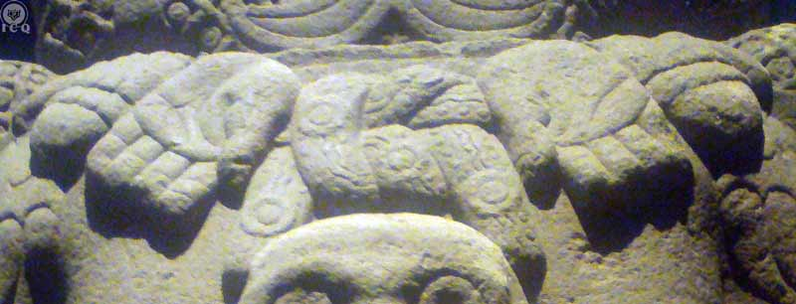

“From its shoulders, hangs the necklace with two hearts in the middle of four hands which are opened in supplication towards the heights and the final touch is a marine knot adorned with four badges upon the vertebral column in between its hands.

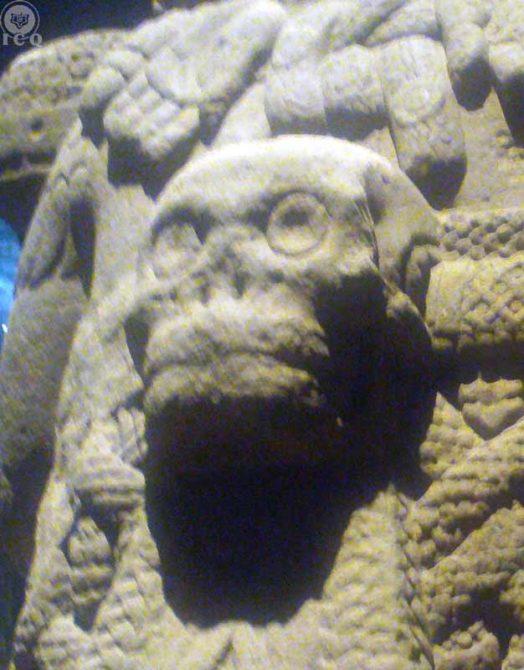

“On its back, at the height of the scapula, the cranium that looks as if it is fastened to the belt of her skirt of serpents, symbolizes Tonantzin, Mother of the Gods, who is hidden behind, in the posterior part of the skirt of Coatlicue, and who is forgotten by this present generation of humans. Her figure protrudes in the posterior part of this deity.

“She is dressed in a lace tunic that descends towards her feet and ends in a single and enormous paw, whose nails are seven elongated balls. This is an emblem of perfection and sacrifice. From its necklace at the height of the thyroid, hang two great flinted tongues, and upon her pectorals lies a laced tunic with six tassels which is the final touch. This is an emblem of creation. On the front, underneath her pectorals, at the height of the lower abdomen, we find a streamer made of very fine arrows from which two great flinted tongues hang. The whole of these in their conjunction symbolize the universal fire of creation.

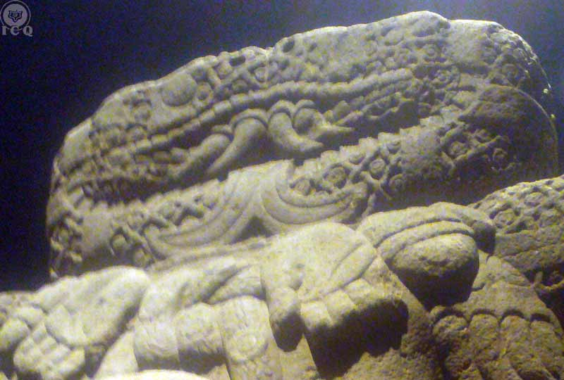

“A ‘sentiment of maternity’ emanates from this precious serpent, which is the final touch to the whole combination of this monolith. Its double-headed face is the emblem of the divine couple.

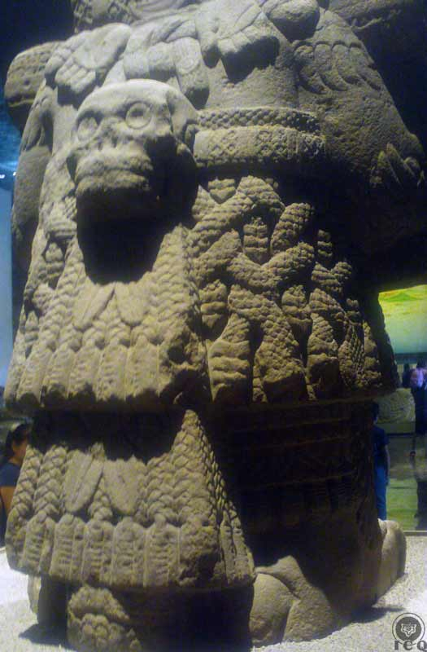

The posterior part of its shoulders towards its feet symbolize Tonantzin, the Mother of the Gods.

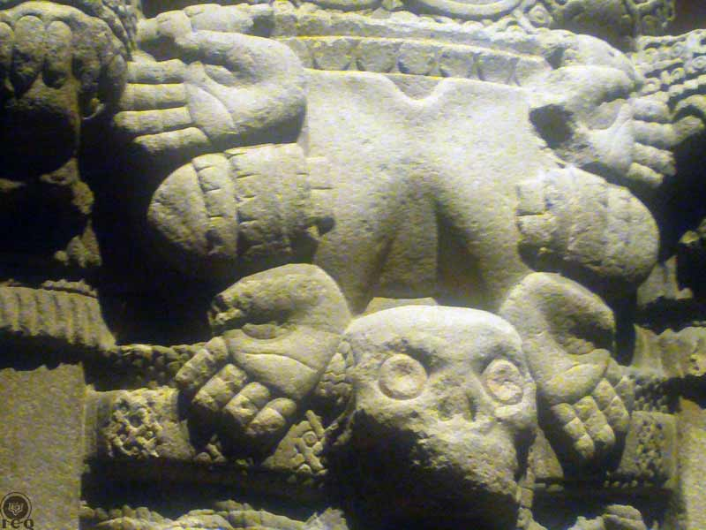

“Her chest with flaccid breasts adorned with the necklace of hands and hearts symbolizes Coatlicue, the shadow of Tonantzin.”
Samael Aun Weor

Appendix – B

The One Adorned with Rattles [Coyolxauhqui]

Description of the monolith found in Mexico City representing “The One Adorned with Rattles [Coyolxauhqui]”, found today in the Museum of the Major Temple, Mexico. The symbolism explained in this work is not that of its relationship to a goddess of the Moon, but that of a psychological aggregate, negative fire, lust and temptation.

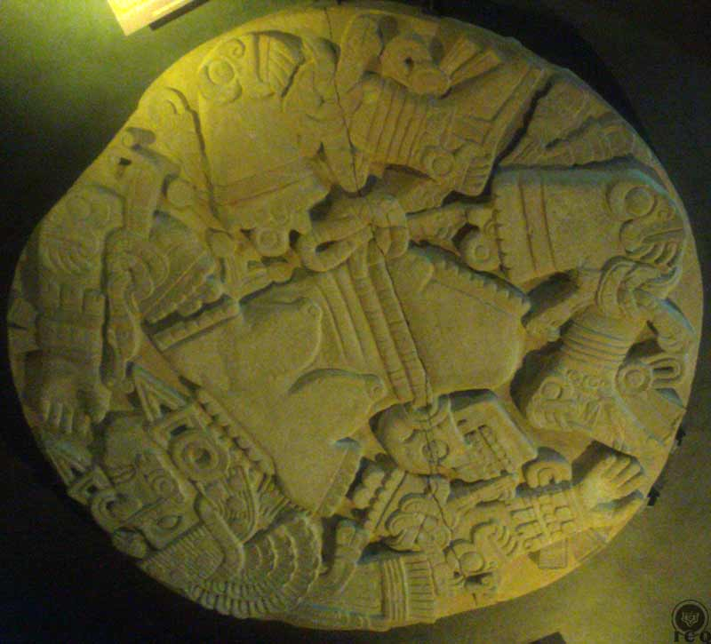

Decapitated and Dismembered

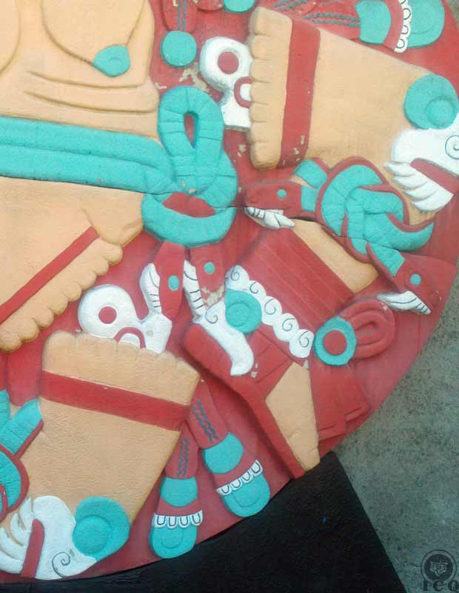

The Left-Handed Hummingbird [Huitzilopochtli] decapitates his sister and tosses her down the hillside of the Mountain of the Serpents. The stone clearly shows this particular aspect of the myth, dismembered, decapitated and bleeding. This monolith is representation of the internal work that must be realized within the internal universe of each human being: the elimination of all psychological aggregates.

The Woman

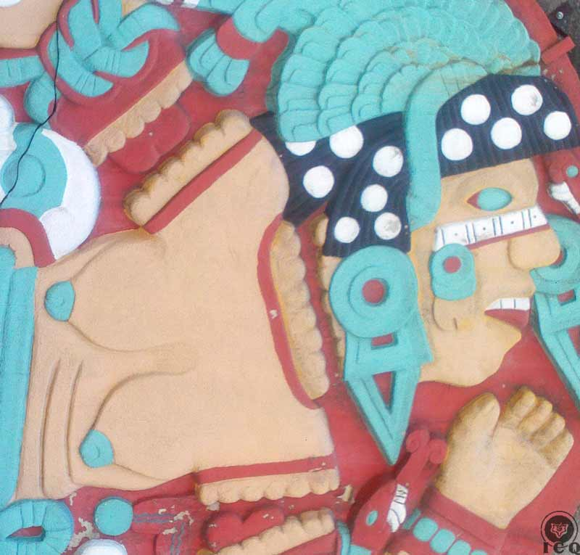

The same monolith holds a multiplicity of meanings to create an impact to the emotional center. The woman in the carving is also a representation of temptation, the mythological Eve, she is also Kundry in Wagner’s Parsifal. She is lust and sexual temptation, imminent danger and constant threat to both men and women.

Serpents

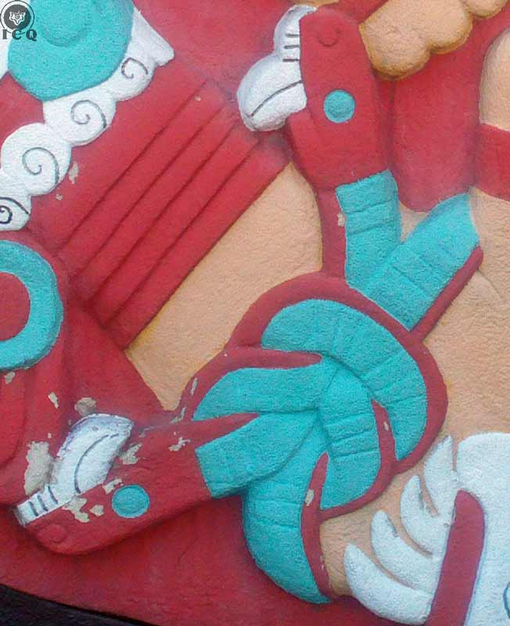

There are knotted serpents on her extremities and her belt is made of a serpent with two heads. This is a symbol of the sexual fire, but when placed in service of the Ego. Psychological aggregates make use of this negative creative energy to grow and harden themselves.

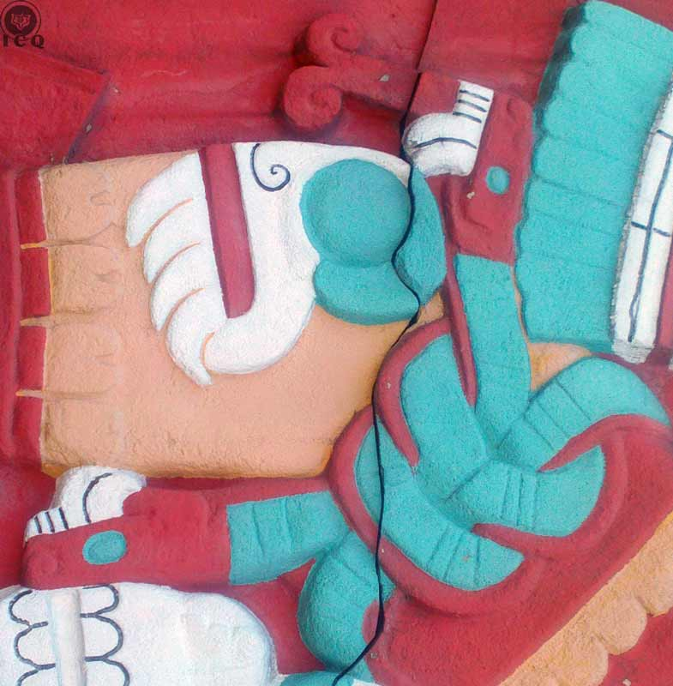

Adornments

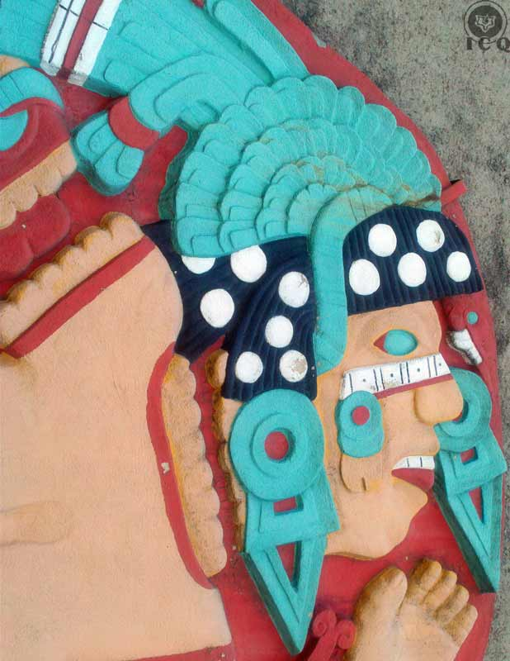

She has been methodically adorned with jewels, a crown of eagle feathers, earrings, a nose ring and a decorative wreath on her head and these are all representations of the positive values of the consciousness as they become trapped by the ego. The rattles on her face are a symbol of her voluptuousness and war.

Claws

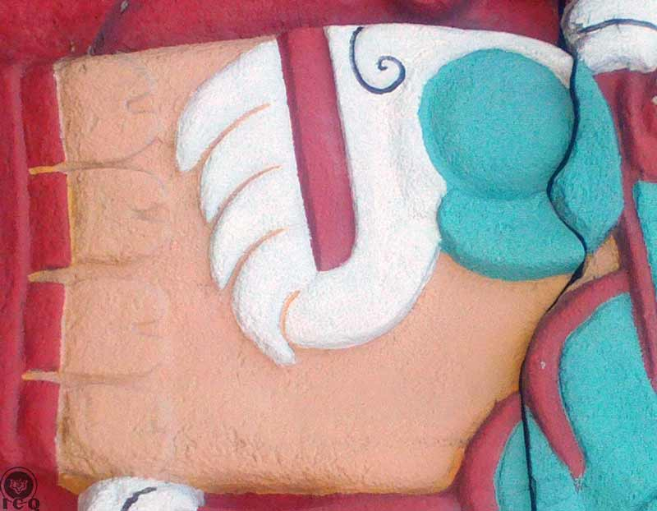

Her knees and her elbows show claws as a symbol of the brutality of the ego; its capacity to destroy anything and everything, bring death to those we love the most and all of this because of the harshness of its mind.

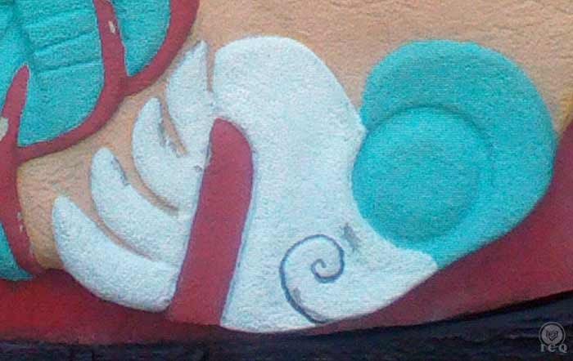

Skulls

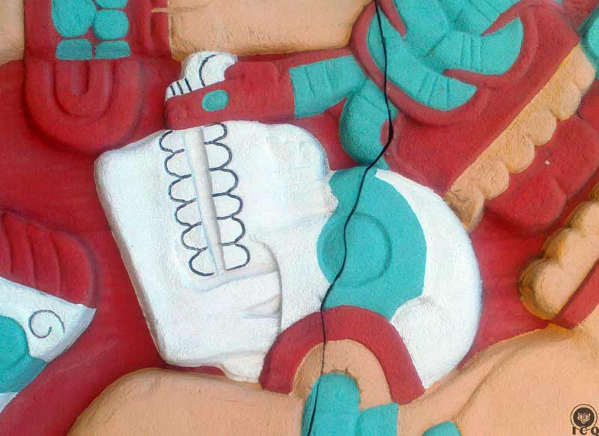

There is a skull on her waistline, similar to that of “The One with the Skirt of Serpents”, goddess of Earth, of life and death. We must remember she is her daughter, yet in this instance the skull is a representation of the extinction of the positive values of the soul, as they wane until they disappear as our psychological aggregates manifest.

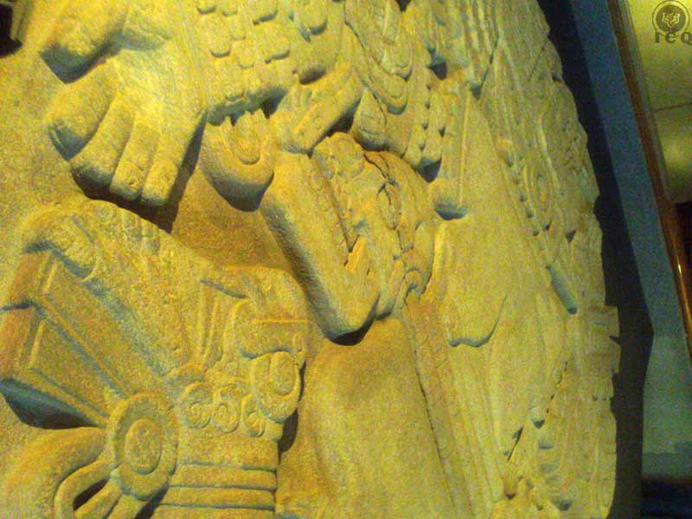

Bibliography

Bhikkhu, Thanissaro. Dhammapada. Web Translation. 1997. Dhp XXII. 7 August 2016. http://www.accesstoinsight.org/tipitaka/kn/dhp/dhp.22.than.html.

Samael Aun Weor. Fundamental Education. Web. 2016. www.gnosticteachings.org.

Samael Aun Weor. My Return into Tibet. 2015. Web. 15 November 2016. www.samaelgnosis.net.

Samael Aun Weor. Revolution of the Dialectic. Web. 2016. www.gnosticteachings.org.

Samael Aun Weor. Revolutionary Psychology. Web. 2016. www.gnosticteachings.org.

Samael Aun Weor. Social Christ. 2015. Web. 15 November 2016. www.samaelgnosis.net.

Samael Aun Weor. Social Transformation of Humanity. 2015. Web. 15 November 2016. www.samaelgnosis.net.

Samael Aun Weor. Tarot and Kabballah. Web. 2016. www.gnosticteachings.org.

Samael Aun Weor. The Mystery of the Golden Blossom. Web. 2016. www.gnosticteachings.org.

Samael Aun Weor. The Secret Doctrine of Anahuac. Web. 2016. www.gnosticteachings.org.

The Gnostic Gospels. The Gospel of Thomas. Watkins Publishing. 2006. Pp. 41.

The Good Music Guide Classical Music Forum. Requiem. Web Translation. Sequentia. 14 November 2016. http://www.good-music-guide.com/reviews/055lyrics.htm.

Samael Aun Weor. Mayan Mysteries. 2015. Web. 15 November 2016. www.samaelgnosis.net.

The name Florentine Codex is given to the writings titled “Universal History of the Things of New Spain” documented by the Spanish Franciscan Monk Bernardino de Sahagún between the years 1540 and 1585. The version of “The Myth of the Birth of Huitzilopochtli” used in this treatise is the translation of Miguel Leon-Portilla, from his works: “Mexico-Tenochtitlan: Su Espacio y Tiempo Sagrados”. INAH. 1979.
Samael Aun Weor. The Secret Doctrine of Anahuac. Christmas Message of 1974-1975.
Samael Aun Weor. The Secret Doctrine of Anahuac. Chapter: Paradises and Infernos
THELEMA is the mantric name of true willpower.
Samael Aun Weor. The Secret Doctrine of Anahuac. Christmas Message of 1974-1975.
Samael Aun Weor. Tarot and Kabballah. Chapter XXXI: Arcanum 9.
Samael Aun Weor. Mayan Mysteries. Chapter: Description of the “N” Contrail
Samael Aun Weor. The Mystery of the Golden Blossom. Chapter 3: The Prestidigitator Devil
Bhikkhu, Thanissaro. Dhammapada. Web Translation. 1997. Dhp XXII. 7 August 2016 http://www.accesstoinsight.org/tipitaka/kn/dhp/dhp.22.than.html
Samael Aun Weor. The Secret Doctrine of Anahuac. Chapter: The Serpentine Binary.
“Demon” from Proto Indo European *dai-mon- "divider, provider" (of fortunes or destinies).
Church: from Greek kyriake (oikia), kyriakon doma "Lord's (house)" or the “House of the Innermost”
Nettle: a herbaceous plant that has jagged leaves covered with stinging hairs.
Samael Aun Weor. The Secret Doctrine of Anahuac. Chapter 14: The Serpentine Binary.
Samael Aun Weor. Revolutionary Psychology. Chapter 13: The Observer and the Observed.
Samael Aun Weor. Revolutionary Psychology. Chapter 13: The Observer and the Observed
Samael Aun Weor. Revolution of the Dialectic. Chapter: The Didactic for the Dissolution of the “I”
Sivananda Saraswati (or Swami Sivananda) (8 September 1887 – 14 July 1963) was a Hindu spiritual teacher.
ibid. Chapter: The Fallacy of the Ego
The Venustic Initiation is associated to Venus, the planet of love.
Samael Aun Weor. Tarot and Kabballah. Chapter: The Initiation of Tiphereth
Samael Aun Weor. The Secret Doctrine of Anahuac. Chapter: The Serpentine Binary
Samael Aun Weor. Tarot and Kabballah. Chapter: Arcanum 5
The Good Music Guide Classical Music Forum. Requiem. Web Translation. Sequentia. 14 November 2016. http://www.good-music-guide.com/reviews/055lyrics.htm
Samael Aun Weor. Revolution of the Dialectic. Chapter: The Individual and Society
Samael Aun Weor. The Secret Doctrine of Anahuac. Chapter: Nahuatl Lucifer
The Gnostic Gospels. The Gospel of Thomas. Watkins Publishing. 2006. Pp. 41.
Samael Aun Weor. My Return into Tibet.
Samael Aun Weor. Fundamental Education. Chapter: Old Age
Samael Aun Weor. Social Transformation of Humanity. Chapter: Transformation and Reform.
Samael Aun Weor. Social Christ. Chapter: Homeless Children.

